INFORMATION & COMMUNICATION TECHNOLOGY
UPPER SIXTH
ICT
First Term Learning Notes
Explanations · worked examples · labelled diagrams
Guided practice · independent questions · answer guidance
2026–2027 | Weeks 1–13 | Lessons 1–46
35 original figures · 9 integration activities · 2 classroom evaluations
A teaching resource based on the supplied progression.
Not an official GCE Board publication.
Revised 23 October 2026

Contents
Click a lesson title or use Word's heading navigation. The PDF has its own paginated contents.
Learning ICT, not memorising summaries
Part 1 — Applying artificial intelligence
Lesson 1 — The concept of artificial intelligence
Lesson 2 — AI ethics and responsible use
Lesson 3 — AI techniques and intelligent systems
Lesson 4 — Machine learning
Lesson 5 — Developing AI systems
Lesson 6 — Integration: Apply AI responsibly
Part 2 — Understanding and designing networks
Lesson 7 — Fundamentals of computer networks
Lesson 8 — Network complexity and operational challenges
Lesson 9 — Integration: Describe a real organisation's networking needs
Lesson 10 — Types of networks by coverage area
Lesson 11 — Choosing the right network for an organisation
Lesson 12 — Integration: Select coverage for three organisations
Lesson 13 — Network architecture: Peer-to-peer and client/server
Lesson 14 — Types of physical network topologies
Lesson 15 — Comparing and choosing network topologies
Lesson 16 — Integration: Design architecture and topology
Part 3 — Building and protecting networks
Lesson 17 — Network equipment
Evaluation 1 — Network foundations and AI
Lesson 18 — Setting up a computer network
Lesson 19 — Selecting equipment for organisational networks
Lesson 20 — Integration: From design to a working network
Lesson 21 — Intranet and extranet
Lesson 22 — Virtual private networks and privacy
Lesson 23 — Computer and network security
Lesson 24 — Data protection and access control
Lesson 25 — Data validation and verification techniques
Lesson 26 — Integration: Secure a school information service
Part 4 — Transmitting data reliably
Lesson 27 — Modes of data transmission
Lesson 28 — Broadband and narrowband transmission
Lesson 29 — Types of data transmission
Lesson 30 — Guided and unguided transmission media
Lesson 31 — Peripheral device control mechanisms
Lesson 32 — Network protocols and their roles
Lesson 33 — Protocol suites and the OSI reference model
Lesson 34 — Integration: Analyse a data-transmission problem
Evaluation 2 — Security and data transmission
Lesson 35 — Error detection and data-transfer checks
Part 5 — Using the Internet to communicate and collaborate
Lesson 36 — History and development of the Internet
Lesson 37 — Internet connectivity technologies and requirements
Lesson 38 — Social networks and collaborative environments
Lesson 39 — Internet services and information retrieval
Lesson 40 — Internet communication and teleworking
Lesson 41 — Integration: Connect, collaborate and communicate
Part 6 — Digital services, learning and HTML
Lesson 42 — Electronic services: E-commerce, e-health and e-government
Lesson 43 — Applications, benefits and challenges of electronic services
Lesson 44 — Computer-assisted learning and e-learning
Lesson 45 — Integration: Design a digital services and learning programme
Lesson 46 — Developing simple web pages using HTML
Consolidation — Explain, apply and evaluate
Source and alignment notes

Learning ICT, not memorising summaries
These notes are written for an Upper Sixth learner who needs to understand a topic, use it and explain a decision—not merely recognise a definition. You should already be able to manage files, use basic application software and describe the main parts of a computer. Whenever a new technical term is introduced, its meaning is explained before it is used to solve a problem.
Our running example is Mboa Community College, a fictional school near Yaoundé. The school has a computer room, an administration office and a small library. Its learners also work with imagined clinics, traders and farming cooperatives. These scenarios are teaching examples, not claims that a particular real organisation uses a particular technology.

How to work through a lesson
Read the opening situation first and try to answer its question using what you already know. Then read the explanation and follow the worked example without skipping its reasoning. A worked example shows how to move from a problem to an answer; it is not just another fact to memorise. Redraw the labelled diagrams and explain each arrow aloud. An arrow normally represents a connection, a direction of communication or a step in a process, not decoration.
Complete the guided activity before attempting the questions independently. Write your answers before consulting the answer guidance. That guidance explains the important reasoning; it is not an official GCE marking scheme. If your answer differs, ask whether it is technically correct and supported by the stated situation. Several design questions have more than one defensible answer.
A useful habit is to keep an ICT notebook with three sections: explanations in your own words; practical evidence such as a test result, screenshot or saved file; and corrections explaining why your first attempt was wrong. A list of successful clicks is less informative than an explanation of what those clicks achieved.

What a good Upper Sixth answer does
Define means give the precise meaning of a term. Describe means give its relevant features or steps. Explain means show how or why something happens. Compare means discuss similarities and differences on the same criteria. Evaluate means weigh strengths and limitations against the needs in the question, then reach a supported judgement. Demonstrate means perform a task and provide evidence that it worked.
For example, “Use fibre because it is good” is not an explanation. “Use fibre between the two buildings because the route exceeds the usual 100 m copper Ethernet channel limit and fibre is not affected by electrical interference; allow for the higher installation cost” is a reasoned recommendation. You will practise this kind of connection between a fact and a consequence throughout the term.
The GCE Board describes Advanced Level assessment as involving thinking, application, synthesis and evaluation, not recall alone [S2]. The earlier MINESEC high-school ICT syllabus also emphasises fundamental principles, practical competence and informed decisions in real-life situations [S3]. These notes therefore combine technical explanations, safe practical work and discussion of social consequences. The supplied 2026–2027 progression sheet, not the older syllabus, determines this book's first-term lesson coverage [S1].

Safe and inclusive practical work
Use a teacher-approved laboratory, test accounts and fictional data. Do not publish learners' personal details, scan networks you do not own, disable security protections to make a task work or make a real payment for a classroom exercise. Ask permission before photographing, recording or sharing another person's work. A practical is successful only if it works and respects safety and privacy.
Where equipment or connectivity is unavailable, use the paper alternative to understand the process, then complete the real practical when supervised equipment becomes available. A paper simulation is useful preparation, but it is not evidence that you can configure a real network or send an actual attachment. Work in rotating groups so that each learner performs the key actions rather than watching one confident classmate do everything.

Scope of this book
The book follows Lessons 1–46, including the nine integration activities, across Weeks 1–13 of the supplied ICT progression. It includes two locally authored evaluations and remediation activities at the points shown in the sheet. The stated weekly workload is eight periods; the school determines the length of a period and the detailed timetable. Part headings in this book organise the reading and are not new official syllabus modules.
First-term HTML covers document structure and basic content. CSS, JavaScript, hosting and the later-term topics are deliberately not taught here. The source and alignment notes at the end explain an inconsistent class label on the supplied PDF and distinguish official source information from teaching examples.

Part 1 — Applying artificial intelligence

Lesson 1 — The concept of artificial intelligence
Week 1 · Supplied progression: PDF page 1
Learning outcomes — supplied progression
• Define AI and explain its history and development.
• Identify and describe the main types of AI.
• Explain common application areas of AI.

Begin with a familiar situation
When Amina types a message, her phone suggests the next word. When she uses a calculator, it follows the arithmetic operation she selects. Both programs process data, but the word predictor tackles a task associated with human language. What makes that task an example of artificial intelligence? The answer concerns the kind of task and the method used, not whether the device looks like a person.

1.1 What artificial intelligence means
Artificial intelligence (AI) is the field of computing concerned with creating systems that perform tasks associated with human intelligence, such as recognising patterns, understanding language, reasoning, planning and making decisions. An AI system takes input from its environment, processes that input using a model or a set of rules, and produces an output. The output may be a prediction, a recommendation, generated content or an action.
Consider an e-mail spam filter. Its input includes properties of a message, such as words, links and the sender's address. Its output is a classification such as “spam” or “not spam”. A person can also make this judgement, but the computer can process many messages quickly. This does not mean that it understands the sender's intentions in the same way a human does.
Some AI systems use explicitly written rules; others use patterns learned from data. Therefore, “AI always teaches itself” is not a correct definition. Equally, not every automatic action is AI. A lamp controlled by a fixed timer is ordinary automation. A system that analyses camera images to identify an obstruction is performing a perception task. The distinction can be a matter of degree, so explain the task rather than merely labelling a product “smart”.

1.2 How AI developed
In 1950, Alan Turing discussed whether a machine's conversational behaviour could be distinguished from a person's. His imitation game encouraged researchers to study observable performance rather than simply assume that machines could never display intelligent behaviour. The term “artificial intelligence” became associated with the Dartmouth research workshop in 1956.
Early researchers built programs that manipulated symbols and followed logical rules. Later, expert systems used knowledge supplied by human specialists: for instance, rules linking symptoms to possible causes. These systems could be useful in narrow fields, but collecting and maintaining all the necessary rules was difficult. Periods of exaggerated promises followed by disappointment and reduced funding are often called AI winters.
Machine learning became increasingly useful as computers became faster and more digital data became available. In 1997, IBM's Deep Blue defeated world chess champion Garry Kasparov in a match. In the 2010s, improvements in neural networks, graphics processors and large datasets produced major gains in image and speech recognition. Generative AI then made systems that produce text, images and other content widely accessible; ChatGPT's public launch in 2022 is one well-known milestone.
These events do not show a smooth march towards a human mind. They show changing methods, resources and capabilities. Progress depends on computing power, useful data, algorithms, investment and human choices. A small school with little relevant data cannot assume that buying an AI application will solve every local problem.

1.3 Main types and useful distinctions
Narrow AI is designed or trained for a particular range of tasks. A crop-image classifier and a chess program are examples. A system may perform many language tasks yet still have important limits and make basic mistakes. Strong performance in one area does not establish unrestricted human-level competence.
Artificial general intelligence (AGI) refers to the proposed ability to perform a very wide range of intellectual tasks with human-like flexibility. Artificial superintelligence describes a hypothetical system exceeding human intellectual capabilities very broadly. These terms describe proposed capability levels; they should not be confused with ordinary product names or taken as evidence of consciousness.
Another classification describes functionality. A reactive system acts on current input without using a stored account of previous interactions. A limited-memory system uses stored or recent information in making decisions. “Theory of mind” and “self-aware AI” are sometimes discussed as further categories, but they are conceptual ideas, not capabilities to assume whenever a chatbot uses emotional language.
A different distinction concerns output. A classification system assigns an input to a category, such as identifying a message as spam. A generative system produces new content, such as a draft letter. These categories answer a different question from narrow versus general: one concerns what the system produces, the other concerns the breadth of its capabilities.

1.4 Applications and their limits
In health, AI can assist a professional by highlighting suspicious areas in a medical image. The benefit is support for detection; the limitation is that inaccurate or unrepresentative training data may produce errors. Remote medical communication alone is not necessarily AI: transmitting a patient's measurements to a doctor is telemedicine, even if no intelligent prediction is made.
In agriculture, a farmer might photograph a leaf so a model can suggest a possible disease. In banking, an AI system may flag unusual transactions for investigation. In education, a tutor may adapt practice questions to earlier responses. In transport, a route-planning system can use traffic data to suggest a journey. In each case, identify the input, the intelligent task, the output and the responsible human user.
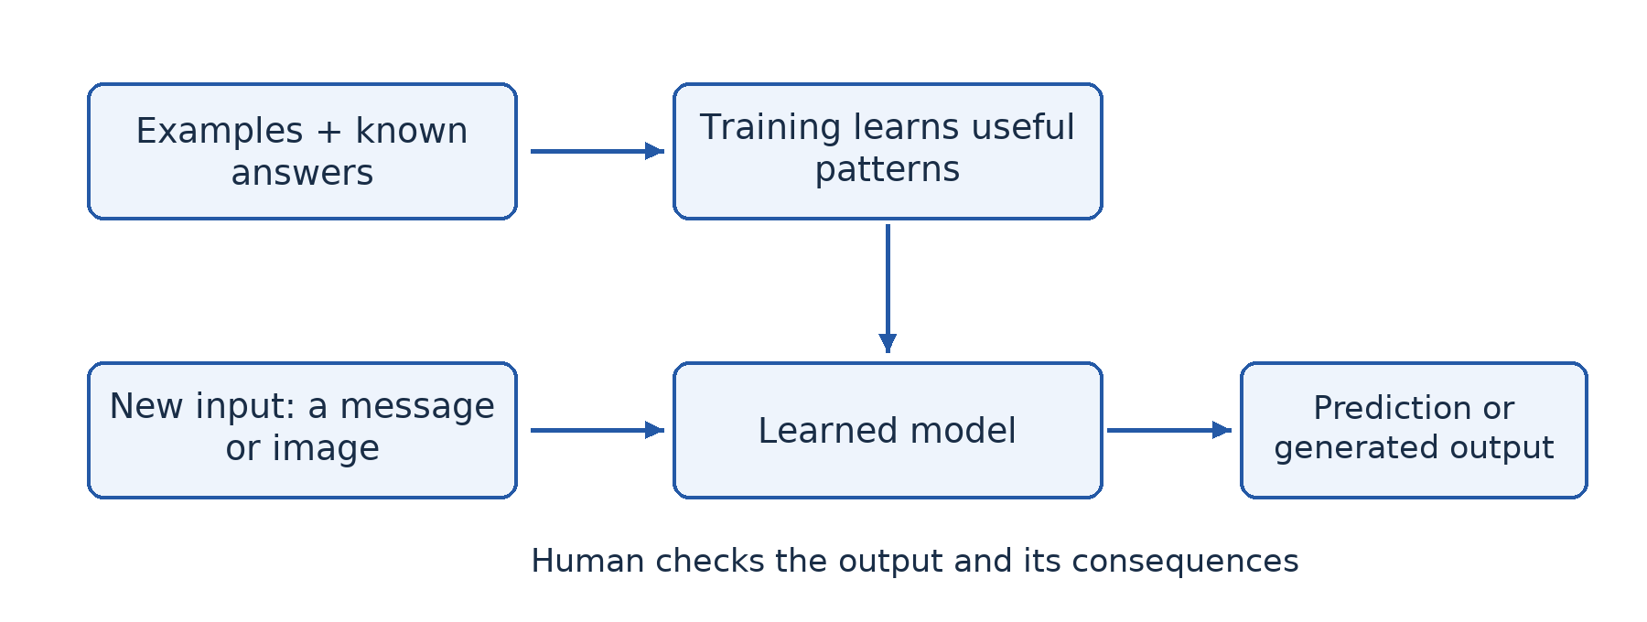
Figure 1.1 — A learned AI model uses patterns from examples to make a prediction about a new input. The prediction still needs an appropriate human decision.

Worked example — Is the clinic using AI?
A fictional clinic sends a patient's heart recording to a doctor in another town. This is an ICT application because it stores and communicates information. It is not enough evidence of AI. If a trained model also analyses the recording and flags a possible abnormality, that additional function is AI. The input is the recording; the task is pattern recognition; the output is a warning; the doctor checks the result before deciding on treatment. The explanation is stronger than calling the entire clinic “intelligent”.

Guided activity
Choose three familiar systems: a calculator, predictive text and an online recommendation feed. For each, write a paragraph identifying its input, processing task and output. Explain which task provides evidence of AI. If you cannot know the internal method, state that uncertainty instead of inventing one. With no device, use descriptions supplied by the teacher.

Check your understanding
1. Define AI and explain why an automatic door is not necessarily evidence of AI.
2. Explain two changes that helped machine learning become more practical.
3. Distinguish narrow AI from generative AI. Can a system fit both descriptions?
4. Suggest an AI application for a farming cooperative and one limitation that must be considered.

Answer guidance
1. AI concerns tasks associated with intelligence. A door opening whenever a simple sensor is triggered may use a fixed control rule without image recognition, learning or complex reasoning.
2. Faster processors reduce training time; larger relevant datasets provide more examples from which patterns can be learned. Explain the connection rather than only naming the changes.
3. Narrow describes the range of capabilities; generative describes producing content. A task-focused text generator can be both.
4. A leaf classifier could suggest disease categories, but it must be tested on local crops and conditions. It should not replace expert advice when the cost of a wrong answer is high.

Lesson 2 — AI ethics and responsible use
Week 1 · Supplied progression: PDF page 1
Learning outcomes — supplied progression
• Explain ethical issues associated with AI.
• Examine the potential risks and benefits of AI.
• Discuss principles for the responsible use of AI.

Begin with a decision, not a slogan
Mboa Community College considers using AI to rank scholarship applicants. The system is fast, but its training examples mostly describe learners from well-equipped urban schools. Could a mathematically calculated ranking still be unfair? Yes. A calculation can reproduce unfair choices already present in its data. AI ethics examines what ought to be done when AI affects people, including who benefits, who may be harmed and who is responsible.

2.1 Bias, fairness and unequal consequences
Bias is a systematic tendency in data, methods or decisions that can distort results. If past scholarship winners mostly attended schools with strong internet access, a model may learn to associate online-course certificates with merit. A rural learner without connectivity may then be disadvantaged even if equally capable. The problem is not that every use of past data is wrong; it is that the data may contain disadvantages unrelated to the purpose of the decision.
Fairness requires asking whether the system performs acceptably for different relevant groups and whether its criteria are justified. Collecting more data helps only if the additional data addresses the actual weakness. Human reviewers can also be biased, so “a person checked it” is not a complete safeguard. Reviewers need clear criteria, authority to disagree and a way to investigate complaints.

2.2 Privacy, transparency and accountability
Privacy concerns appropriate control over information about a person. A tutoring application may collect useful learning responses, but it does not automatically need the learner's home address, identity document or private messages. Collect only necessary information, explain its purpose, control access and decide when it will be deleted. Do not upload classmates' records to a public chatbot merely because doing so is convenient.
Transparency means making relevant facts about a system and its use clear. People should know when AI materially affects a decision. Explainability concerns whether useful reasons for a particular result can be given. In a scholarship process, “the computer said no” does not help an applicant correct an error or appeal an unfair decision.
Accountability means that identifiable people or organisations remain answerable for the system's use. Responsibility cannot be transferred to software. A school needs someone to investigate inaccurate results, correct records and decide whether the system should continue operating. Human oversight must be meaningful, not a ceremonial approval of every machine output.

2.3 Other important ethical issues
Generative AI can produce plausible misinformation, including invented references and false images. A deepfake is manipulated or generated media that convincingly represents someone saying or doing something they did not. A voice-clone payment request could harm a family even when the audio sounds familiar. Verification through an independent, trusted channel is therefore more useful than judging realism alone.
AI also raises questions about copyright, consent and academic honesty. Copying an AI-generated essay without disclosure can misrepresent a learner's own achievement. AI assistance may be permitted for brainstorming but prohibited for an assessed final answer; follow the teacher's stated rules. A system's ability to reproduce content does not establish a legal right to use it.
Automation can remove some tasks while creating others. Evaluate effects on workers, training needs and working conditions rather than saying simply “AI takes all jobs” or “AI creates jobs”. Running large systems also uses energy and other resources. A useful application should be assessed against its costs and against simpler alternatives that might achieve the same goal.

2.4 Weighing benefits against risks
A risk has both a possible harmful outcome and a chance of occurring. Consider likelihood, severity, the number and vulnerability of affected people, and the ability to detect and correct a mistake. A wrong music recommendation is not equivalent to a wrong medical recommendation. Efficiency alone cannot justify removing safeguards from a high-stakes decision.
For the scholarship system, faster processing is a benefit. Unfair exclusion is a potentially serious harm. The school can lower risk by using relevant criteria, testing results across groups, protecting records, publishing the decision process, allowing appeals and keeping final responsibility with a trained panel. If it cannot provide these safeguards, delaying deployment may be more responsible than using an unsuitable system.

Worked example — Explain a principle through an action
Question: “Explain how a school can apply privacy and accountability when using an AI tutor.” A weak answer merely lists “privacy, accountability”. A developed answer states: “The school should use fictional or minimal learner identifiers and restrict access to progress records, reducing unnecessary exposure of personal information. It should appoint a teacher to review incorrect advice and complaints, so learners have someone who can correct harm.” Each principle is linked to an action and a consequence.

Guided activity — A classroom AI charter
In groups, write five rules for using AI in schoolwork. Include verification of factual claims, permitted and prohibited assistance, disclosure, protection of other people's information, and how to report harmful output. For every rule, add the harm it aims to prevent. Test the charter against a learner using AI to translate a self-written paragraph and another submitting an entirely generated assignment. With no internet, use printed examples; no personal information is needed.

Check your understanding
1. Explain how biased training data could disadvantage a group even if no developer intended discrimination.
2. Distinguish transparency from accountability using the scholarship example.
3. Evaluate AI-assisted medical screening by explaining one benefit, two risks and two safeguards.
4. Why is checking a chatbot's answer against another chatbot not always adequate verification?

Answer guidance
1. The model may learn correlations reflecting past unequal opportunities. Applying those correlations to new applicants repeats that disadvantage.
2. Transparency reveals the use and basis of ranking; accountability identifies who investigates errors and corrects decisions. A transparent but uncorrectable process is still inadequate.
3. Faster review may support clinicians. False results and exposed medical records can harm patients. Use validated performance tests, professional review, access restrictions and appropriate consent; connect each safeguard to its risk.
4. Systems may rely on similar data or repeat the same error. Consult a trustworthy independent source, an original document or an appropriate expert.

Lesson 3 — AI techniques and intelligent systems
Week 1 · Supplied progression: PDF page 1
Learning outcomes — supplied progression
• Describe common AI techniques and their applications.
• Explain the characteristics of intelligent systems (smart school, smart city, smart health, smart home).
• Compare AI techniques and intelligent systems based on their applications.

From a technique to a complete system
A school installs a camera at its gate. The camera alone records images; it does not make the school intelligent. An intelligent system needs input, processing, a decision or recommendation and an appropriate response. It also needs a purpose. This lesson connects individual AI techniques to the larger systems in which they operate.

3.1 Common techniques
A rule-based system applies explicit rules to known facts. For example, a troubleshooting program may ask whether a printer has power and whether paper is loaded. If the answers match a rule, it recommends a possible remedy. Rules are relatively easy to inspect, but maintaining a large set becomes difficult when cases overlap or conditions change.
An expert system uses a knowledge base of specialist facts and rules together with an inference engine that applies them to a problem. A user interface gathers facts and presents advice; some systems also explain which rules led to the conclusion. Such a system can support a worker in a narrow domain, but it cannot be assumed to possess all the judgement of the specialist whose knowledge was encoded.
Machine learning derives useful patterns from training examples rather than requiring a person to write every decision rule. It can help when recognising a pattern is difficult to express as a short rule. A model trained on images of different leaves can learn features useful for classification, but its success depends on representative examples and meaningful testing.
Computer vision extracts information from images or video. Reading text in a photographed document and recognising an object are vision tasks. Natural language processing (NLP) handles human language, for example translating text, identifying topics or responding to a question. Speech recognition turns spoken audio into text; speech synthesis produces speech from text. These are different operations, and confusing one with the other makes an explanation inaccurate.
Search and optimisation explore possible choices to find a satisfactory or good solution. A route planner considers roads and costs such as distance or travel time. Robotics combines sensing, control and physical action. A robot may use vision to locate an object and planning to move an arm, but a chatbot does not become a robot merely because it performs language tasks. Modern systems often combine several techniques rather than use only one.

3.2 The structure of an intelligent system
A sensor gathers information from the environment. A camera senses light; a temperature sensor measures temperature. A processing component interprets that information using rules or a model. The system then recommends or selects an action. An actuator is a device that produces a physical action, such as a motor opening a vent. A display can present advice for a person to act on instead.
Feedback returns information about the result so that later actions can be adjusted. A room controller measures the new temperature after operating a fan. Feedback is not the same as machine learning: a simple thermostat uses feedback without learning a model from examples. This distinction prevents us from calling every feedback controller an AI system.
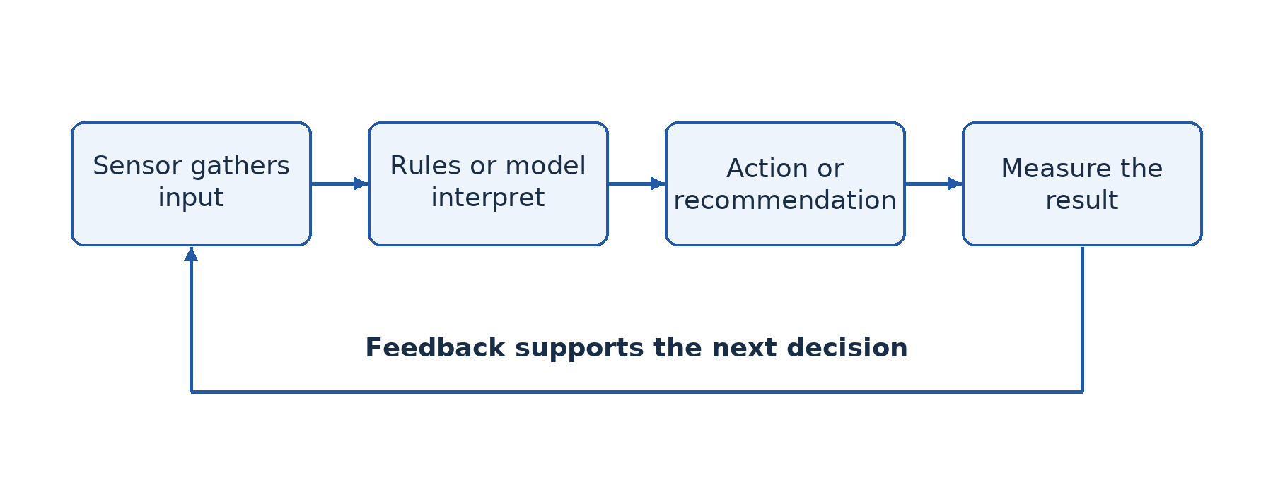
Figure 3.1 — Sensing, interpreting, acting and checking form a feedback loop. AI may be used in the interpreting stage; the whole loop also includes ordinary hardware and human decisions.

3.3 Smart school, city, health and home
In a smart school, an adaptive learning application may select practice based on earlier answers. Inputs are learner responses; processing identifies areas of difficulty; output is recommended practice; feedback comes from later results. The teacher checks whether those recommendations actually help. Privacy and unequal access are design concerns, not optional additions.
A smart city might combine traffic sensors and models to recommend signal timing. The objective is safer and more efficient movement, not simply installing many cameras. A smart-health system might identify an unusual trend in monitored measurements and alert a clinician. A smart home might interpret a spoken request and control a light. Each system combines connectivity, software and sometimes AI; not every component needs to be intelligent.
Compare systems using their purpose, input, technique, output, users and consequences of error. A school tutor and a medical warning system may both use machine learning, yet medical errors can carry different risks. The appropriate level of human oversight depends on the task, not merely the brand of software.

Worked example — Choose techniques for a library
The library wants to digitise printed titles and answer routine opening-hour questions. Optical character recognition, a computer-vision application, can turn photographed titles into text. A small rule-based question-answer system may be sufficient for fixed opening hours. A large generative model is not automatically necessary. The decision starts from the task; it then considers accuracy, cost, connectivity and the consequences of wrong answers.

Guided activity
Design a paper diagram for a smart classroom that reduces wasted lighting. Identify the sensor, processing rule or model, output, actuator and feedback. Then explain whether AI is actually necessary. For an extension, replace the simple occupancy sensor with a camera that must distinguish people from moving curtains. Explain why image recognition changes both the technical problem and the privacy risk. Do not install cameras or collect photographs of classmates.

Check your understanding
1. Explain the roles of a knowledge base and an inference engine in an expert system.
2. Distinguish speech recognition, NLP and speech synthesis using a voice assistant.
3. Give an example of feedback that does not involve machine learning.
4. Compare an intelligent health warning system with a smart-home voice controller on input, output and risk.

Answer guidance
1. The knowledge base stores specialist facts and rules; the inference engine applies them to the current facts to reach a conclusion or recommendation.
2. Recognition converts the request's audio into text; language processing interprets or formulates the response; synthesis converts response text into spoken audio.
3. A thermostat repeatedly comparing measured temperature with a fixed target uses feedback. It need not learn its rule from data.
4. Health measurements produce a clinical alert requiring careful professional review; microphone input may produce a lighting action. Both need security, but the likely severity of a wrong output differs.

Lesson 4 — Machine learning
Week 1 · Supplied progression: PDF page 1
Learning outcomes — supplied progression
• Define Machine Learning (ML) and explain its relationship with AI.
• Explain the basic principles of Machine Learning.
• Build and test simple Machine Learning models using Teachable Machine.

Why examples matter
Suppose the library wants a computer to distinguish pictures of a notebook from pictures of a calculator. Writing a rule for every possible colour, angle and background is difficult. Instead, we can supply labelled examples and train a model to recognise useful patterns. Machine learning (ML) is a branch of AI in which a system learns patterns from data to perform a task, rather than having every decision rule explicitly programmed.

4.1 Inputs, labels, training and prediction
A dataset is a collection of examples. In supervised learning, examples have known target answers called labels. An image labelled “calculator” supplies both input and target output. During training, an algorithm adjusts a model so that its predictions better match training labels according to a chosen measure of error. A model is the learned representation used to make predictions.
When the trained model receives a new image, it performs inference: it uses what was learned to produce an output. Training and inference are different stages. A deployed model does not necessarily retrain itself whenever a user shows it another object. Someone must decide whether and how new data will be used for future training.
In unsupervised learning, data has no supplied target labels and the method looks for patterns such as groups of similar records. In reinforcement learning, an agent learns a strategy through actions and feedback represented by rewards. These approaches solve different problems; they are not interchangeable names for the same training process.

4.2 Testing honestly
A model that succeeds on examples it has already seen may fail on new ones. Generalisation is the ability to perform usefully on new examples from the intended setting. Overfitting occurs when a model fits details of training data so closely that it performs poorly on new data. A learner memorising an answer sheet without understanding provides a useful analogy.
Keep test data separate from training data. If the same photograph appears in both, the test is less informative. Collect variety: different angles, distances, lighting conditions and backgrounds. If every notebook is photographed on a blue desk and every calculator on a white desk, the model may learn the desk colour rather than the object. A balanced number of examples is helpful, but balance alone does not remove this hidden shortcut.
A displayed confidence score indicates the model's output strength according to its method. It is not a promise that the answer is correct, and it need not be a well-calibrated real-world probability. Try an unfamiliar object; a two-class model may still force it into one of its two known categories. An “unknown” category or a cautious human interpretation may therefore be needed.
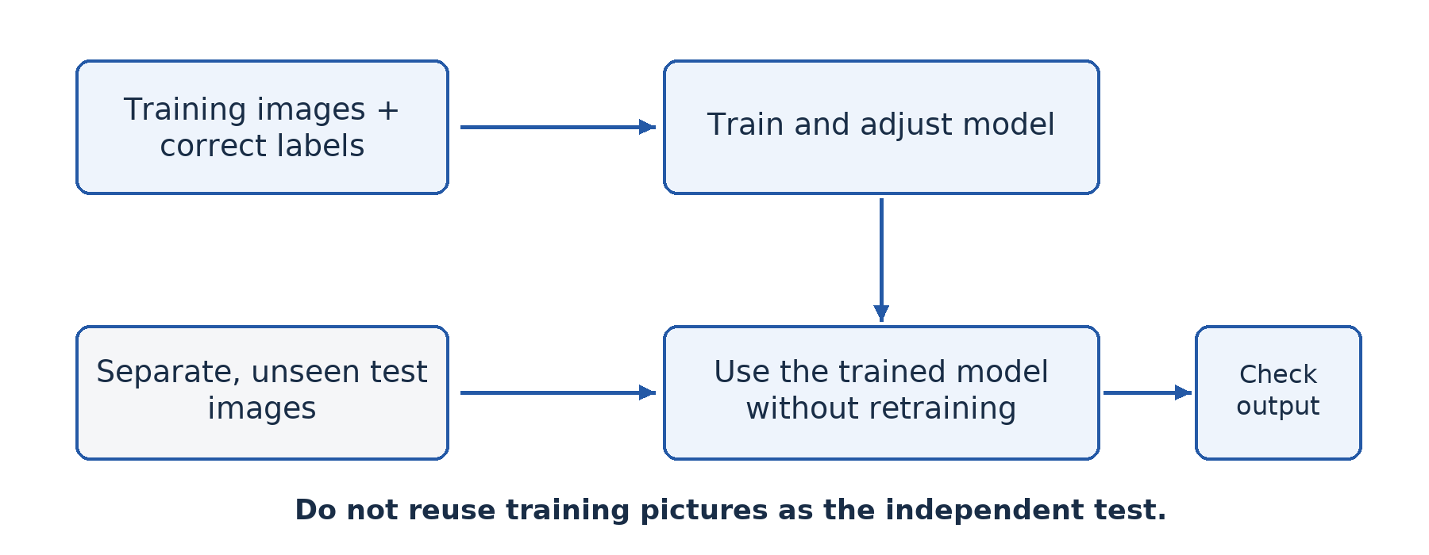
Figure 4.1 — Training examples build the model; separate new examples test it. Reusing the training pictures as the test makes performance look better than it may really be.

4.3 Guided practical — Build with Teachable Machine
Teachable Machine is a web-based learning tool that lets you train small models without writing the training code. The teacher should check access and browser camera permissions before the lesson. Use objects, not faces, and follow school rules about data collection. An interface may change, but the training-and-testing process remains the same.
1. Open the teacher-approved Teachable Machine site and choose an image project with standard image classification. Rename the two classes “Notebook” and “Calculator”. Add a third “Neither” class if the teacher wants to investigate unknown inputs.
2. Collect at least 30 training images per class. Vary the object's angle, distance and position. Use similar background variety for each class so that the background does not reveal the answer. If using a webcam, capture only the objects and the work surface.
3. Before training, reserve at least ten different test images for each class. Do not upload these to the training classes. Another group can provide them, helping avoid accidental reuse.
4. Train the model using the tool's training control. Observe that the program uses examples to build a model; it is not being given a hand-written rule saying exactly what every calculator looks like.
5. Present each test image, record its true label and the predicted label, and count the correct predictions. Also test a new background, an awkward angle and an unrelated object. Record a failure rather than repeatedly changing the input until the output looks correct.
6. Identify one likely cause of error, add suitable training examples, and train again. For a fair final comparison, use a fresh held-out test set rather than repeatedly tuning the model to the same test pictures. Save the permitted project or screenshots and write a short conclusion about its limits.
If devices are unavailable, the teacher can provide image cards with object and background features. Learners propose a rule from training cards and then test it on unseen cards. This illustrates generalisation; it does not replace later hands-on model training.

Worked example — Measure a result
A model correctly classifies 17 of 20 held-out images. Its accuracy on that test is correct predictions divided by all predictions: 17 ÷ 20 × 100 = 85%. This does not show that it is 85% accurate for all future users. Twenty images are a small sample, and they may not represent new conditions. If all three errors involve dark rooms, the next question concerns lighting, not merely how to raise the displayed number.

Check your understanding
1. Distinguish a training example, a label, a model and inference.
2. A model gets every training image right but only half of new images right. Explain a likely problem.
3. Calculate test accuracy when 36 of 45 predictions are correct.
4. Why should each class be photographed against several of the same backgrounds?

Answer guidance
1. The example is an input case; its label is the known target answer; the model is the learned representation; inference applies that model to input to produce a prediction.
2. It may have overfitted or learned irrelevant shortcuts. Examine variety and separation of data rather than claiming it is ready because training performance is high.
3. 36 ÷ 45 × 100 = 80%. State that this describes the specified test set.
4. Shared background variety reduces the chance that background alone predicts the label. The aim is to learn the intended object-related pattern.

Lesson 5 — Developing AI systems
Week 2 · Supplied progression: PDF page 1
Learning outcomes — supplied progression
• Describe the major stages involved in developing an AI system.
• Identify programming languages and tools used in AI development.
• Explain why Python is widely used in AI development.

A model is only one part of a solution
The farming cooperative asks for an AI service that identifies unhealthy leaves. A developer immediately starts choosing software. What has been missed? The cooperative's real need might be early referral to an agricultural adviser, and some photographs may be too poor for any reliable decision. Building an AI system begins with understanding the problem, not selecting a fashionable language.

5.1 Define the problem and success criteria
State who will use the system, what input they can realistically provide, what output is needed and how that output will be used. For leaf photographs, specify the crops and diseases covered. Decide what happens when the image is unclear or the disease is outside that scope. A useful success criterion might require acceptable performance on locally collected test images and an explicit “seek expert advice” pathway.
Also decide whether AI is appropriate. If farmers mainly need a directory of nearby advisers, a simple searchable directory may be cheaper and more dependable than a predictive model. A good ICT professional can justify not using AI when it does not solve the actual problem.

5.2 Obtain and prepare suitable data
Collect relevant examples with permission and accurate labels. A photograph labelled by an agricultural expert is generally more useful than an unverified caption copied from the internet. Check image quality, remove duplicates, correct inconsistent labels and document where data came from. Personal information in photographs should be avoided or removed where appropriate.
Divide data so that model development and final testing remain meaningfully separate. If multiple near-identical pictures of the same leaf appear in both sets, performance can be misleading. Training data teaches the model; validation data can guide choices during development; a final held-out test estimates performance after those choices. For a simple classroom project, the teacher may use a training/test split while explaining the purpose of the additional validation stage.

5.3 Build, evaluate and integrate
Choose an appropriate method and tools, train the model, and compare its output with known answers. Evaluate not only overall accuracy but the types of mistake. A missed serious disease and an unnecessary referral may carry different costs. Check performance for the users, devices and conditions that matter, including poorer lighting or lower-quality phone cameras.
Deployment means putting the system into real use. The model must be connected to an interface, storage and any required communication services. It needs access control, error handling and understandable output. A warning should tell a farmer what action is sensible; a mysterious score alone may be useless. Users need instructions and a way to report problems.
Monitoring and maintenance continue after deployment. New crops, changing disease patterns and different camera conditions may reduce performance. Record failures safely, review them and retrain or withdraw the model when necessary. A development process is therefore iterative: evaluation can send the team back to data collection or even to redefining the problem.
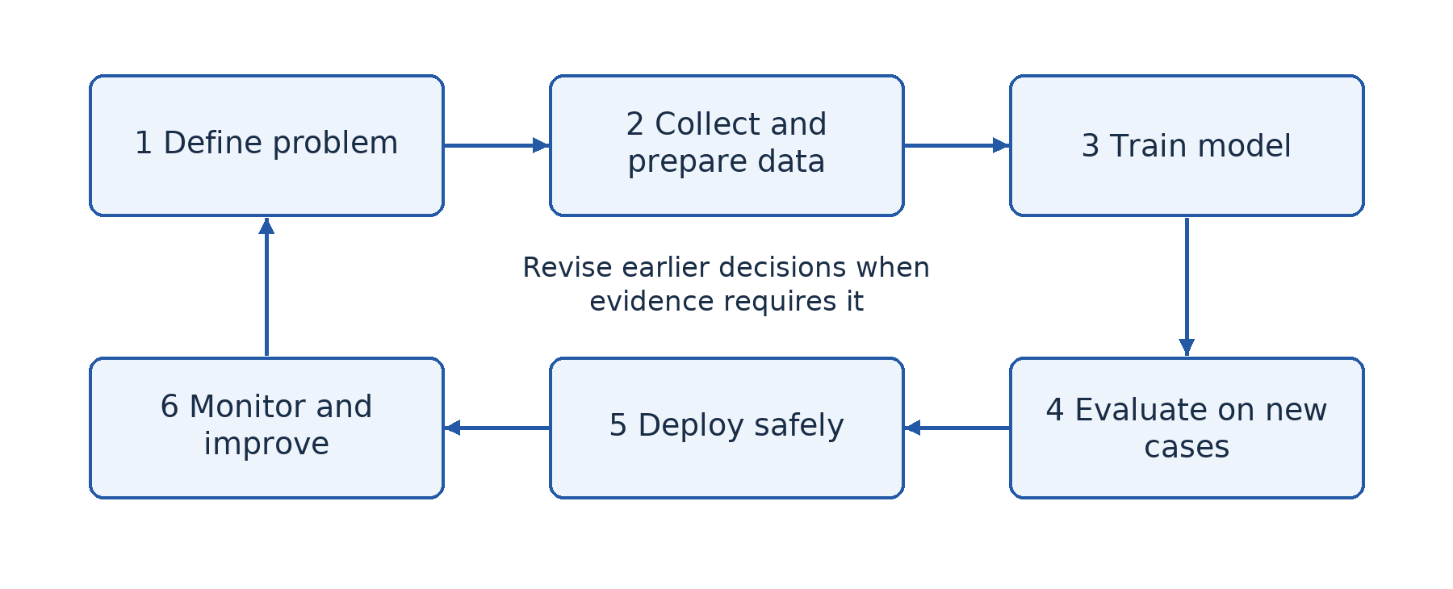
Figure 5.1 — AI development is a cycle. Testing and monitoring can send a team back to the problem or the data instead of simply moving forwards.

5.4 Languages and tools
Python is widely used because its syntax is relatively readable and it has extensive libraries for data processing, numerical computation and machine learning. A library is reusable code that saves developers from writing every operation themselves. Examples include NumPy for numerical arrays, pandas for structured data, scikit-learn for many learning methods, and TensorFlow or PyTorch for neural-network work. Naming a library is not the same as explaining its purpose.
Python also has tutorials, a large community and tools such as notebooks that combine explanation, code and output. Many performance-intensive operations are executed by underlying compiled libraries, so “Python is popular because it is always the fastest language” is misleading. R is useful for statistics, C/C++ for performance-sensitive components, and JavaScript for web interfaces and some browser-based models. Tools such as Teachable Machine lower the entry barrier for demonstrations, but they do not remove the need for good data and testing.

Worked example — Write a development plan
For a leaf-screening assistant, begin with the purpose “suggest whether an adviser should inspect a photographed leaf”, not “diagnose every disease”. Obtain labelled, permitted images from relevant crops. Train a suitable classifier and test it on new farms' images. Present tentative results with a referral message. Before pilot use, check privacy, connectivity and error consequences. During the pilot, collect feedback and stop using the system if errors make it unsafe. This sequence connects technical work with a responsible real-world service.

Guided activity
Write a one-page proposal for an AI tool that helps the fictional school library. Include the problem, a simpler non-AI alternative, required data, preparation, method, test, user interface, privacy safeguard and maintenance plan. A classmate must find one assumption that would need checking before money was spent. No coding or internet is required; this activity tests planning rather than programming fluency.

Check your understanding
1. Why should problem definition come before model selection?
2. Explain two data-preparation activities and their effect on reliability.
3. Give three reasons for Python's popularity without claiming it is inherently fastest.
4. Distinguish deployment from monitoring and explain why both are necessary.

Answer guidance
1. The required task, users and consequences determine whether AI is appropriate and which methods could solve the problem.
2. Removing duplicates reduces misleading reuse; correcting labels stops the model learning incorrect associations. Other justified quality improvements are acceptable.
3. Readable syntax, extensive relevant libraries and community support reduce development effort. Link each reason to the developer's task.
4. Deployment makes the system available to users; monitoring checks its continuing behaviour. A successfully installed system can later become unreliable or inappropriate.

Lesson 6 — Integration: Apply AI responsibly
Week 2 · Supplied progression: PDF page 2 · Locally authored integration task

The situation
A fictional cooperative near Mboa Community College wants to help farmers recognise damaged leaves. It has two shared smartphones and unreliable connectivity. Its members include users who cannot easily read long English explanations. The committee has heard that AI is always accurate and wants to replace visits from an agricultural adviser. Your team must respond with a realistic proposal, not a sales advertisement.
This integration task combines Lessons 1–5. The progression sheet names an integration lesson but does not prescribe this scenario or the criteria below. The task and scoring guidance are locally authored.

What you must produce
Prepare a two-page proposal and a five-minute demonstration or paper simulation. Explain the proposed intelligent task by identifying its input, processing and output. State the system's scope and distinguish AI analysis from the separate communication service that sends a question to an adviser. Identify at least one useful non-AI alternative.
Describe the examples needed for training and how an independent test would be organised. If equipment is available, adapt the harmless object-classification practical from Lesson 4; do not pretend that an unvalidated classroom model can diagnose crop disease. If equipment is unavailable, use clearly labelled training cards and separate test cards to demonstrate the same reasoning.
Explain how the proposal addresses bias, privacy, uncertainty and accountability. Include what the cooperative should do when the system gives no reliable answer. Consider local-language instructions, shared devices, data costs and offline access. State which claims still need expert verification before a real service could operate.

A route through the problem
First agree on a narrow goal, such as helping a user decide when to request expert inspection. Next list available resources and constraints. Then select a technique and explain why it fits the task. Plan the data and test before designing an attractive interface. Finally ask another group to challenge a weak point: What happens with a different crop? Who corrects an error? Does the system expose another person's information? Revise the proposal in response.
The teacher should ensure that every group member can explain one design choice. A polished poster with no understanding is not adequate evidence of competence. Equally, a modest paper prototype can show sound planning, provided it is honestly described as a prototype rather than a working deployment.

Assessment criteria — 20 marks
Problem and scope, 4 marks: identify users, a specific task, inputs and outputs, and a clear limit. Technical plan, 6 marks: choose a suitable method, describe representative data, separate training from testing and interpret a test result without overclaiming. Responsible use, 6 marks: explain relevant risks and practical safeguards, including human responsibility and an escalation route. Communication and reflection, 4 marks: present an understandable proposal, share the work and explain at least one improvement made after criticism.

Guidance for review
A strong proposal does not promise perfect diagnosis or assume constant internet access. It gives a reasoned choice, recognises uncertainty and explains how users obtain help. For example, a low-confidence result could lead to a saved photograph and a later adviser consultation rather than an automatic treatment recommendation. If the group finds that data or validation is inadequate, recommending a non-AI information service is a defensible conclusion.
After presentations, write an individual paragraph answering: “Which part of our proposal would most likely fail in real use, and what evidence would help us improve it?” This reflection makes the difference between repeating AI vocabulary and applying the ideas responsibly.

Part 2 — Understanding and designing networks

Lesson 7 — Fundamentals of computer networks
Week 2 · Supplied progression: PDF page 2
Learning outcomes — supplied progression
• Describe a computer network.
• Compare networked computers with stand-alone systems.
• Identify real-world examples of computer networks (e.g., home Wi-Fi, school labs, the internet) versus standalone computer setups.

Start with a resource-sharing problem
The fictional school office has a printer connected to one computer. A secretary carries files from other computers on a flash drive whenever someone wants to print. This takes time and can spread malware. What changes if the computers and printer can communicate directly? They become part of a network, allowing the printer to be offered as a shared resource.

7.1 What makes a computer network?
A computer network is a collection of connected devices that can communicate and share data or resources using agreed rules. The devices may be computers, phones, printers, servers or other equipment. A node is a device or connection point in the network. A link carries communication between nodes through a cable or wireless medium. A protocol is an agreed set of communication rules; later lessons examine particular protocols.
Connection alone is not sufficient. Two devices may have cables attached but still be unable to exchange useful information because their settings or protocols are incompatible. A working network therefore needs devices, an appropriate communication medium, suitable interfaces, software and correct configuration. A network interface provides a device's connection, such as Ethernet or Wi-Fi.
Data communication is the transfer of data from a source to a destination. A sender prepares a message, the medium carries its signal and a receiver interprets it. In most practical networks, the same device can be a sender at one moment and a receiver at another. When a learner requests a web page, the computer sends a request and later receives the server's response.

7.2 Networked and stand-alone computers
A stand-alone computer works independently of a network for its current tasks. It can create a document, run local applications and print to a directly connected printer without communicating with other computers. It may still transfer data using removable media. Stand-alone does not mean useless, old or necessarily free from malware.
A networked computer can share files, use common printers, access services and communicate with other users. Several learners can retrieve teaching materials from one server rather than receiving separate flash drives. Staff can maintain a shared record instead of several inconsistent copies. However, access rights and working procedures must prevent accidental overwriting and unauthorised disclosure.
Networking introduces dependencies. If a shared file server fails, many users may lose access at once. If one stand-alone computer fails, other independent computers may continue unaffected. A stand-alone machine may offer adequate privacy for a local task, but it lacks the convenience of controlled sharing and central management. The appropriate choice depends on the job and the risks.

7.3 Networks in everyday life
A home Wi-Fi network may connect phones, a laptop and a printer to a router. The local connections form a network even when the internet service is temporarily unavailable. The router can connect that local network to other networks through an internet provider. Thus, a network is not the same thing as the Internet.
A school laboratory can use a wired network to distribute learning materials locally. A business can connect offices in different towns. The Internet is a very large interconnection of many independently operated networks. It is not one computer, one website or one company's equipment.
Resource sharing includes more than hardware. A database, storage space, an application service and an internet connection can all be shared resources. Sharing should be purposeful and controlled: the ability to communicate does not mean every user should have access to every file.
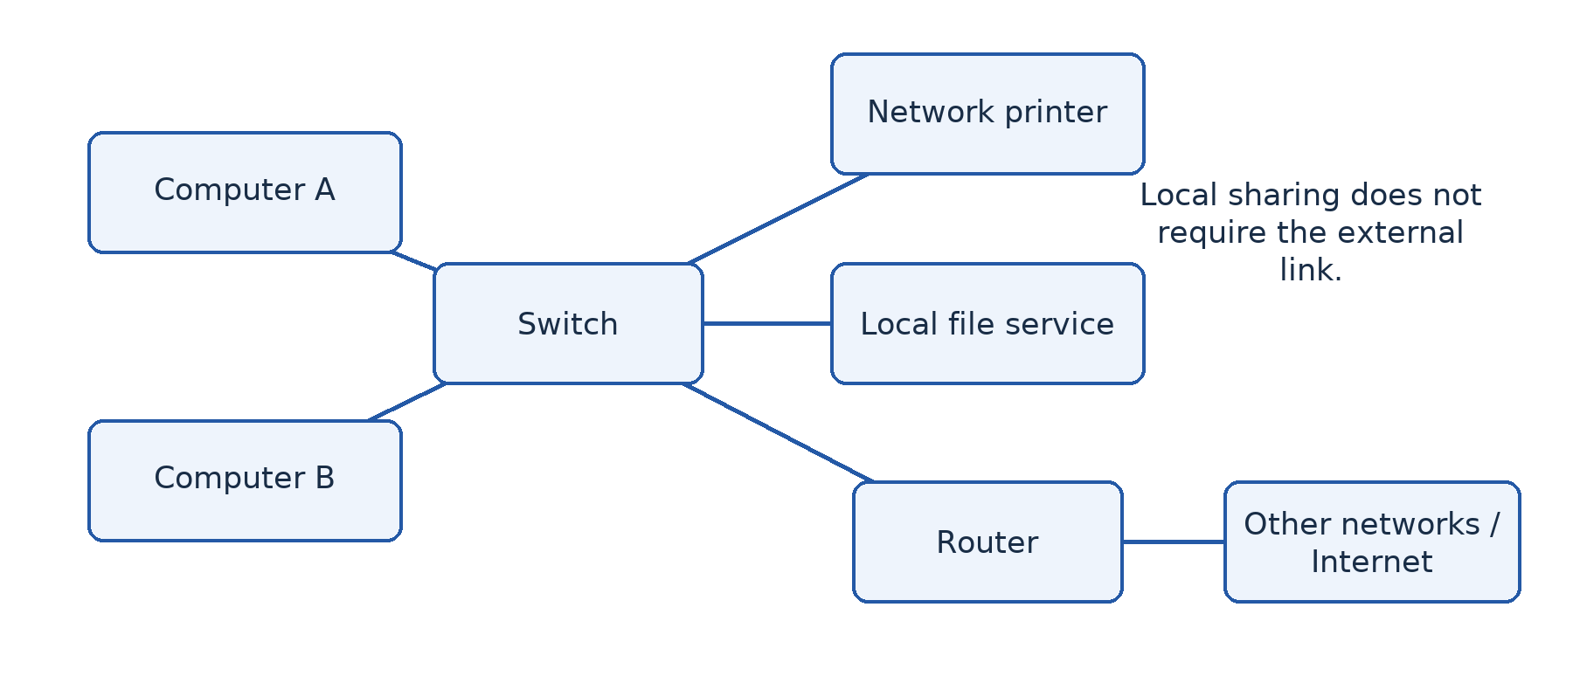
Figure 7.1 — A local network can share a printer and files without Internet access. A router provides a route to other networks when an external connection is available.

Worked example — Choose a sensible improvement
The office has three computers and prints ten documents each day. Connecting them to a small local network could allow all three to use one printer and a controlled shared folder. This reduces carrying flash drives and maintaining duplicate files. The explanation must also mention permission settings, a backup and the effect of printer failure. Buying internet service is not a prerequisite for local printing, although it may be useful for other tasks.

Guided activity
Draw a stand-alone setup and a small network for the same three users. Label the devices, links and shared resource. Under the drawings, explain the path followed by a print request. With equipment, identify the actual network interface and connection indicator on a supervised computer; do not change settings. Without equipment, use device cards and string to represent links.

Check your understanding
1. Define a computer network using devices, communication and rules in your answer.
2. Explain two differences between a networked laboratory and stand-alone computers receiving files on flash drives.
3. Can a school's local network work when its Internet subscription expires? Explain.

Answer guidance
1. Connected devices communicate and share data or resources according to agreed protocols. Merely naming cables is insufficient because wireless networks also exist.
2. Network distribution can update a shared file once and allow controlled access; flash-drive distribution requires separate transfers and can create inconsistent copies. Networks also introduce shared-service dependencies and management needs.
3. Yes, local services can continue if their equipment and configuration remain operational. External Internet services will not be reachable through that expired connection.

Lesson 8 — Network complexity and operational challenges
Week 2 · Supplied progression: PDF page 2
Learning outcomes — supplied progression
• Identify and discuss the benefits and limitations of networks.
• Explain the complexity involved in setting up and maintaining data communication networks.
• Explain the complexity of interoperability between heterogeneous systems.

Why does adding devices create work?
Mboa's first three connected computers work well. The school now wants forty computers, teachers' laptops, wireless access and a shared records system. Extending a network is not simply buying more cable. Each new device introduces questions about addressing, capacity, permissions, compatibility, support and security.

8.1 Benefits and limitations
Networks improve communication by allowing messages and shared documents to move quickly between users. They support collaboration because authorised users can work on common information. Sharing a printer or storage service may reduce unnecessary duplication. Central administration can make account management, updates and backups more consistent.
Each benefit creates conditions to manage. Shared documents need agreed ownership and access rights. A central backup is useful only if it runs successfully and can be restored. A network can reduce the number of printers but create queues at the remaining printer. A congested connection can make a fast computer appear slow because the delay is outside that computer.
Networks also make it easier for an infection or stolen account to affect multiple systems. Security controls, segmentation, updates and user training reduce this risk but do not eliminate it. Costs include installation, equipment replacement, electricity, subscriptions, technical support and staff time. Compare total running costs rather than only the initial purchase price.

8.2 Complexity during installation
A designer begins by identifying users and services, measuring distances and checking the building. Cables need safe routes, protection and labels. Wireless coverage depends on walls, interference and access-point placement, not just the strength printed on a box. Long runs or links between buildings may require different media from short desktop connections.
Devices need suitable network addresses and compatible settings. If two computers are accidentally assigned the same IP address, communication can become unreliable. Servers must have sufficient processing, memory and storage for the expected workload. Shared services need permissions that match users' duties. Equipment also needs reliable power and appropriate physical protection.
Documentation reduces future confusion. Record the intended layout, device names, address plan, cable labels, configuration responsibilities and recovery procedures. Keep secret material such as passwords separately in approved secure storage rather than writing it on a public network diagram.

8.3 Complexity during operation
A network requires monitoring, updates, backup testing and fault diagnosis. Scalability is the ability to expand to meet increased demand without unacceptable loss of service or disproportionate redesign. Reserving spare switch ports helps with physical growth; planning account management and storage capacity helps with organisational growth.
Availability concerns access to services when needed. A single inexpensive device that connects everyone can become a single point of failure. A bottleneck is a part whose limited capacity restricts overall performance. Forty users sharing one external link cannot each assume exclusive use of its advertised capacity. Real traffic also includes protocol overhead and changing demand.
Good troubleshooting isolates the cause. If one computer cannot print, test its cable, address, permissions and printer selection. If no computer can print, investigate the printer and shared service before replacing every computer. Change one suspected factor at a time and record the result so that a lucky temporary recovery is not mistaken for an explained repair.

8.4 Interoperability in heterogeneous systems
Heterogeneous systems differ in hardware, operating systems, applications or data formats. Interoperability is their ability to exchange and use information effectively. A Windows computer and a Linux computer may communicate using TCP/IP, but a file produced by one application might still open incorrectly in another. Connectivity and useful compatibility are related but distinct.
Shared standards reduce barriers. Common protocols allow different devices to communicate; widely supported document formats improve exchange. Yet drivers, authentication methods, application versions, character encoding and permissions can still create problems. A printer needs a suitable driver or supported printing method, not merely a reachable address. Test the actual task before concluding that two systems are interoperable.

Worked example — Explain, then recommend
Teachers can open a shared folder but some cannot edit its spreadsheet. The connection itself is working. Possible causes include read-only permissions, an incompatible file format or a document lock. A sensible investigation checks the exact error, permissions and application support before buying another switch. A recommendation might use a supported common format and role-based edit rights, followed by testing from both operating systems.

Guided activity
Use the school-network diagram from Lesson 7 and expand it to twenty learners and three staff. Annotate one possible bottleneck, one shared-service failure, one security concern and one compatibility concern. For each, explain an appropriate control. In a supervised lab, compare how the same harmless document opens on available applications; record differences instead of assuming identical appearance.

Check your understanding
1. Explain why a network can lower hardware costs but increase support costs.
2. Distinguish scalability, availability and a bottleneck.
3. Two computers can exchange messages but cannot use each other's specialised files. Explain why communication alone does not prove full interoperability.

Answer guidance
1. Sharing reduces duplicate resources, but accounts, security, updates and shared-service faults require continuing administration.
2. Scalability concerns growth; availability concerns access when required; a bottleneck restricts the rate or capacity of the overall system. Give an appropriate example of each.
3. They share a communication method, but file formats or applications may be incompatible. Test the intended file operation and choose supported formats or software.

Lesson 9 — Integration: Describe a real organisation's networking needs
Week 3 · Supplied progression: PDF page 2 · Locally authored integration task

The situation
A fictional community clinic has a reception computer, a consulting-room computer and a laboratory computer. Staff currently move paper results between rooms. A committee suggests networking the computers, sharing a printer and keeping one appointment list. The clinic has occasional power cuts and no full-time network administrator.
Your group is the advisory team. Explain the proposal to a manager who does not know networking vocabulary. Combine the basic concepts from Lesson 7 with the operational reasoning from Lesson 8. This is a locally authored scenario for the progression's integration lesson.

Your task
Draw the existing stand-alone arrangement and a proposed network. Label the devices, communication links and services. Explain how a result could move from the laboratory to an authorised clinician. Identify what can work locally without Internet access and what would require an external connection.
Write a short report explaining three benefits and three limitations. Every point must include a consequence for the clinic. “Resource sharing” alone is not enough; explain which resource is shared and how that changes the staff's work. Protect confidentiality by keeping the scenario fictional and not collecting real patient records.
Now identify four questions the clinic must answer before installation. Include the number of users, the type of information, a power or recovery issue, and compatibility between the existing systems. State an initial safeguard for each important risk. Distinguish facts given in the question from assumptions that require investigation.

Review and evidence
Exchange reports. Ask the other group to follow a result through your diagram and point out one failure that could interrupt the journey. Revise the diagram or explanation in response. Each learner should then explain the difference between a connected device and a usable shared service.
A strong report recognises that networking can improve access to a result while also increasing the consequences of an unauthorised account. It recommends controlled sharing rather than making all records visible to everyone. It also budgets for maintenance and backup instead of assuming that installation finishes the job.

Assessment criteria — 20 marks
Award 5 marks for accurate network and stand-alone explanations with labelled drawings; 5 marks for benefits and limitations developed in the clinic context; 6 marks for realistic requirements, interoperability concerns and safeguards; and 4 marks for clear communication, justified assumptions and revision after review. These are classroom criteria, not an official examination rubric.

Individual follow-up
Write one paragraph answering: “Why would buying an Internet subscription alone not solve this clinic's information-sharing problem?” A good answer discusses the local connections, suitable services, compatible software and access rules that the subscription does not automatically supply.

Lesson 10 — Types of networks by coverage area
Week 3 · Supplied progression: PDF page 2
Learning outcomes — supplied progression
• Describe types of networks (LAN, MAN, WAN, CAN, PAN).
• Classify properly based on coverage a given network (e.g., home Wi-Fi setup, a university).
• Compare the network types in terms of coverage area, typical speed, cost, and number of devices/users supported.

Classify the extent, not the brand
A phone connects to wireless earphones; a school connects its computer room; a bank links branches in different regions. These arrangements differ in geographical extent and purpose. Coverage categories provide a useful first description, but they do not tell us every detail about speed, cost, ownership or security.

10.1 PAN and LAN
A personal area network (PAN) connects devices around an individual, usually over a short distance. A phone communicating with a smartwatch or Bluetooth earphones is a familiar example. It commonly supports a small number of personal devices and modest power use. Its exact range and data rate depend on the technology and environment.
A local area network (LAN) connects devices within a limited area such as a home, office, laboratory or building. Ethernet and Wi-Fi are common LAN technologies. A school laboratory can form a LAN without public Internet access. LAN ownership and administration are often under one organisation, allowing that organisation to decide its internal equipment and access rules.
A wireless LAN (WLAN) is a LAN that uses wireless links for at least part of its local access. Wi-Fi is a technology, not a geographical coverage category equivalent to WAN. A LAN may combine wired desktop connections with wireless laptop connections. Likewise, a phone can participate in a PAN through Bluetooth and in a WLAN through Wi-Fi at different times or simultaneously.

10.2 CAN, MAN and WAN
A campus area network (CAN) links LANs across the buildings of a campus or similar organisation. A university might connect its library, laboratories and administration blocks. Here CAN means campus area network; in another field the same abbreviation can mean controller area network, so always interpret it in context.
A metropolitan area network (MAN) connects sites across a town or city-scale area. A council might connect several offices through metropolitan links. A wide area network (WAN) spans a broad geographical area, such as different towns, regions or countries. A bank's inter-town branch network is a WAN. Its links often depend on telecommunications providers rather than cables owned entirely by the bank.
The Internet interconnects networks globally and is commonly discussed as the largest example of wide-area networking. A private company WAN is not therefore “the Internet”. These descriptions concern extent, not whether the information is public.
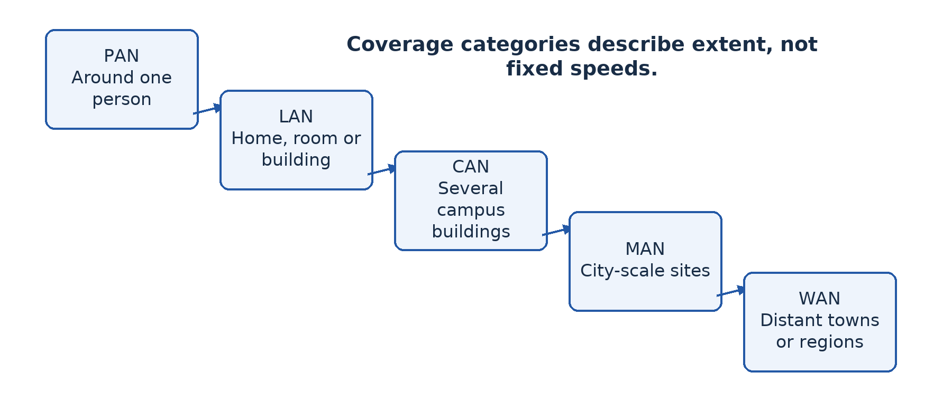
Figure 10.1 — Coverage grows from an individual's devices to local, campus, city and wide-area connections. The boundaries are descriptive, not exact kilometre rules.

10.3 Compare without inventing fixed limits
A PAN generally has fewer devices and lower installation cost than an organisation-wide network because its purpose and extent are small. A LAN may support tens, hundreds or more devices depending on design. A campus or wide-area system can join many local networks and users. No single device count defines a category: a small business can have a WAN linking only two distant offices.
LANs often provide high local capacity at relatively low cost per connection because distances are limited and one organisation controls the equipment. WAN links may have higher recurring costs and greater delay because they cross larger distances and provider networks. However, a modern fibre WAN link can be faster than an old LAN. “A WAN is always slower” is not a reliable rule.
Bandwidth describes a communication capacity in a specified context; latency is delay. A link can have high capacity but noticeable delay over a long route. When comparing options, discuss extent, technology, subscription and installation costs, delay, reliability and expected users. Avoid claiming an exact speed from the coverage label alone.

Worked example — One university, several descriptions
Within the library, computers and a printer form a LAN. The university links the library LAN to LANs in three other campus buildings, forming a CAN. A university office in another town connects through a provider, adding a WAN link. A student's phone and earphones form a PAN. The answer identifies the level being described rather than forcing the whole situation into one exclusive category.

Guided activity
Classify five situations supplied by the teacher: a home network, a smartwatch link, several campus buildings, council offices across a city and a business linking two countries. For each, justify the category using the extent. Then state two properties that still cannot be known without more information. Draw the university example and label its individual LANs and the links between them.

Check your understanding
1. Distinguish LAN, CAN and WAN using one institution with multiple sites.
2. Why is “Wi-Fi” not a sufficient answer to a question asking for a coverage category?
3. Explain why two distant offices can form a WAN even with only six computers.
4. Compare likely costs and performance of a laboratory LAN and an inter-town WAN without using absolute speed claims.

Answer guidance
1. A building's LAN connects local devices; a CAN links campus buildings; a WAN links distant sites. Explain the geographical level in each case.
2. Wi-Fi describes a wireless access technology. It is commonly used inside a LAN but does not by itself describe every network connected beyond that access point.
3. Wide geographical extent, not a minimum number of computers, makes the inter-site connection wide-area.
4. The LAN usually offers low local delay and controlled installation; the WAN often adds provider fees and greater route delay. Actual capacity depends on the selected technology and service.

Lesson 11 — Choosing the right network for an organisation
Week 3 · Supplied progression: PDF page 2
Learning outcomes — supplied progression
• Identify the networking needs of different types of organizations.
• Select the most appropriate network type for a given organizational scenario.
• Evaluate the key factors involved in choosing one network type over another for a specific organization's needs.

Begin with requirements
A trader with two laptops and a university with several campuses both need connectivity, but they do not need identical systems. A defensible choice starts by asking what users must accomplish. The word “best” has no useful meaning until the criteria are clear.

11.1 Understand organisational needs
Identify the number of users, their locations and the applications they use. An office sharing small documents has different traffic from a media department transferring large videos. Count simultaneous use rather than only registered users. A school with forty learners may have twenty computers, but a shared wireless network can add many staff and personal devices.
Ask which services must remain available. A clinic may need local records even during an Internet outage; a shop may need payment and stock services during business hours. Identify sensitive data and who should access it. Consider whether staff have the skills and time to maintain accounts, updates and backups. A sophisticated design with no realistic support plan can be worse than a simpler maintainable solution.
Measure physical distances and examine power, buildings and provider availability. An existing conduit may make a cable practical; a public road between buildings may make installation difficult or require permission. Do not assume that a listed commercial service reaches the actual site or performs as advertised there.

11.2 Choose coverage and then implementation
First choose the extent. One office normally needs a LAN. Several buildings under one campus may need a CAN of interconnected LANs. Sites in different towns require WAN connectivity. The organisation may need more than one category, so a complete recommendation can include a LAN at every branch and a WAN joining branches.
Next choose appropriate access technologies, devices and services. A coverage label does not specify whether desktops use Ethernet, laptops use Wi-Fi or sites use a leased or encrypted Internet-based link. Those choices come from capacity, distance, mobility, cost and security requirements. Later lessons develop the equipment and media decisions in detail.
Evaluate total cost of ownership: purchase, installation, subscriptions, electricity, maintenance, training, replacement and downtime. A cheap device that cannot support the necessary users or security can be expensive to replace. Conversely, buying maximum specifications without a genuine need wastes resources that might be better spent on reliable power or backup.

11.3 Weigh trade-offs and explain a conclusion
A recommendation should compare at least one reasonable alternative using the same criteria. Wired connections can provide stable capacity for fixed computers, while wireless access supports mobility and avoids a cable to each moving device. A combination often fits better than treating wired and wireless as mutually exclusive. Greater coverage can increase complexity, and redundancy costs money but can reduce disruption.
State assumptions explicitly. “Assuming the provider can deliver a reliable connection at both sites” is more honest than pretending availability has been checked. Specify how important assumptions will be verified, such as a site survey, provider quotation or practical performance test. A design is a reasoned proposal, not a guarantee made without evidence.

Worked example — A school in two buildings
Mboa has a laboratory and administration block on the same campus. It needs local file sharing, controlled access to staff records and Internet access for research. Recommend a LAN within each block and a campus connection between them. Fixed laboratory computers can use wired access; supervised staff mobility may justify Wi-Fi. Staff records require permissions regardless of whether a connection is wired or wireless.
If the school later opens a centre in another town, add WAN connectivity rather than stretching the definition of the campus link. Compare subscription costs, outages and secure remote access before choosing the external service. The original local design should still allow essential local services to work during provider failure.

Guided activity
Interview a classmate role-playing a shop manager. Ask six questions before suggesting equipment. Write a recommendation with a coverage category, expected users, two priorities, one alternative and a justified conclusion. Exchange roles using a clinic or council. No computer is required. In a lab, identify the actual local service and external connection as evidence, without changing configuration.

Check your understanding
1. List four requirements that must be established before selecting a network, and explain why each matters.
2. A firm has one office in Yaoundé and one in another region. Recommend a coverage arrangement and justify it.
3. Explain why the cheapest purchase price may not produce the lowest total cost.
4. What makes a recommendation an evaluation rather than an unsupported preference?

Answer guidance
1. User count affects capacity; location affects coverage; applications affect traffic; sensitivity affects access controls. Power, budget and support are also relevant when explained.
2. Use local networks within each office and a WAN link between the geographically separated offices. Choose the implementation after checking service and security needs.
3. Recurring fees, replacement, maintenance, training and downtime contribute to the full cost. Relate a particular cost to a realistic design weakness.
4. It weighs alternatives against stated criteria and reaches a conclusion connected to the organisation's needs, including limitations and assumptions.

Lesson 12 — Integration: Select coverage for three organisations
Week 3 · Supplied progression: PDF page 2 · Locally authored integration task

The situation
Your advisory group receives three requests. A tailor uses a phone, payment terminal and laptop at one stall. A college wants to connect a laboratory, library and office on one campus. A cooperative has offices in three different towns. Each wants “a network” but has not described its requirements clearly.
Use Lessons 10–11 to develop a recommendation for each. These are fictional classroom cases, and the criteria below are teaching guidance for the integration lesson.

Tasks and evidence
For each organisation, identify users, locations, shared services and two questions still requiring investigation. Propose the relevant coverage category or combination. Explain why it fits the geographical extent. Do not name a product as if that answered the coverage question.
Next compare the three cases on likely costs, capacity, management and external-service dependence. Discuss tendencies rather than fixed speed or device-count rules. A cooperative with only nine computers can still require a WAN because the offices are distant. A college's many computers do not automatically make its single-campus network a WAN.
Draw one clear sketch for each request and write a manager-friendly recommendation of about 150 words per case. Include a lower-cost alternative and a reason for accepting or rejecting it. State assumptions about connectivity, power and technical support. Identify a local service that should keep working if the external Internet link fails.

Review process
Give the recommendations to another group. Their role is to challenge an unexplained claim such as “WAN is faster” or “wireless has no maintenance”. Answer with a correction or evidence-based justification. Keep the first and revised versions so the teacher can see the improvement.

Assessment criteria — 20 marks
Use 6 marks for correct, justified coverage classifications; 6 marks for requirements and meaningful comparisons; 4 marks for feasible alternatives and explicit assumptions; and 4 marks for labelled sketches, clarity and individual explanation. Do not award full credit to a correct acronym with no reasoning.

Guidance for a strong answer
The tailor may need a small local network, with a PAN for a particular short-range personal link if the equipment supports it. The campus needs local networks joined across its buildings. The inter-town cooperative needs WAN connectivity between local networks. These are starting points, not complete installation specifications. A strong answer still investigates compatibility, privacy, actual service availability and the people who will maintain the system.
Finish individually: explain why a network category cannot tell a buyer its exact speed or security level. Use one of your three recommendations to illustrate the missing information.

Lesson 13 — Network architecture: Peer-to-peer and client/server
Week 4 · Supplied progression: PDF page 2
Learning outcomes — supplied progression
• Explain network types based on the logical relationship between nodes.
• Compare the advantages and disadvantages of each configuration.
• Choose the appropriate network design for a given organisation.

Who provides the service?
Coverage tells us where a network extends. Network architecture in this lesson concerns how devices take the roles of requesting and providing services. A client requests a service; a server provides a service. These are roles, not simply sizes of computer cases. A server can provide files, authentication, printing, web content or database access.

13.1 Peer-to-peer architecture
In a peer-to-peer (P2P) arrangement, participating computers can provide resources directly to one another without depending on a dedicated central server for those shared resources. One user's computer might share a folder; another might share a printer. Each can be a client for one operation and a server for another.
P2P can suit a small, trusted group because it needs little dedicated infrastructure and can be inexpensive to start. Users retain control of their own shared resources. However, each resource depends on its host being switched on, connected and correctly configured. Backup and permissions can become inconsistent when every owner manages them separately.
As the network grows, locating the correct version of a file and managing accounts across many computers becomes difficult. A learner should not conclude that P2P has “no security”; security settings exist, but consistent administration can be harder. Nor does peer-to-peer describe a physical shape. The computers can be physically connected through a central switch while sharing resources as peers.

13.2 Client/server architecture
In a client/server arrangement, one or more dedicated or centrally managed servers provide services to client devices. A file server can maintain a central shared folder; an authentication service can manage user identities; a database server can process authorised requests. Users do not need every classmate's computer to remain on to reach a central file service.
Central management can make access rights, backups and updates more consistent. A server can be selected for the expected workload and protected in a secure location. Yet centralisation creates an important dependency: if an essential server fails, many clients may be affected. Backups, recovery procedures and sometimes redundant services are needed.
Costs include server resources, administration skills and possibly software licences or support. Free software can reduce some purchase costs but not the need for knowledge, maintenance or reliable power. A small installation does not automatically need expensive server hardware; a busy installation should not depend on an unsuitable desktop without a recovery plan.
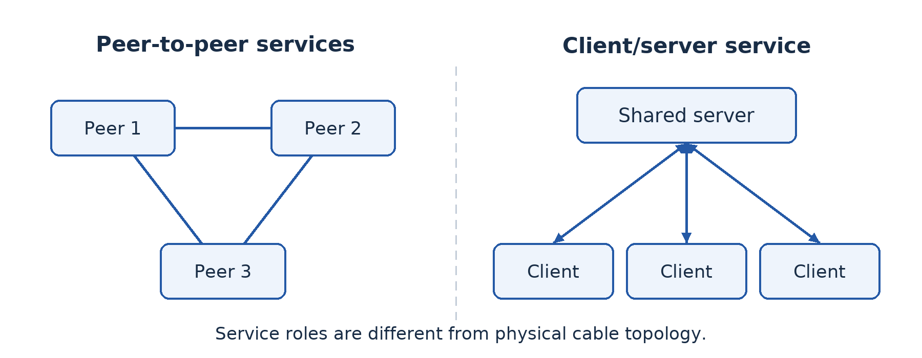
Figure 13.1 — Peer computers share directly with one another; clients request a centrally provided service. The lines show service relationships, not prescribed cable layouts.

13.3 Compare on the same criteria
For cost, P2P often has a lower starting cost, while client/server adds central-service resources and administration. For management, P2P distributes responsibility and client/server centralises it. For availability, a P2P resource depends on its individual host; a central server can be engineered for availability but may become a shared failure point. For growth, central account and file management are usually easier to scale than many separately configured shares.
Real organisations combine patterns. A school can use a central records service while two authorised teachers share a temporary file directly. The useful question is which architecture fits the particular service and management needs. Architecture should not be confused with a topology, which concerns the connection arrangement explored next.

Worked example — Choose for two contexts
Two teachers need to share a temporary planning folder. A carefully configured P2P share may be adequate, provided its owner keeps the host available and backups exist. A school with hundreds of user accounts and protected records has stronger reasons for centrally managed client/server services: consistent access control, organised backup and a clear administrator. The recommendation must also fund reliable power and recovery rather than treating centralisation as automatic reliability.

Guided activity
Role-play a P2P file request using three learners as resource owners. Then repeat with one learner as a central file server and the others as clients. Remove a resource owner or the server and describe exactly which service disappears. In a supervised lab, identify a real service provider and client; do not assume the computer nearest the switch is the server.

Check your understanding
1. Define client, server and peer-to-peer using roles rather than physical appearance.
2. Explain two advantages and two limitations of centralising a file service.
3. Can a physical star network use peer-to-peer sharing? Explain.
4. Recommend an architecture for a small temporary workgroup and for a large school records system.

Answer guidance
1. Clients request services, servers provide them, and peers can provide resources directly to one another without a dedicated central provider for those resources.
2. Central rights and backups improve consistency; costs and server failure dependence must be managed. Develop each point through its effect on users.
3. Yes. Star describes physical connections to a central device; P2P describes the computers' service roles.
4. A small trusted workgroup may reasonably use P2P; a managed records system usually benefits from central services. Other answers need defensible requirements and safeguards.

Lesson 14 — Types of physical network topologies
Week 4 · Supplied progression: PDF page 2
Learning outcomes — supplied progression
• Describe the types of physical network topologies (mesh, star, ring, bus, tree).
• Identify the physical layout and connection pattern of each topology.
• Explain the advantages and disadvantages of each topology.

Read the connections carefully
A physical topology is the arrangement of devices and the physical links between them. It answers “what is connected to what?” A logical topology concerns how communication proceeds, which may differ from the physical arrangement. A neat drawing is useful only when its connection pattern and failure consequences are understood.

14.1 Star topology
In a star, each endpoint has a separate link to a central device, commonly a switch in a wired LAN. A computer sends a frame through its link to that device, which forwards it as appropriate. A failure in one endpoint's cable normally disconnects that endpoint, not all the others. Adding an endpoint is straightforward if a suitable port and cable route are available.
The central device is important. If it fails or loses power, the attached endpoints cannot communicate through it. More cable is usually needed than for a shared linear bus because each endpoint has its own run. Modern switched Ethernet commonly uses star or extended-star physical arrangements, but the central device must be suitable for the workload.
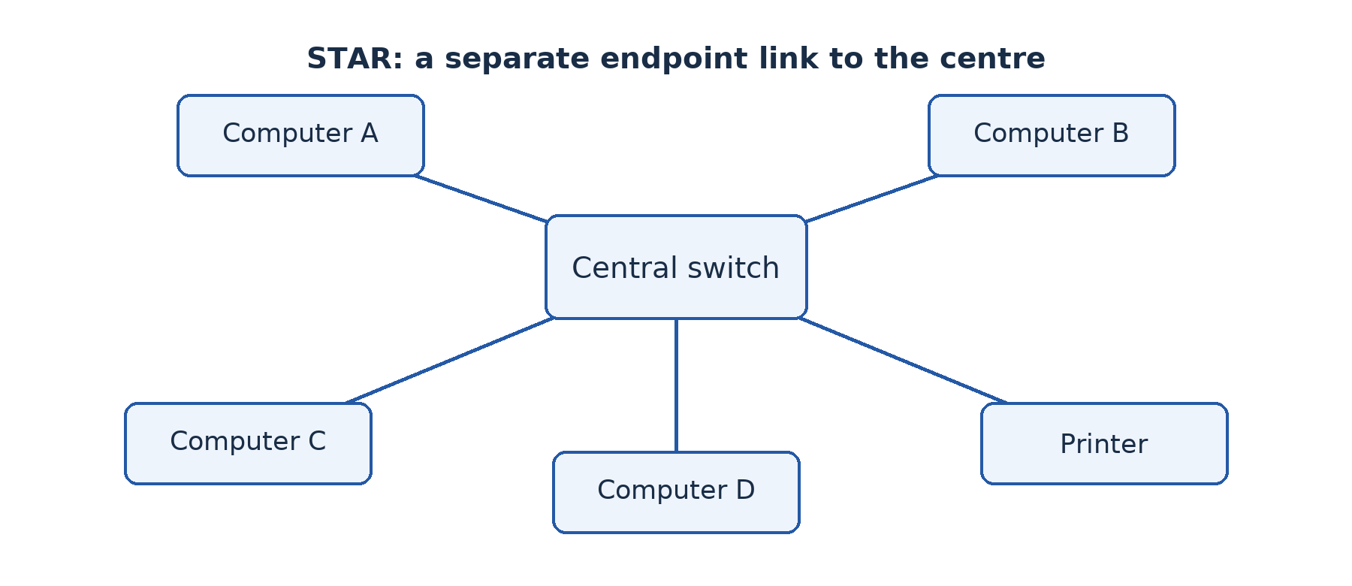
Figure 14.1 — In a star, every endpoint has its own link to the central switch. One endpoint cable failure differs from failure of the switch itself.

14.2 Bus topology
In a traditional bus, devices attach to a shared backbone cable. Signals travel along that common medium. Traditional coaxial Ethernet buses need correct termination to absorb signals and avoid reflections. All devices depend on the shared path, and a backbone fault can disrupt the segment.
A bus can use less cable in a simple linear arrangement, but fault location, expansion and shared-medium contention can be troublesome. It is important historically and conceptually; it is not normally the preferred choice for a new general-purpose school Ethernet LAN. Do not draw separate cables from every computer to a switch and label that drawing a bus.
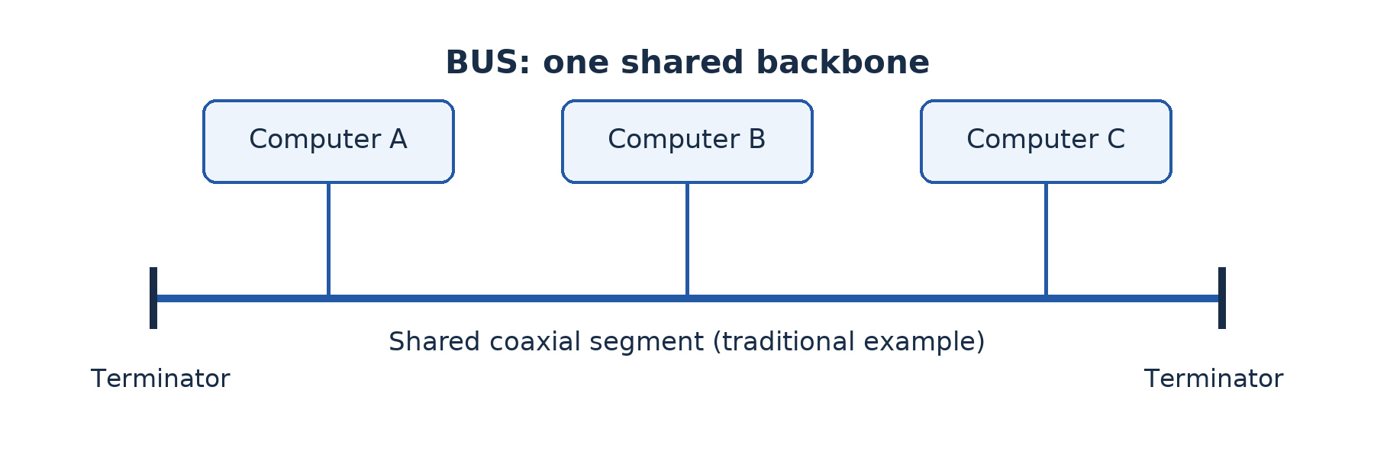
Figure 14.2 — A traditional bus shares a backbone with terminators at its ends. The small branches attach devices to the shared cable.

14.3 Ring topology
In a ring, each node connects to two neighbours so that the links form a closed loop. Data in a simple ring follows the ring's path. Some implementations use a token to control transmission: a station transmits when it holds the token. Token passing is a particular access method, not a requirement of every network that looks circular.
An orderly access method can make use of a shared path predictable. However, a break or failed node in a simple unprotected ring can interrupt service, and changing connections can disrupt the ring. Practical resilient ring technologies may use protection mechanisms or additional paths, so distinguish a simple textbook ring from an engineered redundant implementation.
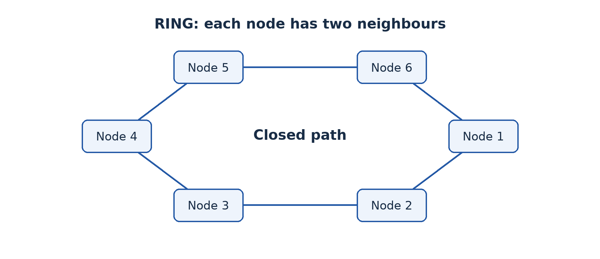
Figure 14.3 — In a simple ring, each node has two neighbours and the links form a closed path.

14.4 Mesh topology
In a mesh, nodes have multiple interconnections. A full mesh connects every node directly to every other node. A partial mesh provides multiple paths without every possible direct link. Alternative paths can improve resilience if routing and other controls can use them when a link fails.
The cost is more links, ports and management. For a full mesh with n nodes, the number of undirected links is n(n − 1) ÷ 2: every node connects to n − 1 others, and dividing by two prevents counting each link twice. Four nodes need 4 × 3 ÷ 2 = 6 links. Ten nodes need 45, showing why full mesh becomes costly as size increases.
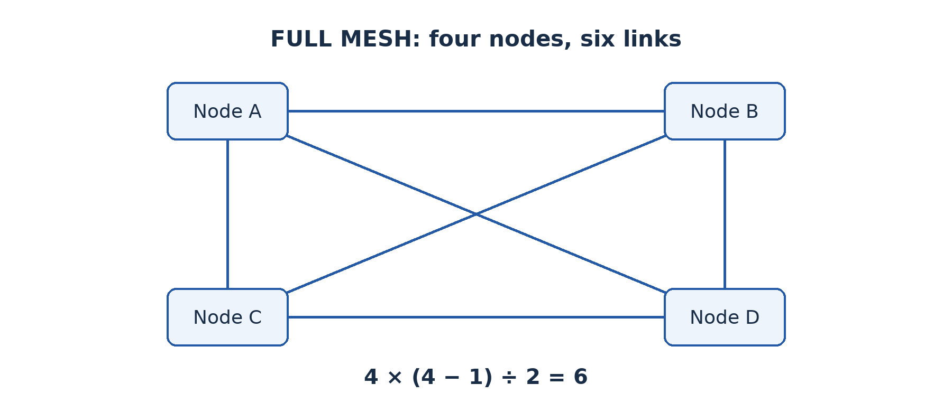
Figure 14.4 — Four nodes in a full mesh require six direct links. Multiple routes exist, but they add cost and configuration work.

14.5 Tree topology
A tree uses a hierarchy of connections, often with groups of endpoints connected to local switches and those switches connected upwards. It can organise a growing network into manageable branches. An extended star with a clear hierarchy is a familiar practical form.
Failure effects depend on position. A failed endpoint link affects one endpoint; a failed branch switch affects its branch; a failed higher-level connection can isolate several branches. A tree is not automatically resilient merely because it has many cables. Higher-level capacity and failure protection require deliberate planning.
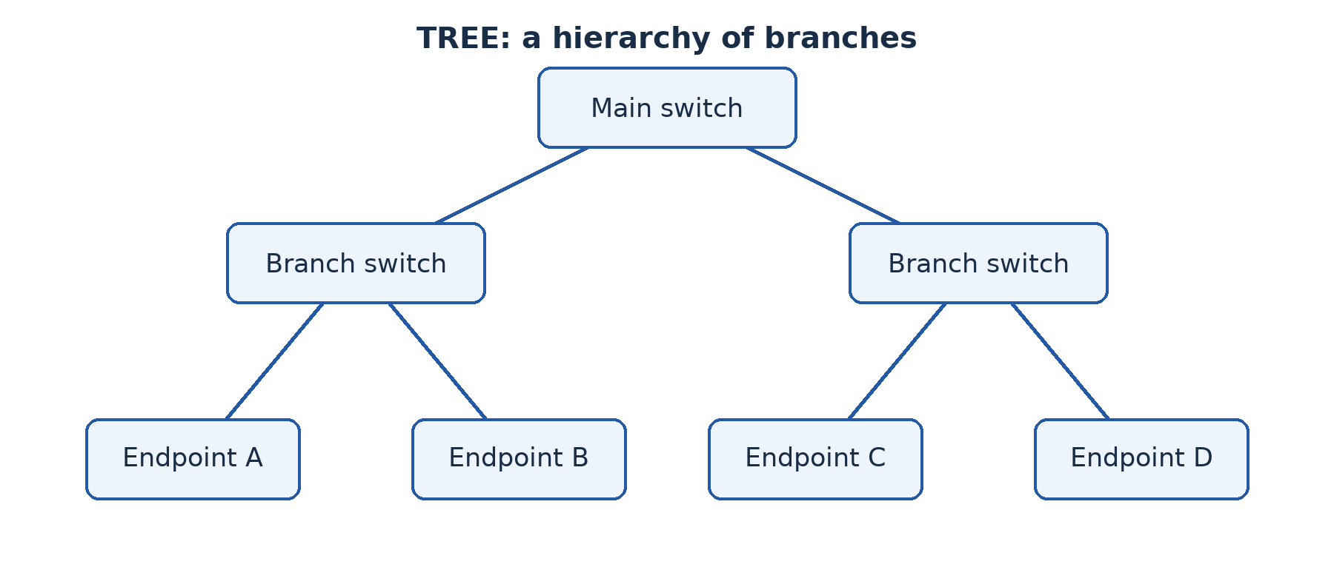
Figure 14.5 — A tree groups endpoints into branches. Failure near the root can affect more users than failure at one leaf.

Worked example — Reason from a failure
Five computers connect separately to a switch. One cable is unplugged and only its computer loses connection. This is consistent with a star. If the switch is then powered off and all five lose communication, that shows dependence on the centre. It does not mean the earlier one-cable test was wrong. The component that fails determines the extent of disruption.

Guided activity
Build each topology using labelled device cards and string. Remove one endpoint link, then an important shared component. For each case, trace which pairs still have a physical route. Mark the failure on a drawing and explain its consequence. Do not assume that a surviving physical route guarantees usable communication: suitable configuration is still required.

Check your understanding
1. Draw and label star, bus, ring, mesh and tree layouts.
2. Explain why a star can tolerate an endpoint cable failure but not necessarily a central-switch failure.
3. Calculate the links needed for a full mesh of five nodes.
4. Explain one strength and one limitation of a hierarchical tree.

Answer guidance
1. Show the actual connection pattern: separate centre links, a shared backbone, a closed loop, multiple interconnections and hierarchical branches respectively.
2. Separate endpoint links isolate many cable faults; the common switch is needed for traffic passing through the centre.
3. 5 × 4 ÷ 2 = 10 links. State the full-mesh and undirected-link assumptions.
4. Branching supports organised expansion; dependence on higher-level links can isolate multiple branches. Explain which users are affected.

Lesson 15 — Comparing and choosing network topologies
Week 4 · Supplied progression: PDF page 3
Learning outcomes — supplied progression
• Compare the different types of physical network topologies.
• Evaluate which topology suits specific organisational needs.
• Propose a suitable network topology for a given organisation.

A choice needs a stated purpose
The school asks which topology is “the best”. There is no answer independent of needs. A topology is suitable when its connection pattern, costs, failure behaviour and capacity fit the users and site. This lesson uses the facts from Lesson 14 to make a justified design decision rather than repeat five definitions.

15.1 Choose comparison criteria
Begin with cost, including cables, ports, central devices, installation and support. A bus may appear to use less cable, but maintenance and outdated equipment can remove that apparent saving. A full mesh provides many routes but requires rapidly increasing numbers of links. A star is usually practical for desktop access, though it needs an appropriate central switch.
Consider reliability and the effect of failure. Ask which component is shared and how many users depend on it. A separate link in a star protects other endpoints from that particular cable failure, but the centre remains important. A mesh offers possible alternate routes; those routes help only if the network can actually use them. A tree can isolate faults by branch while also concentrating dependencies near its root.
Consider scalability, ease of maintenance and performance. A labelled star can make endpoint faults easier to locate. A hierarchical arrangement can extend across rooms, but links carrying several rooms' traffic need enough capacity. Physical layout alone does not determine speed: switch capacity, media, traffic and protocols also matter. A circular drawing is not evidence that data will move faster.

15.2 Connect the criteria to the organisation
For a school laboratory of twenty fixed computers, switched star access is usually a sensible proposal. Each computer has a manageable individual connection, additions are straightforward within spare capacity, and one workstation cable fault need not disconnect the class. Protect the switch and provide adequate ports and power. Explain the central dependency instead of hiding it.
For several buildings, an extended star or tree can connect local access switches to a main distribution point. The design must examine the inter-building medium, uplink capacity and the impact of losing that central point. A critical organisation may justify additional links or equipment, creating a partially meshed or redundant design. A small school may reasonably accept some downtime rather than pay for a full mesh of every computer.

Worked example — Evaluate a proposal
Mboa has twelve laboratory computers and a shared printer. A supplier proposes full mesh between all thirteen endpoints, claiming it is the only reliable choice. A full mesh would require 13 × 12 ÷ 2 = 78 direct links, plus suitable interfaces and management. That is disproportionate for ordinary desktop access.
A switched star needs one endpoint link per device and suitable switch capacity. It provides simpler installation and endpoint fault isolation, but its central switch is a failure point. A reasoned conclusion recommends the star, appropriate physical protection, backup of configurations and a realistic replacement or recovery plan. If high availability is later required, investigate targeted redundancy rather than automatically meshing every endpoint.

Guided activity
Compare star, tree and full mesh for a fictional campus with three buildings. Write one paragraph per option using the same criteria: installation, likely failure impact, expansion and maintenance. Make a final recommendation that mentions one limitation of your chosen option and how you would reduce it. Ask a classmate to remove one link from your drawing and explain the result.

Check your understanding
1. Why is “star is best because it is fastest” an inadequate evaluation?
2. Recommend a physical layout for a laboratory and explain two relevant reasons and one limitation.
3. A tree's upper link fails. Why might many users be affected even though their local cables are intact?
4. How can a designer improve resilience without fully meshing every desktop?

Answer guidance
1. It gives no evidence about equipment or workload and ignores other criteria. Topology alone does not determine throughput.
2. A switched star can support manageable individual connections and fault isolation. Its central switch needs protection and a recovery plan.
3. Several branches rely on that common route to other services. Intact endpoint links do not replace the missing upstream connection.
4. Add suitable redundant uplinks or central equipment where needed, with appropriate loop-prevention or routing design and testing. A second cable alone is not a complete resilience strategy.

Lesson 16 — Integration: Design architecture and topology
Week 4 · Supplied progression: PDF page 3 · Locally authored integration task

The situation
A fictional college has eighteen laboratory computers, four administration computers and six library computers in three nearby buildings. Learners need teaching files and printing. Administrative records must not be freely available to learners. The college expects a second laboratory next year and has a modest maintenance budget.
Produce a design that combines coverage, architecture and topology. These are different decisions. “LAN” describes local extent, “client/server” describes service roles, and “star” describes a connection arrangement. A strong proposal uses each term to answer the right question.

Required work
Draw a labelled physical design with endpoints grouped into buildings, suitable central devices and inter-building links. Use a key for symbols. Show where teaching files and administrative services are provided, but do not mistake a server for the central switch. Write a separate explanation of which devices request services and which provide them.
Compare P2P with centrally managed services for this college. Then compare a simple switched-star arrangement within each room with an overall hierarchical campus arrangement. Explain the effect of one endpoint cable failure, one branch-switch failure and one main-link failure. State how expansion could occur without replacing every connection.
Do not yet invent exact product specifications or prices. Instead identify the required port counts, likely traffic priorities, information requiring restricted access and assumptions that need a site survey. The detailed equipment choice comes in the next part of the book. A network drawing is a design proposal, not evidence that the installation has been built.

Peer review and improvement
Another group acts as the school's management committee. They ask why a cheaper alternative was rejected, what happens during a power cut and how staff records remain private. Answer with reasoning, not “because the diagram says so”. Revise one weak point and keep a brief record of the change.

Assessment criteria — 20 marks
Use 5 marks for accurate coverage and architecture reasoning; 5 marks for a coherent, labelled physical topology; 6 marks for failure analysis, privacy requirements and growth planning; and 4 marks for comparing alternatives and explaining the revised design. These locally authored criteria assess understanding rather than drawing neatness alone.

Review guidance
A defensible solution may use local switched stars, a campus hierarchy and central services for accounts or files. It should recognise the main distribution point's importance and separate staff permissions from physical connection choices. Other feasible solutions can earn credit if the constraints are met and the trade-offs are explained. Finish by writing individually one sentence that distinguishes coverage, architecture and topology without using them as synonyms.

Part 3 — Building and protecting networks

Lesson 17 — Network equipment
Week 5 · Supplied progression: PDF page 3
Learning outcomes — supplied progression
• Explain the role of key network components (modem, hub, router, NOS…).
• Differentiate between the various network components based on their functions.
• Identify the appropriate network components required for a computer network.

Follow a message through the equipment
A learner clicks a web link. Data leaves the computer through its network interface, crosses a local connection and may pass through a switch, router and provider equipment before reaching another network. These devices perform different jobs. A useful explanation follows the message instead of describing every box as something that “connects the Internet”.

17.1 Interfaces, hubs and switches
A network interface card or controller (NIC) provides a device's network connection. It may be built into the motherboard or added separately. An Ethernet interface connects to a suitable cable; a wireless interface communicates using radio. The interface has link-level identification, commonly a MAC address, used in local frame delivery. The computer's IP address performs a different addressing role across IP networks.
A traditional hub repeats incoming electrical signals to its other ports without learning which destination is on which port. Attached devices share the medium, and older half-duplex Ethernet with hubs must manage collisions. Hubs are important for comparison but are not the normal choice for a new general-purpose wired LAN.
A switch connects devices within a LAN and learns which source MAC addresses are reachable through its ports. It uses its forwarding information to send many frames towards the appropriate port rather than repeating every ordinary frame everywhere. Unknown destinations and broadcast traffic require different handling; a switch does not guarantee that absolutely every frame goes to only one port. Switched Ethernet normally gives separate full-duplex links to endpoints.

17.2 Routers, modems and access points
A router forwards packets between IP networks according to addressing and routing information. A computer sending to a different network commonly uses a router as its default gateway. In a small installation, one combined home gateway may also offer switching, wireless access, address assignment and firewall functions. Those functions remain conceptually different even when housed in one case.
A modem adapts signals for a particular access technology, historically modulating and demodulating signals such as those used over telephone lines. A fibre connection commonly uses an optical network terminal (ONT) to terminate the provider's optical service. Do not assume every external connection uses the same type of modem. The access equipment must match the service supplied.
A wireless access point (AP) connects wireless clients to the local network. It provides Wi-Fi access; it does not by itself guarantee an Internet subscription or perform all routing functions. Its placement, configuration and security affect coverage and performance. Several access points may be needed for a large site, planned to avoid poor coverage and excessive interference.

17.3 Software and supporting components
A network operating system (NOS) or network-service software manages relevant resources and services: accounts, shared files, authentication and administration. Modern operating systems include many networking capabilities, so NOS is not necessarily a separate physical machine. A server's operating system must be configured with the required services and permissions.
Cables, connectors, patch panels and racks organise physical connections. A patch panel provides labelled termination and patching; it does not replace an active switch. An uninterruptible power supply (UPS) provides temporary power and can support orderly shutdown during an outage. It is not an unlimited substitute for electricity. Equipment needs ventilation, physical security and safe installation as well as network specifications.
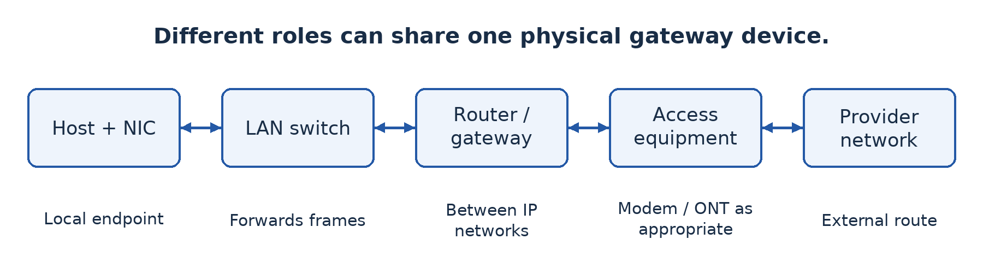
Figure 17.1 — Local switching, routing and provider-access functions are distinct, even if a small gateway combines several in one device.

Worked example — Choose a basic set
For eight wired computers and one network printer, select suitable NICs, nine endpoint cable runs and a switch with enough ports plus room for an uplink and growth. Add a router and compatible provider-access equipment only if external-network access is required. Add a wireless AP if authorised wireless users need local access. A shared file service needs suitable host resources and software; buying an additional switch does not itself create that service.

Guided activity
Examine supervised equipment or labelled photographs. For each item, identify a port or interface and explain its role. Then place device cards in the order a local print request and an external web request might follow. A combined gateway can appear under several roles, but explain those roles separately. Do not unplug production cables or assume an unfamiliar port's purpose from its shape alone.

Check your understanding
1. Distinguish a hub, switch and router by their forwarding roles.
2. Explain why a Wi-Fi access point does not necessarily provide Internet access.
3. A shared folder is unavailable although the switch is on. Why might the problem involve software or permissions?
4. Choose equipment for a ten-computer local file-sharing network that has no external connection.

Answer guidance
1. A hub repeats signals, a switch forwards local frames using learned MAC information, and a router forwards packets between IP networks. Mention appropriate units rather than treating the terms as interchangeable.
2. It provides wireless local access; an external route, provider service and correct configuration are separate requirements.
3. The host may be off, the service stopped or the requesting user unauthorised. Physical connectivity alone does not provide a usable file service.
4. Suitable interfaces, cables, a switch with capacity and a configured file-sharing host are sufficient in principle. A modem or paid Internet subscription is not essential to that local task.

Evaluation 1 — Network foundations and AI

Instructions
This is a locally authored classroom evaluation at the Week 5 point in the progression, not an official GCE paper. Suggested conditions are 60 minutes and 40 marks. Answer in complete explanations where requested; diagrams must be labelled. The questions cover Lessons 1–17, excluding content not yet taught. The teacher may assess practical evidence separately.
1. Define AI and distinguish an intelligent prediction from simple fixed automation. Give one example of each. [6]
2. A school AI ranks applicants using past winners' records. Explain two ethical risks and a corresponding safeguard for each. [8]
3. A college has one campus and an office in another town. Recommend coverage categories for the internal and inter-site connections, explaining both. [6]
4. Compare peer-to-peer and client/server file sharing on management and availability. Recommend one for a large school records service. [8]
5. Draw a switched star containing four computers and a printer. Explain the effect of one endpoint cable failure and of the central-switch failure. [6]
6. Distinguish a switch, router and wireless access point. [6]

Marking guidance
For Question 1, allow 2 marks for a precise AI definition and 2 marks each for the two explained examples. A timer alone is not evidence of learning or perception. For Question 2, allow 4 marks per developed risk-and-safeguard pair: identify the risk, explain how it arises, give a relevant control and show how it helps. Bias/testing and privacy/minimal controlled data are suitable pairs.
For Question 3, allow 3 marks for a justified local or campus arrangement and 3 marks for the WAN connection between towns. For Question 4, allow 2 marks each for management comparison, availability comparison, a suitable recommendation and its contextual justification. For Question 5, allow 2 marks for the correct labelled layout and 2 marks each for the distinct failure explanations. For Question 6, allow 2 marks per correctly explained device role.
Accept alternative technically sound examples. Do not award explanation marks for repeating the same fact in different words. These allocations are teaching guidance, not a claim about the Board's marking practice.

Remediation 1 — Correct the reasoning
If you confused coverage, architecture and topology, redraw the same school network and label one example of each. If your ethical answer only named a principle, rewrite it as a cause, a possible harm and a specific control. If your failure analysis was wrong, remove the relevant connection from a model and trace the surviving paths. Finally answer a fresh short question without copying the model answer. The aim is corrected understanding, not copying a longer definition.

Lesson 18 — Setting up a computer network
Week 5 · Supplied progression: PDF page 3
Learning outcomes — supplied progression
• Demonstrate the steps involved in setting up a basic computer network.
• Identify the essential equipment and how they are interconnected.
• Set up and test a peer-to-peer computer network.

Build a small network and prove it works
A diagram becomes useful when the planned equipment is interconnected, configured and tested. In this practical, two authorised laboratory computers share a harmless file as peers. There is no need for Internet access. The procedure distinguishes physical connection, IP reachability and access to the actual service; success at one level does not automatically prove success at the next.

18.1 Prepare a safe laboratory
The teacher must provide two computers with compatible Ethernet interfaces, a switch and two suitable patch cables, plus permission to use an isolated test network. Most modern Ethernet interfaces support automatic crossover handling; a switch avoids depending on a direct cable's compatibility. Use existing safe equipment, not exposed wiring. Do not alter a live school network or invent addresses on it.
Save the original settings before making changes. Use teacher-created local test accounts with passwords and a folder containing fictional data only. Identify the operating system and the appropriate network-settings tool. The steps below describe a Windows-to-Windows SMB sharing exercise; names of controls vary by version. The teacher must confirm that file-sharing services and supported authentication are available.

18.2 Guided practical — Connect and configure
1. Connect Computer A and Computer B to separate switch ports and turn on the equipment. Check link indicators and cable seating. A light indicates a physical link, not proof that file access is configured.
2. Use the teacher's address plan. For this isolated example only, assign A the address 192.168.50.10 and B 192.168.50.11, both with subnet mask 255.255.255.0 (also written /24). Do not reuse these addresses on an existing managed network without approval. No default gateway or DNS server is required for direct communication by these addresses in this isolated local exercise.
3. On each computer, inspect settings using the network interface panel or ipconfig. Check that the intended Ethernet interface has the correct address and that no duplicate address is used. If the teacher instead supplies DHCP, use the automatically assigned addresses and record them rather than mixing two conflicting plans.
4. From A, run ping 192.168.50.11, subject to the teacher's firewall policy. From B, test A similarly. A reply shows IP reachability for this test. If there is no reply, investigate the cable, interface, address and approved ICMP firewall rule. A host may block ping while file sharing still works, so a failed ping alone does not identify the cause.
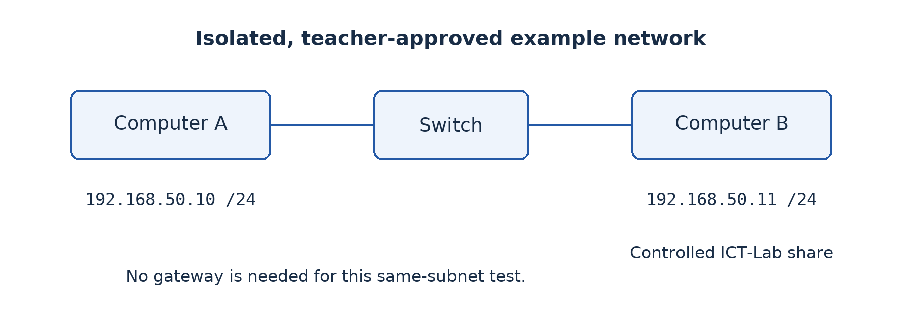
Figure 18.1 — The isolated lab gives two hosts distinct addresses in the same subnet. Test the connection and then the file-sharing service separately.

18.3 Configure controlled sharing
5. On B, create a folder named ICT-Lab containing welcome.txt. The file should say only “This is our authorised test file.” Enable sharing for this folder using the teacher-created account. Use a trusted private-lab network profile where the operating system requires it.
6. Set both the share permissions and the underlying file-system permissions appropriately. Begin with read access for the other test user. Do not enable anonymous guest access or grant everyone full control merely to make the demonstration easy. The effective access depends on the applicable permission layers.
7. Permit the supported file-sharing service through the firewall only on the approved lab interface or subnet. The teacher should prepare or approve the scoped rule. Do not switch off the firewall, expose SMB to the Internet or open unrelated services.
8. From A, open \\192.168.50.11\ICT-Lab in the file manager and authenticate with the permitted account on B. Confirm that welcome.txt opens. Record the actual service test; ping alone was not enough.
9. Try saving an edit as the read-only user. It should be denied. If the teacher authorises a write-access test, change permission only for the intended account, try again and record the difference. This demonstrates that connectivity and authorisation are separate.
10. Repeat with A providing a different controlled share so that both computers take client and server roles. Afterwards remove the shares and temporary rules, restore approved settings and delete only the test data and test accounts as directed.

Worked example — Diagnose in layers
A can ping B but cannot open the share. Replacing the cable is not the first conclusion: IP communication has already succeeded. Check the share name, service status, file-sharing firewall rule, account identity and effective permissions. If the file opens but cannot be edited, read-only permission may be working correctly. A denied operation is not necessarily a network fault.

Evidence and equipment-light alternative
Submit a labelled physical sketch, recorded addresses, one reachability result, proof of opening the shared file and a permission-test observation. Never include passwords in screenshots. With no equipment, role-play the same sequence using address and permission cards. Record that as a simulation and complete the real configuration later; do not present a paper drawing as proof of a working share.

Check your understanding
1. Why must the two hosts have different addresses under the same approved subnet plan?
2. Explain why a successful ping does not prove file-sharing access.
3. Give three possible causes when a share is unreachable despite a working physical link.
4. Why should a file-sharing firewall rule be scoped rather than disabling the firewall?

Answer guidance
1. Unique addresses identify the hosts; suitable subnet settings allow them to recognise the local destination. Duplicate or inconsistent settings can prevent reliable communication.
2. Ping tests an IP-level exchange, not the file-sharing service, credentials or file permissions.
3. Incorrect addresses, stopped service, a blocked service rule, wrong share name or failed authentication are plausible. State what test would distinguish your chosen causes.
4. A scoped rule permits the required task while preserving unrelated protections and limiting exposure. Disabling the firewall removes controls far beyond the practical's needs.

Lesson 19 — Selecting equipment for organisational networks
Week 6 · Supplied progression: PDF page 3
Learning outcomes — supplied progression
• Select appropriate network equipment for specific organizational needs (e.g., a school).
• Explain the factors to consider when selecting network components.
• Plan and design a network setup suitable for an organization's size and purpose.

Turn requirements into quantities
The principal asks for “a powerful network”. A purchasing list cannot be justified by adjectives. Translate needs into port counts, distances, traffic, wireless coverage, services and support. Equipment choice is an application of the requirements work from Lesson 11 and the device roles from Lesson 17.

19.1 Capacity, compatibility and growth
Count all connections: computers, printers, access points, servers and uplinks. An uplink uses capacity and often a port. Allow reasonable spare capacity for growth and maintenance, but do not buy unnecessary equipment without a reason. A switch's number of ports is different from the data rate each port supports and the total traffic it can handle.
Check compatibility among interfaces, cables, optical modules and provider equipment. A fibre cable cannot simply be plugged into a copper Ethernet socket. Wireless clients must support the chosen security and radio capabilities. Old devices that cannot use an acceptable security configuration may need replacing or isolating rather than weakening security for everyone.
Consider distance and environment. A standard copper Ethernet channel is commonly limited to 100 m for the relevant twisted-pair installation. Measure the complete route, including patching, rather than the straight-line distance between rooms. Inter-building links may favour fibre for distance and electrical isolation, subject to suitable equipment and professional installation.

19.2 Reliability, security and support
Evaluate operating conditions, warranty, available support, replacement parts, energy use and heat. A device with impressive specifications can still be unsuitable if staff cannot maintain it. Managed switches can offer useful monitoring and segmentation features, but those features require correct configuration. A small simple network may not need every advanced function.
Select a router or firewall for the required external connection, traffic, access rules and remote-access needs. The fastest advertised wireless rate does not guarantee each user's actual throughput. A shared radio medium, interference, signal conditions and client limitations all affect performance. Plan an on-site coverage test rather than relying only on packaging claims.
Budget for safe cable installation, labelling, racks or secure cabinets, backup power and documentation. These less visible items often determine whether a network remains maintainable. Obtain current quotations instead of inventing prices; compare the same specification and included support across suppliers.

Worked example — Count the ports
A school has 20 wired learners' computers, one teacher computer, one network printer and one wireless access point in a laboratory. Those are 23 endpoint connections. If the same switch also connects to a router by a separate port, all 24 ports of a 24-port switch are used. It offers no spare port for growth. A proposal should either provide additional appropriate capacity or explain a realistic expansion plan.
This calculation does not establish the best switch by itself. Check port speeds, power requirements, access-point power delivery if needed, management, uplink arrangements and budget. The lesson is to count the actual roles and connections rather than guess from the number of learners.

19.3 Produce a usable plan
A plan should include a labelled diagram, a list of equipment with quantities and purposes, a port allocation, proposed address management, permission requirements, power arrangements and a testing checklist. State assumptions about future users and external service. Keep credentials out of the public plan and store secure configuration records separately.

Guided activity
Prepare a specification for a fictional school with the laboratory above and a five-computer office in another building. Separate essential items from optional improvements. For each item, write what requirement it satisfies. If real equipment is available, inspect its documented port and interface specifications without changing configuration. If not, compare teacher-supplied product sheets and identify missing information before making a decision.

Check your understanding
1. Explain why counting computers alone can underestimate the number of switch ports required.
2. Give four equipment-selection factors and connect each to a school requirement.
3. A supplier offers fast wireless access but no site survey. What performance assumptions remain uncertain?
4. Why should a purchasing specification include installation and support, not only device names?

Answer guidance
1. Printers, access points, servers and uplinks also use connections. Growth requires spare capacity or a planned expansion route.
2. Examples include capacity for simultaneous users, compatible interfaces, distance suitability and maintainable security. Explain the consequence of a mismatch.
3. Coverage through walls, interference, shared capacity and actual client capabilities remain uncertain. A stated peak radio rate is not a per-user service guarantee.
4. Safe installation, correct setup, maintenance and recovery affect real operation and total cost. Boxes alone do not produce a dependable service.

Lesson 20 — Integration: From design to a working network
Week 6 · Supplied progression: PDF page 3 · Locally authored integration task

The situation
The fictional school approves a small pilot before buying a campus network. Your team must connect two laboratory computers, share a test file safely and recommend equipment for later expansion to twelve computers and a printer. Use only the teacher-approved isolated lab.

Required evidence
First produce a physical sketch and an equipment list with quantities and purposes. Explain the planned address assignment and which user may read or edit the shared file. Then perform the Lesson 18 practical, taking turns so every learner configures or tests at least one key step. Record addresses, one connectivity observation, one successful service test and one permission test. Do not record passwords.
Next investigate a teacher-created harmless fault, such as an unplugged test cable, an incorrect test share name or deliberately read-only permission. State the symptom, a hypothesis, a targeted test and the result. The teacher must not introduce faults into a production network or ask learners to disable protections. Restore the approved lab setup after testing.
Finally write an expansion recommendation. Count endpoint and uplink ports, allow justified growth and identify the services, power and maintenance needed. Distinguish a successful two-host pilot from proof that a twelve-host installation will automatically meet every future performance requirement.

If equipment is unavailable
Use device, address and permission cards to simulate the process and diagnose paper fault scenarios. Submit the design and reasoning as preparatory work, with a clear note that real configuration remains outstanding. Arrange later supervised practical completion. Honest evidence is part of professional competence.

Assessment criteria — 20 marks
Use 4 marks for a coherent plan and equipment quantities, 8 marks for safe configuration and meaningful test evidence, 4 marks for fault diagnosis and restoration, and 4 marks for a justified expansion recommendation and individual explanation. Simulation evidence can assess understanding, but the practical-performance component should be completed on real equipment later.

Review guidance
Strong work distinguishes link lights, IP reachability and authorised file access. It treats denied editing as expected when read-only access was specified. It also explains why a switch, suitable host software, permissions and backup are all necessary parts of the solution. Finish individually by writing the first three checks you would make if the shared file could no longer be opened tomorrow.

Lesson 21 — Intranet and extranet
Week 6 · Supplied progression: PDF page 3
Learning outcomes — supplied progression
• Explain the concept of an intranet and an extranet.
• Explain the technologies and requirements used to implement intranets and extranets.
• Contrast the uses of intranets and extranets in organisations.

The same web technology can serve different audiences
The school wants staff to view internal notices in a browser. A textbook supplier should see orders but not staff records. Both services can use web pages, yet their intended audiences differ. This is the starting point for distinguishing an intranet from an extranet.

21.1 Intranet
An intranet is a private organisational information network or service environment that uses Internet technologies for authorised internal users. It can provide notices, forms, teaching materials and internal applications. Browser-based access does not make it a public website. A web server can be reached on the local network without public Internet connectivity.
The organisation needs an internal network, appropriate servers or hosting, addressing and name resolution as needed, browsers and relevant applications. User accounts, authentication and access rights control who can use which service. Reliable storage, updates and backup remain necessary. An intranet is not secure merely because it is called private; misconfiguration or an authorised user's compromised account can expose it.

21.2 Extranet
An extranet provides controlled access to selected organisational information or services for authorised external parties, such as suppliers, partners or customers. The supplier might log in to view its own orders and update delivery information. It should not receive unrestricted access to all internal files.
An extranet can be implemented through an authenticated secure web portal, a carefully controlled VPN arrangement or other appropriate technologies. It requires a way to verify external users, restrict their permissions and protect communications. Logging, account review and removal of expired partner access help maintain control. It is not simply “the Internet outside the office”.

21.3 Contrast purpose and implementation
An intranet's principal audience is internal users; an extranet extends selected services to authorised outsiders. Both may use browsers, web servers, HTTPS and databases. The difference concerns audience and controlled scope rather than a completely different set of cables. A public website presents information to the general public and therefore serves a different access purpose again.
External access adds exposure and identity-management questions. Who approves a supplier account? Which records can it see? When does permission expire? The organisation should separate sensitive internal services from externally accessible services according to its design. Do not assume that giving a partner a password to a shared administrator account is an acceptable shortcut.

Worked example — One school, three audiences
The public website displays admissions information. The staff intranet contains internal notices and teaching resources for authenticated employees. A supplier extranet shows only approved purchase orders relevant to that supplier. A parent portal may provide selected family-specific information through authenticated external access. The useful explanation identifies the audience and limits; the physical location of the user alone does not determine their rights.

Guided activity
Create three paper screens for the fictional school's public site, staff intranet and supplier extranet. For each, state who may access it, what information is included, how users are authenticated where necessary and what they must not see. With lab access, inspect only a teacher-approved demonstration portal using test accounts. Do not attempt to discover hidden pages or other users' information.

Check your understanding
1. Define intranet and extranet and explain their different audiences.
2. Why can an intranet work without a public Internet connection?
3. Give three requirements for a supplier extranet and explain their purpose.
4. Is an extranet simply a public website with a private-looking name? Explain.

Answer guidance
1. An intranet serves authorised internal organisational users; an extranet extends selected services to authorised external parties. Both require controlled scope.
2. Internet technologies such as HTTP can operate on a local network with local services. Global connectivity is not inherent in a browser-based interface.
3. Authentication verifies the supplier, authorisation limits its records, and protected transport helps prevent interception. Logging and account expiry are also relevant.
4. No. It requires actual access controls and appropriate service boundaries, not only a title or difficult-to-guess address.

Lesson 22 — Virtual private networks and privacy
Week 6 · Supplied progression: PDF page 3
Learning outcomes — supplied progression
• Describe the principles of a Virtual Private Network (VPN).
• Explain how protocols are used to ensure privacy and confidentiality during data transmission.
• Set up a secured VPN using firewalls and digital signatures.

Follow the protected part of the journey
A teacher working away from school needs a restricted internal resource. Sending all credentials and data over an untrusted connection without appropriate protection is risky. A virtual private network (VPN) creates a protected logical connection over another network. It can carry permitted traffic through an authenticated, encrypted tunnel between defined endpoints.

22.1 How a VPN works
The VPN client and gateway establish a connection, authenticate the relevant parties and agree on protection. Traffic selected for the tunnel is encapsulated inside protected packets. The outer network carries those packets between endpoints; at the receiving VPN endpoint they are checked and the inner traffic is recovered and forwarded according to policy.
Encryption protects confidentiality between the VPN endpoints. Integrity protection helps detect unauthorised modification, and authentication helps establish the parties' identities. Remote-access VPNs connect an individual device to an organisational gateway. Site-to-site VPNs connect networks through their gateways. Technologies include IPsec-based VPNs and TLS-based solutions such as OpenVPN; the details and configuration requirements differ.
A VPN does not make every action anonymous, repair an infected laptop or guarantee that a destination website is honest. The VPN operator can have visibility into relevant traffic, and traffic beyond the tunnel endpoint needs its own appropriate protection. In a split tunnel, only selected traffic enters the VPN; in a full tunnel, the configured general traffic is routed through it. Neither arrangement removes the need for access rules.
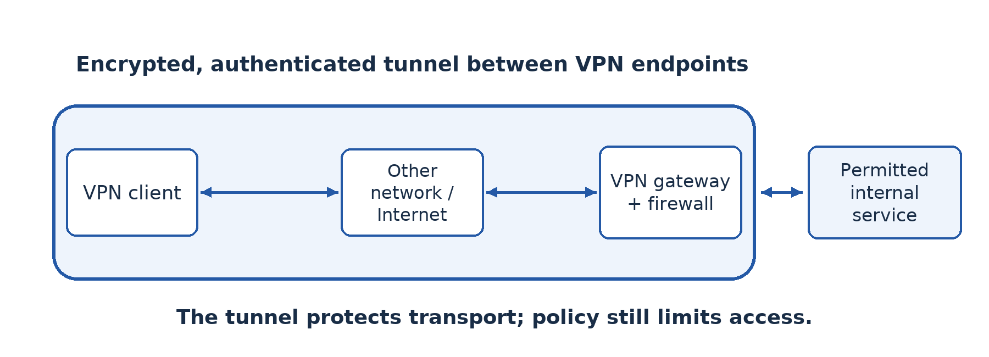
Figure 22.1 — The encrypted tunnel ends at the VPN gateway. Access beyond it remains controlled; the tunnel is not unlimited permission to use every internal service.

22.2 Firewalls, certificates and digital signatures
A firewall applies rules to network traffic. The gateway should allow the VPN's required traffic and restrict VPN users to the services they are authorised to use. A VPN authenticates and protects a connection; a firewall controls permitted traffic. They complement rather than replace each other.
A digital certificate binds an identity to a public key under a trusted issuer's signature. In a certificate-authenticated VPN, the software checks the certificate's trust chain, validity and expected identity, and the protocol uses cryptographic authentication. A digital signature is a cryptographic value created using a private key and checked with the corresponding public key. It can support authenticity and integrity; it does not by itself hide the data.
The progression asks for a secured VPN using firewalls and digital signatures. The practical therefore uses signed certificates for authentication and explicit firewall policy. Merely adding a picture of a handwritten signature to a document does not secure a VPN, and signing an unrelated file is not a substitute for authenticated tunnel setup.

22.3 Guided practical — Connect to an authorised lab gateway
Teacher preparation: provide an isolated or properly authorised gateway running a supported certificate-authenticated VPN, a reachable internal test service, current VPN client software and a unique learner client profile. The profile must include or securely reference the trusted CA material and client credentials, require server-identity verification and define the intended tunnel routes. Configure the gateway firewall to allow the VPN listener, permit this test user to the specified internal test service, and deny unrelated internal access. Test the policy beforehand. Do not use a random public VPN profile or production credentials.
For a repeatable lab, the teacher can use an OpenVPN gateway on the authorised lab network with an internal resource reachable only through the VPN's allowed route. Server and client certificates must be signed by the lab's trusted CA, and each client needs a separate identity. The teacher keeps the CA private key secure, defines certificate-revocation and cleanup procedures, and supplies the endpoint and test-service addresses from the actual lab plan. Software installation and gateway administration are supervised prerequisites, not actions learners should improvise on school infrastructure.
1. Inspect the approved profile's source and expected gateway identity with the teacher. Import it into the supported VPN client without publishing embedded keys or passwords.
2. Before connecting, attempt the designated internal test service and record the expected lack of access from the external lab segment. Record the current route or interface state using the approved system tool.
3. Connect using the assigned credentials. Check that the client validates the gateway certificate and reports a protected connection. Stop and report any identity or certificate warning; do not bypass it.
4. Inspect the new tunnel interface or route and reach the permitted internal test page or share. Record the connection status and successful service test without exposing secrets.
5. Attempt only the teacher-designated disallowed test resource. It should remain blocked by policy. Do not scan for other services. The teacher can show the relevant firewall-log entry and explain how it relates to the rule.
6. Disconnect and confirm that access through the VPN route is removed. Reconnect only if instructed. Remove the profile and revoke or expire the temporary identity under the teacher's cleanup procedure.
If the school cannot provide the gateway and credentials, trace packet and certificate cards through a paper tunnel and firewall. This teaches the roles but does not count as completing actual VPN configuration.

Worked example — Explain what failed
A client connects but cannot reach the staff database. Possible causes include a missing route, an unavailable service or an access rule that intentionally excludes that account. Do not turn off the firewall. Compare the intended permissions, tunnel route and a teacher-approved service test. A secure VPN should not automatically make every internal resource accessible.

Check your understanding
1. Explain confidentiality, integrity and authentication in a VPN connection.
2. Distinguish a VPN tunnel, a firewall rule and a digitally signed certificate.
3. Why must a learner not ignore a gateway-certificate warning?
4. State two things a VPN does not guarantee.

Answer guidance
1. Encryption hides traffic content between endpoints; integrity protection detects modification; authentication establishes relevant identities. Each addresses a different problem.
2. The tunnel carries protected traffic, the rule limits permitted communication, and the signed certificate supports a trusted identity-to-key binding.
3. The client may not be communicating with the expected gateway. Bypassing validation removes an important authentication safeguard.
4. It does not guarantee safe endpoint software, honest websites, complete anonymity or unlimited internal authorisation. Explain the limitation you select.

Lesson 23 — Computer and network security
Week 7 · Supplied progression: PDF page 4
Learning outcomes — supplied progression
• Explain concepts related to computer and data security (confidentiality, integrity, availability).
• Identify security measures used to protect computer systems (including user accounts, passwords, authentication, firewalls and security protocols).
• Explain how digital signatures, encryption and other security measures help protect computer systems.

What are we trying to protect?
An unauthorised person reads a staff record, another person changes a mark, and a power failure prevents access to all records. These are three different security problems. Computer and network security protects systems and information against unauthorised access, alteration, disruption and other harms. Good security begins by identifying the asset and the kind of harm, not by naming a product.

23.1 Confidentiality, integrity and availability
Confidentiality means information is accessible only to authorised parties. Exposing a learner's private record violates confidentiality. Integrity means information remains accurate and complete against inappropriate alteration. Changing a mark without permission violates integrity. Availability means authorised users can obtain the service or data when required. A failed storage device or a denial-of-service attack can threaten availability.
The three goals are often called the CIA triad. They can interact: a system that nobody can access may protect secrecy but fail to provide useful availability. A convenient shared password may improve short-term access while weakening confidentiality and accountability. Choose balanced controls based on risk.
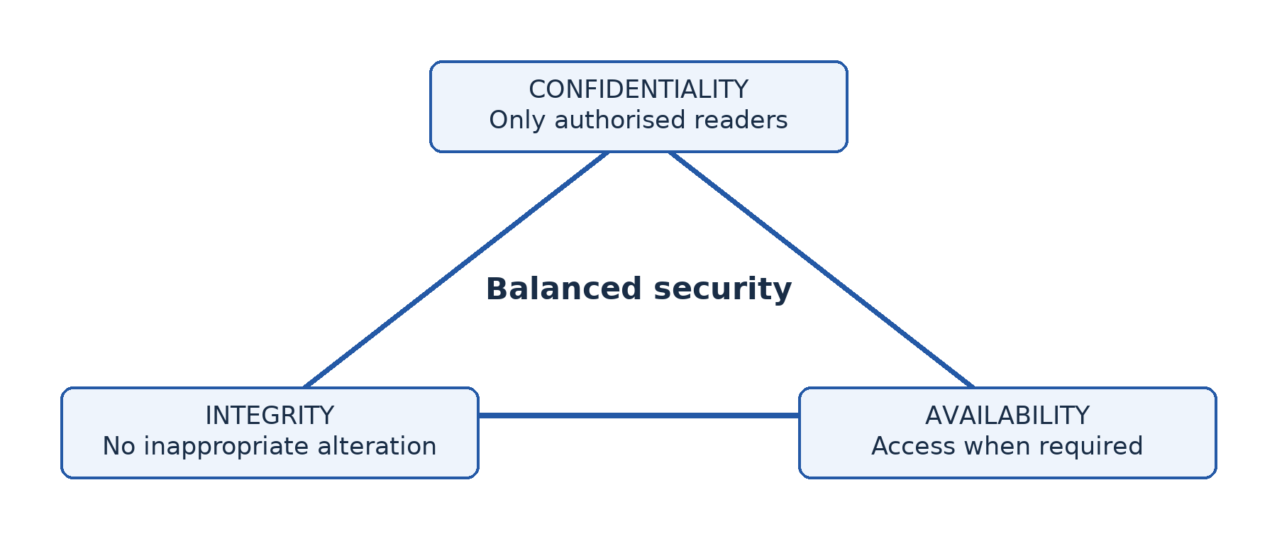
Figure 23.1 — Confidentiality, integrity and availability are distinct security goals. Controls should address the relevant harm without ignoring the others.

23.2 Threats and layered controls
A threat is a potential cause of harm. A vulnerability is a weakness that could be exploited or exposed. Risk concerns the chance and consequences of harm in the circumstances. An unpatched service is a vulnerability; exploitation is a threat scenario; the value and exposure of the affected records influence the risk.
Malware can steal, alter or destroy information. Phishing deceives a user into revealing information or taking an unsafe action. Social engineering targets human behaviour rather than relying only on a software weakness. Physical theft, fire, accidental deletion and power failure also matter. Security is not limited to malicious strangers on the Internet.
Use layers: individual accounts, strong unique passwords or passphrases, multi-factor authentication where supported, least-privilege permissions, timely updates, anti-malware measures, appropriate firewall rules, encryption, backups, physical controls and user training. No one layer makes the system completely safe. Backups should be protected from the same incident and restoration should be tested.
Authentication verifies an identity; authorisation determines what that identity may do. Logging records significant actions for investigation and accountability. A password authenticates a user only if it is actually kept secret; a shared administrator account makes it harder to determine who performed an action.

23.3 Encryption and digital signatures
Encryption transforms plaintext into ciphertext using an algorithm and key, so someone without the required key cannot easily read the content. Symmetric encryption uses a shared secret key for encryption and decryption. Asymmetric cryptography uses a related public/private key pair for functions such as establishing protected communication and creating signatures. Actual secure systems combine suitable methods rather than encrypting everything with a single simplistic operation.
A cryptographic hash produces a fixed-length digest from data. A suitable hash helps reveal alteration because a changed message is expected to produce a different digest. A hash alone does not prove who created a message: an attacker could change both a file and an unprotected hash.
For a digital signature, the signer uses a private key in a signature scheme applied to the message or its cryptographic representation. The verifier uses the corresponding public key to check the signature. A valid check supports that the signed data has not changed and that it was signed using the relevant private key. Trust still depends on correctly identifying the public key and protecting the private key. A signature is not simply “encrypting the whole document with a private key”, and it does not provide confidentiality by itself.
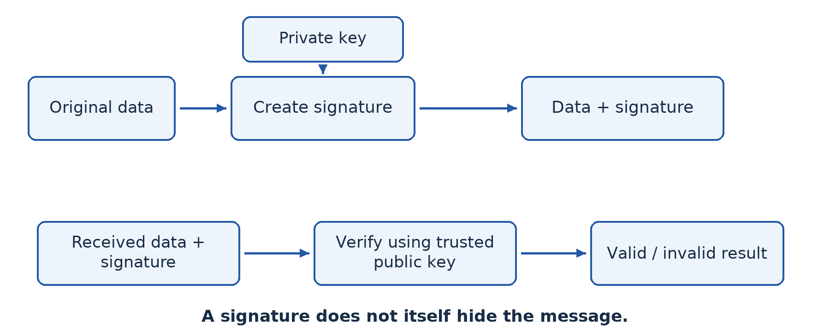
Figure 23.2 — Signing uses the private key; verification uses the corresponding public key. The recipient also needs a trustworthy way to associate that key with the claimed signer.

Worked example — Select controls by goal
The school's marks file needs confidentiality through restricted staff accounts and suitable encryption. Integrity requires authorised editing, logs and recovery from inappropriate changes. Availability requires reliable storage, protected backups and a tested recovery procedure. Sending a signed exported report can help a recipient check origin and alteration, but it does not hide the report from unintended readers unless confidentiality is protected separately.

Guided activity
Use fictional scenarios: a stolen laptop, a fake password-reset message and an unavailable server after a power cut. Identify the asset, threat, weakness, likely CIA impact and two complementary controls. In a lab, inspect a harmless file's properties and a browser's certificate information under supervision. Do not collect passwords, open suspicious links or test attacks against real systems.

Check your understanding
1. Explain CIA using three different harms to a school records system.
2. Distinguish authentication from authorisation with an example.
3. Explain what encryption and digital signatures each provide and what each does not automatically provide.
4. Why are backups insufficient without restoration tests and protection from the same incident?

Answer guidance
1. Unauthorised reading harms confidentiality, unauthorised alteration harms integrity and inaccessible records harm availability. Explain the user's resulting problem.
2. Logging in verifies identity; the account's permission to edit marks is authorisation. A valid login does not imply administrative rights.
3. Encryption protects readable content from parties without the key; signatures support authenticity and integrity. Neither automatically guarantees all other security goals or trustworthy endpoint behaviour.
4. A backup may be incomplete, unreadable or also destroyed or encrypted by the incident. Testing and separation help establish recoverability.

Lesson 24 — Data protection and access control
Week 7 · Supplied progression: PDF page 4
Learning outcomes — supplied progression
• Explain how encryption and access rights are used to protect computer data.
• Describe methods used to control access to data and prevent unauthorised use.
• Explain the importance of protecting data confidentiality, integrity and availability.

Not every employee needs every record
A receptionist needs appointment times, a clinician needs relevant clinical records and a cashier needs payment information. Giving everyone full access is convenient only until information is exposed or altered. Access control determines who or what may use a resource and which operations are permitted. It connects identity to a justified level of authority.

24.1 Accounts, roles and least privilege
An account should identify an individual or a clearly managed service. A role groups permissions according to duties, such as teacher, learner or records officer. Role-based access control can make administration more consistent than assigning every permission independently to every user. Review roles when duties change and remove access when a user leaves.
Least privilege means granting only the access necessary for the task, for the appropriate duration. A learner viewing teaching notes generally needs read access, not permission to overwrite the teacher's master copy. A staff member creating reports may not need to create new administrator accounts. Separate high-privilege administration from ordinary daily work where practical.
Authentication methods include something known, such as a password; something possessed, such as a security token; and an inherence factor, such as an approved biometric. Multi-factor authentication uses different categories, not merely two passwords. Biometrics introduce their own privacy and accuracy issues; a person's fingerprint cannot simply be changed like a forgotten passphrase.

24.2 Encryption at rest and in transit
Data at rest is stored data, such as a laptop's files or a server's database. Storage encryption can reduce exposure if a device is stolen while protected. It does not stop an already authorised logged-in user from misusing accessible information. Data in transit moves between endpoints; protected protocols such as HTTPS help prevent interception and undetected alteration along that connection.
Key management matters. A lost decryption key can make legitimate information inaccessible, while a stolen key can undermine confidentiality. Use approved key recovery and secure storage procedures. Backups also require suitable access control and encryption because copying data does not remove its sensitivity.
Data minimisation means retaining only information needed for a legitimate purpose. Set retention periods, delete securely when appropriate and keep a clear account of who is responsible. An organisation should check current applicable law and policy for real personal-data processing; this classroom discussion is not legal advice or a claim that a particular software setting ensures legal compliance.

24.3 Protect all three security goals
Access controls mainly limit actions, but an effective data-protection plan also preserves integrity and availability. Read-only permissions reduce accidental editing; version history and logs help investigate changes; backup and restoration support recovery. Excessively restrictive or poorly managed accounts can prevent authorised work, so access requests and recovery procedures need timely administration.
Physical protection matters too. Locking an unattended screen, securing server rooms and controlling removable media reduce opportunities that network passwords alone do not address. Staff need training to recognise phishing and to report incidents promptly rather than hide mistakes.

Worked example — A shared teaching folder
The school creates a folder where teachers may update notes and learners may read them. Use separate teacher and learner groups, assign appropriate edit and read permissions, and test with accounts from both groups. Protect a recoverable master copy and log significant changes. Encryption can protect storage or transfer where required, but it does not replace the permission distinction. A learner's failed edit is evidence that a particular control may be working.

Guided activity
On a teacher-approved lab folder containing fictional text, test access with a read-only account and an editing account. Try opening, changing and deleting the test file only as instructed. Record the expected and actual results, then restore the original data. Do not use administrator access to bypass a denied operation. Without equipment, use user-role and action cards and explain which permission authorises or rejects each action.

Check your understanding
1. Explain least privilege and role-based access control using staff and learner folders.
2. Distinguish authentication factors from permissions.
3. Why does storage encryption not remove the need for a screen lock and user permissions?
4. Propose one control for confidentiality, one for integrity and one for availability of school records.

Answer guidance
1. Roles group rights by duty, and least privilege limits each group to necessary actions. A learner need not edit master notes to read them.
2. Factors help verify identity; permissions determine allowed actions after identity is established. Different steps answer different questions.
3. Once data is decrypted for a logged-in session, someone using that session may access it. Access and physical controls remain necessary.
4. Restricted access, controlled editing or versioning, and protected tested backups are suitable examples when each is linked to its particular goal.

Lesson 25 — Data validation and verification techniques
Week 7 · Supplied progression: PDF page 4
Learning outcomes — supplied progression
• Explain and contrast the concepts of data validation and verification.
• Describe validation techniques (e.g., range check, format check, length check…).
• Describe verification techniques such as visual check and double entry.

A believable value can still be wrong
A clerk enters a learner's mark as 68 instead of 86. Both values lie between 0 and 100. A range rule accepts 68, yet the record does not match the source. This shows why validation and verification answer different questions.

25.1 Validation checks acceptability
Validation checks whether data meets specified rules about its permitted form, range or relationships. It aims to reject unacceptable input before processing. It does not normally establish that an acceptable value is true. A date in the right format can still be the wrong date of birth.
A presence check requires a value in a compulsory field. It does not make that value meaningful: typing a random character may satisfy presence while failing another rule. A type check requires an appropriate data type, such as an integer for a whole-number score. Distinguish an identifier from a quantity: a phone number may need text storage to preserve a leading zero or country prefix, even though it contains digits.
A range check restricts a value to limits, such as 0 through 100 inclusive. A length check restricts the number of characters, for example a school identifier defined to contain eight characters. A format check checks a pattern, such as two letters followed by six digits. A format rule for an e-mail address does not prove that the mailbox exists or belongs to the intended person.
A lookup or list check accepts only values from an approved set, such as the school's valid class names. A consistency check compares related data, such as ensuring an end date is not before a start date. A uniqueness check prevents duplicate values where a field must identify one record. A check digit is a calculated character used in some identifiers to help detect selected entry errors; it does not prove the identity itself is genuine.

25.2 Verification checks faithful transfer
Verification checks whether data has been copied or entered in accordance with the original source. A visual check compares the entered record with the source document. It can detect the 68-versus-86 mistake if the checker looks carefully. It is vulnerable to fatigue and to repeating an expectation rather than observing the source.
Double entry enters the same data independently twice and compares the entries. A mismatch prompts correction against the source. Independent entry is important: copying the first entry into the second provides no useful check. Both operators can still make the same mistake or faithfully copy an incorrect source, so verification is not proof of real-world truth.
For a critical field, combine methods. Validate the mark's range and verify it against the approved marks sheet. In these notes, verification concerns data transfer or entry, not the different everyday meaning of verifying a user's identity. Always read the context of the term.
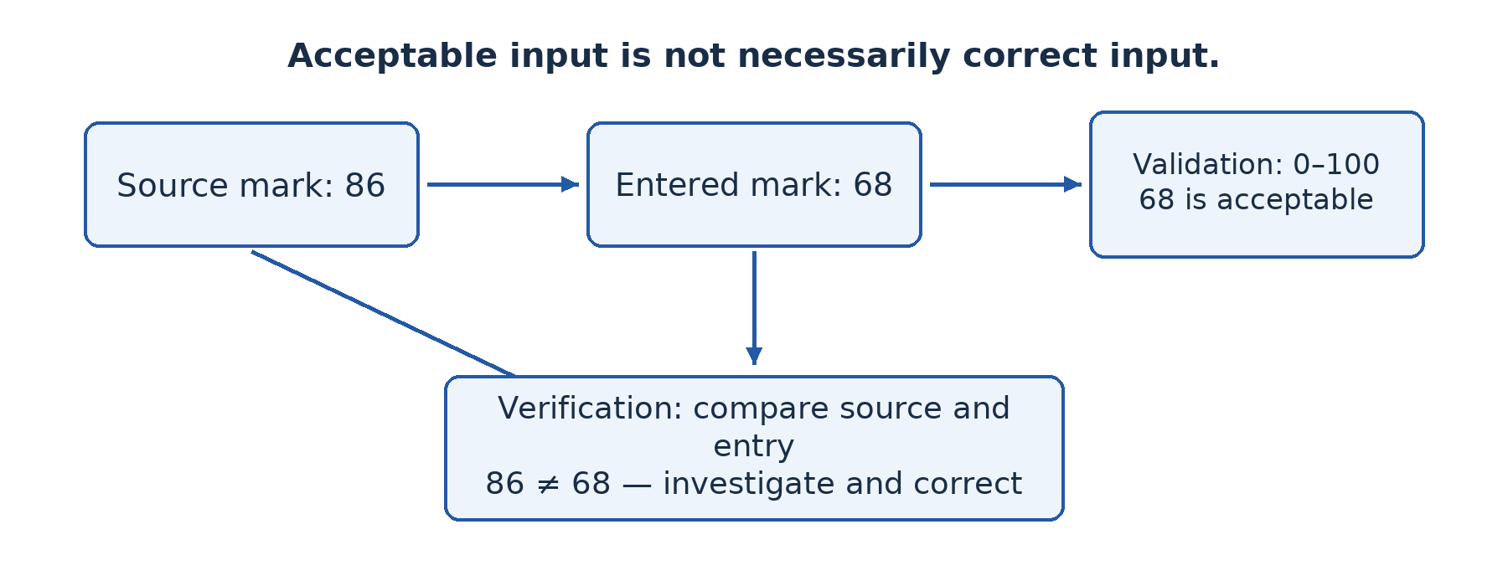
Figure 25.1 — Validation checks rules; verification checks the entered value against its source. The value 68 passes the range rule but fails comparison with the source value 86.

Worked example — Design checks for registration
A fictional registration form contains a school-defined ID, name, class and mark. Require an ID and validate its defined pattern and uniqueness. Use a list for the class and an integer range from 0 to 100 for the mark. Names should allow legitimate variety; a rule that rejects every space, hyphen or accented character can wrongly exclude real users.
Then compare the name and mark with the authorised source, using visual checking or independent double entry for important fields. If a student really earned 86 but the source document itself says 68, faithful copying alone will not resolve the issue. The school needs an authorised correction process, not a validation rule pretending to know the truth.

Guided practical
In a supervised spreadsheet, create columns for fictional IDs, classes and marks. Apply the program's data-validation facility to the mark cells, using the whole-number range 0–100 and an error message explaining the rule. Set the error action to reject invalid input where the application supports it; merely showing a warning may still permit the value. Test -1, 0, 50, 100, 101, text and a blank. Record which boundary values pass and whether a separate presence rule is needed.
Next create a small approved class list and apply a list-based rule. Have a partner enter five fictional records from a printed source, then compare them visually. Repeat independent entry for the marks and investigate mismatches. Some spreadsheet operations can bypass or overwrite validation, so do not treat a classroom setting as a complete production data-integrity system. Without equipment, perform the same accept/reject and source-comparison tests using cards.

Check your understanding
1. Explain why 68 can pass validation even when 86 is the correct mark.
2. Choose and explain suitable checks for an eight-character identifier, a compulsory class and a percentage mark.
3. Distinguish visual checking from double entry and give a limitation of each.
4. Why can verified data still be factually incorrect?

Answer guidance
1. A range rule checks acceptability, not agreement with the source. Both values satisfy 0–100.
2. Use length and any defined format for the identifier, presence plus an approved list for class, and numeric type plus range for the mark. Explain any uniqueness requirement separately.
3. Visual checking compares against the source and can miss errors through fatigue; double entry compares independently entered values and can miss identical mistakes. Neither should be described as infallible.
4. The source itself can be wrong, or the checking method can miss a mismatch. Correct transfer is distinct from establishing real-world truth.

Lesson 26 — Integration: Secure a school information service
Week 7 · Supplied progression: PDF page 4 · Locally authored integration task

The situation
A fictional school stores staff documents, teaching notes and registration records on networked computers. Teachers need remote access; a supplier needs selected order information. Last week a learner accidentally edited the master notes, an implausible mark was entered and a staff member received a suspicious password request.
Your team must propose a layered improvement plan using Lessons 21–25. Do not access real records or test an attack. Use a paper design and teacher-controlled demonstration accounts.

Required work
Classify the public, intranet and extranet services and explain the intended audiences. Draw the teacher's remote-access path and mark the VPN endpoints, authentication and firewall-controlled access. Explain what the VPN protects and why it does not authorise every internal action. Refer to signed certificates rather than a scanned signature image.
Assign read and edit rights to learners, teachers, records staff and the supplier. State at least one example of least privilege. For each reported incident, identify the threatened security goal and an appropriate response. Include protected backups and restoration testing so the plan is not limited to preventing unauthorised reading.
Design validation rules for a mark and a school identifier, plus verification against an approved source. Demonstrate the important difference by using an incorrect but in-range mark. Include a phishing-response rule that uses an independently trusted channel rather than replying to the suspicious message.

Evidence and review
Submit a labelled service diagram, a written access-policy explanation, test results from fictional records and a short risk-response plan. If a supervised lab is available, show read-only versus edit access and a validation boundary test. VPN performance evidence requires the prepared gateway from Lesson 22; otherwise label that component as a simulation awaiting practical completion.
Another group reviews whether a proposed control addresses the stated risk. For example, encryption alone does not prevent a permitted user from changing a mark, and range validation alone does not detect a transposed in-range mark. Revise one mismatched control before submission.

Assessment criteria — 20 marks
Use 4 marks for audience and service separation; 6 marks for technically correct VPN, authentication and access-control reasoning; 6 marks for relevant CIA controls, data checks and test interpretation; and 4 marks for safe evidence, review and individual explanation. The criteria are locally authored for this integration lesson.

Review guidance
A strong solution combines technical controls with responsibilities and procedures. It explains who approves access, who reviews incidents and who restores data. Finish individually with two short paragraphs: one explaining why validation is not verification, and another explaining why a VPN is not a replacement for least-privilege permissions.

Part 4 — Transmitting data reliably

Lesson 27 — Modes of data transmission
Week 8 · Supplied progression: PDF page 4
Learning outcomes — supplied progression
• Explain logical topology methods (CSMA/CD, CSMA/CA).
• Describe different transmission modes (simplex, half-duplex, full duplex).
• Illustrate the direction of signal flow for a given data transmission scenario.

Separate two questions
A walkie-talkie lets each user speak, but normally not both at once. A telephone conversation allows both parties to speak at the same time. These are differences in direction of communication. Another question asks how devices share a communication medium without interfering with each other. The progression places both under this lesson, but they are not the same classification.

27.1 Simplex, half-duplex and full-duplex
Simplex communication carries information in one direction only for the connection being described. Traditional radio broadcasting sends from a station to listeners without a return path on that broadcast channel. A separate phone-in line does not make the broadcast channel itself duplex. Always define the connection being classified.
Half-duplex communication permits both directions, but not simultaneously on the shared channel. With a simple walkie-talkie, one user presses to talk while the other listens; they exchange roles afterwards. Both parties can send, so half-duplex is not the same as simplex.
Full-duplex communication permits simultaneous transmission in both directions. A modern switched Ethernet link normally supports this, as does the conversational service of a telephone connection. Separate channels or signal techniques may support simultaneous directions. It does not mean that a user must actually speak or send data continuously.
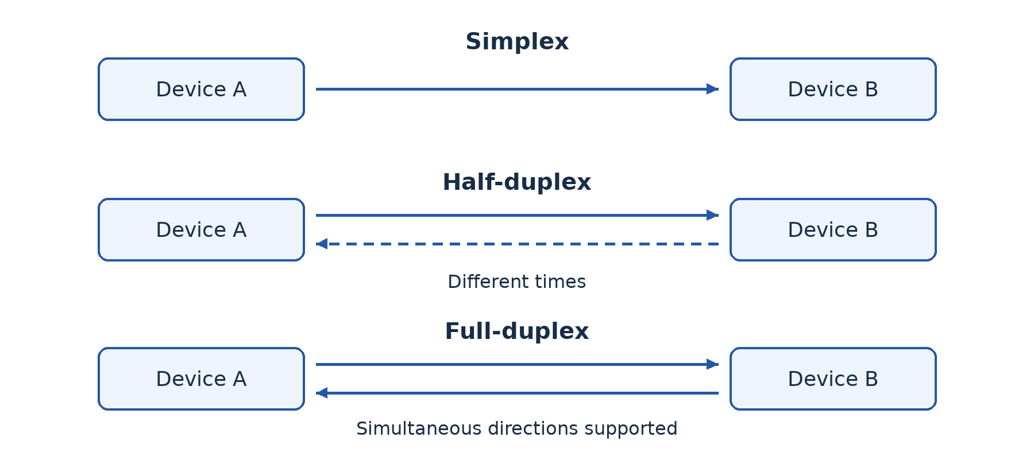
Figure 27.1 — Simplex has one direction; half-duplex has alternating directions; full-duplex supports both directions at the same time.

27.2 Sharing a medium: CSMA/CD
Carrier Sense Multiple Access with Collision Detection (CSMA/CD) was used by shared, half-duplex Ethernet. “Carrier sense” means listening to determine whether the medium appears busy. “Multiple access” means several stations can use the same shared medium. A station transmits when permitted by the method, but propagation delay means two stations can start before each hears the other's transmission.
If a collision is detected, the stations stop and wait for different randomly selected backoff intervals before retrying. The random delays reduce repeated simultaneous attempts. Listening first reduces some conflicts but cannot guarantee none will occur. This explanation concerns shared half-duplex Ethernet, not the normal full-duplex switched Ethernet links of a new laboratory.

27.3 Sharing a medium: CSMA/CA
Carrier Sense Multiple Access with Collision Avoidance (CSMA/CA) is associated with Wi-Fi. A wireless station cannot rely on detecting a collision while transmitting in the same way as shared wired Ethernet. It listens, follows timing rules and uses a random backoff before transmitting when appropriate. Acknowledgements help determine whether a frame was received successfully; optional coordination mechanisms can reduce some hidden-station problems.
“Avoidance” does not mean collisions are impossible. Two stations can still choose conflicting times, and interference can corrupt a frame. Retries may be required. In typical shared-channel Wi-Fi operation, devices take turns using the radio channel rather than each receiving a dedicated full-duplex channel like an Ethernet switch port.
The sheet describes these as logical-topology methods. More precisely, they are media-access methods: rules about how devices use a shared medium. The physical layout, logical flow, access method and duplex mode are related descriptions but should not be used as synonyms.

Worked example — Classify carefully
A room has laptops connected to one Wi-Fi access point and desktops connected by full-duplex Ethernet to a switch. Both sets belong to a local network. Typical Wi-Fi access uses CSMA/CA and shared-channel turn-taking. The full-duplex switched Ethernet links do not use CSMA/CD to handle collisions during ordinary operation. “All LANs use collision detection” would therefore be wrong.

Guided activity
Use two learners and message cards to demonstrate simplex, half-duplex and full-duplex. Then let four learners share one speaking channel. First model listen-and-detect with teacher-controlled simultaneous starts; then model listen-and-wait with random number cards. Discuss why a classroom role-play is an analogy, not a literal electrical or radio implementation. Draw arrow diagrams for each duplex mode.

Check your understanding
1. Distinguish simplex, half-duplex and full-duplex with a labelled example of each.
2. Explain why listening before sending cannot guarantee no collision on a shared medium.
3. Compare the purpose of CSMA/CD and CSMA/CA and identify their usual teaching contexts.
4. Why is a star drawing insufficient to determine a network's access method?

Answer guidance
1. Show one direction, alternating two-way communication and simultaneous two-way communication respectively. Classify a specified channel, not every possible service used by the devices.
2. Signals take time to propagate, so two stations may both observe an apparently idle medium before either transmission reaches the other.
3. Both organise access to a shared medium. Collision detection belongs to shared half-duplex Ethernet; avoidance is used in Wi-Fi. Modern switched full-duplex Ethernet does not need CSMA/CD on each link.
4. A physical star may contain different central devices and technologies. The connection pattern alone does not specify the rules used by the links.

Lesson 28 — Broadband and narrowband transmission
Week 8 · Supplied progression: PDF page 4
Learning outcomes — supplied progression
• Define broadband and narrowband transmission.
• Differentiate between broadband and narrowband transmissions.
• Identify the appropriate transmission type used in a given communication situation.

Capacity must match the task
A sensor sends a short temperature reading every hour. A clinic wants a clear live video consultation. Both transfer data, but the required rate and timing differ greatly. Buying the highest advertised capacity for every task can waste money; buying too little can make a service unusable.

28.1 Meaning in context
Narrowband describes communication using a relatively limited channel bandwidth and generally supporting modest data rates for the context. It can be appropriate for short messages, low-rate telemetry and some voice or control applications. Broadband describes a wider-capacity communication service or channel arrangement supporting higher data rates and richer or multiple services in that context.
In everyday Internet use, broadband refers to high-capacity access rather than a universal physical threshold. Definitions and regulatory minimum rates can change. In signal engineering, bandwidth is measured in hertz and refers to a range of frequencies; data rate is measured in bits per second. The quantities are related by the technology and signal conditions, but they are not identical units.
Do not confuse broadband versus narrowband with baseband versus broadband signalling as used in some engineering discussions. The first-term objective is to distinguish communication needs and appropriate capacity, not to assume that every use of the word broadband means exactly the same modulation method.

28.2 Capacity, throughput and delay
A service may advertise a maximum capacity of 20 megabits per second (20 Mb/s or Mbps). Throughput is the useful rate actually achieved under given conditions. Contention, signal quality, server limits and protocol overhead can reduce it. Latency is delay, which affects interactive work even when capacity is high.
A byte contains eight bits. A 10 megabyte file contains about 80 megabits under decimal units. At an ideal, fully available 4 Mb/s, the minimum transfer time is 80 ÷ 4 = 20 seconds. Real transfer takes longer when overhead, changing rate or other users are involved. Confusing MB/s with Mb/s leads to a factor-of-eight error.
A short sensor message may tolerate low capacity and some delay while benefiting from low power use and wide coverage. A live video call needs sustained capacity in both required directions and acceptable delay and variation. High download capacity alone does not establish that the upload path will support the clinic's outgoing video.

Worked example — Recommend without overbuying
A cooperative has battery-powered soil sensors and an office receiving training videos. Low-rate, low-power communication may be suitable for periodic sensor readings because messages are small. The office needs a higher-capacity connection for video downloads and several users. The two services can coexist. The recommendation links the capacity to the task rather than declaring narrowband obsolete or broadband automatically necessary everywhere.

Guided activity
Calculate ideal transfer times for a 12 MB teaching file at 2 Mb/s and 8 Mb/s using decimal units. Then explain why measured times could be longer. Rank four applications—hourly sensor reading, text message, web research and multi-user live video—by likely capacity demand, stating assumptions. With equipment, time an authorised local file transfer and report the file size, elapsed time and limitations of the measurement.

Check your understanding
1. Distinguish bandwidth in hertz from data rate in bits per second.
2. Explain broadband and narrowband without claiming a timeless universal speed boundary.
3. Calculate the ideal transfer time for 12 MB at 8 Mb/s.
4. Why might a lower-capacity service be appropriate for a remote sensor but inadequate for interactive video?

Answer guidance
1. Frequency bandwidth describes a range of frequencies; data rate describes transferred bits per unit time. Technology and signal conditions connect them.
2. They describe relatively wider- and narrower-capacity arrangements in a specified context. Current service definitions must be checked rather than assumed.
3. 12 × 8 = 96 megabits; 96 ÷ 8 = 12 seconds, before overhead and contention. At 2 Mb/s, the same ideal calculation gives 48 seconds.
4. Small infrequent readings need little data capacity and may prioritise power and coverage. Video requires sustained traffic and acceptable interactive delay.

Lesson 29 — Types of data transmission
Week 8 · Supplied progression: PDF page 4
Learning outcomes — supplied progression
• Explain and contrast serial and parallel data transmission methods.
• Differentiate between synchronous and asynchronous transmission and identify their use in given situations.
• Illustrate and differentiate between analog and digital signals.

Several classifications can apply at once
“Serial”, “synchronous” and “digital” do not answer the same question. Serial versus parallel concerns how bits are arranged across paths. Synchronous versus asynchronous concerns timing and framing. Analog versus digital concerns signal representation. One communication system can therefore be serial, synchronous and digital without contradiction.

29.1 Serial and parallel
Serial transmission sends successive bits along a communication path in sequence. A simplified drawing shows one bit after another on one data path. Real systems may use differential pairs or several serial lanes, so “serial means exactly one physical wire” is too literal. USB and many modern high-speed links use serial signalling.
Parallel transmission sends several bits at the same time across multiple data paths, often representing parts of a word together. It can transfer several bits per timing event, but requires more conductors and coordination. Over increasing distance or higher rates, differences in arrival time (skew), interference and cable complexity become important.
It is wrong to conclude that parallel is always faster. Modern serial links can operate at very high signalling rates and avoid some parallel coordination problems. Compare actual technologies, distance and cost. Parallel communication remains useful in appropriate short internal connections, while serial methods are common for external and long-distance communication.
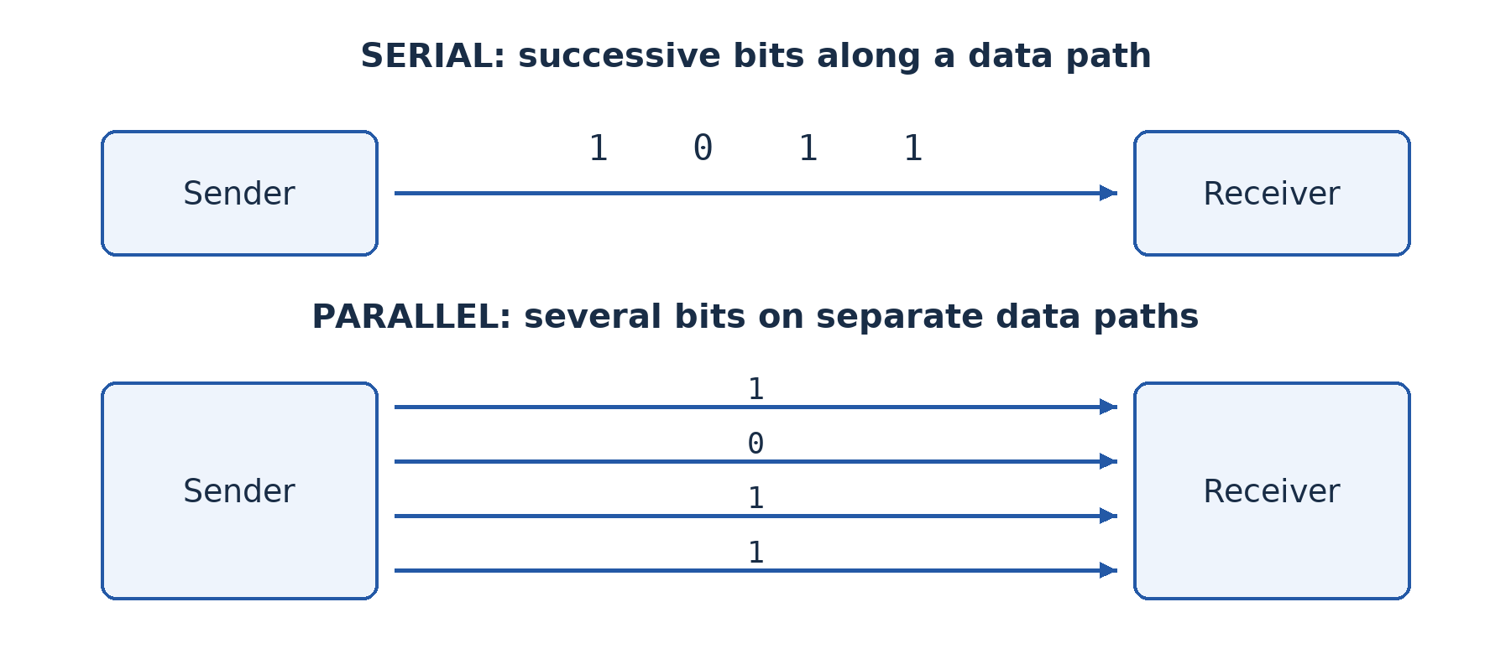
Figure 29.1 — Serial sends successive bits along a path; parallel sends several bits together on separate data paths. These are simplified logical drawings.

29.2 Synchronous and asynchronous timing
In synchronous transmission, sender and receiver coordinate timing so that bits can be interpreted as an organised stream or blocks. Timing may be supplied explicitly or recovered from the signal. Block framing and other control information may still be present; synchronous does not mean “no overhead at all”. It is efficient for sustained transfers when the method is designed appropriately.
In common asynchronous serial transmission, a character can be sent after an irregular gap. A start bit tells the receiver when the character begins, and agreed timing allows the receiver to sample the following bits. One or more stop bits mark the end or provide separation. Optional parity may be included. The devices still need compatible rates and framing settings; asynchronous does not mean “no timing”.
For an illustrative frame with one start bit, eight data bits and one stop bit, 10 transmitted bits carry 8 data bits. The useful-data proportion is 8 ÷ 10 × 100 = 80%, ignoring other overhead. If a parity bit is added, the frame becomes 11 bits under these assumptions. State the format before calculating; real systems differ.
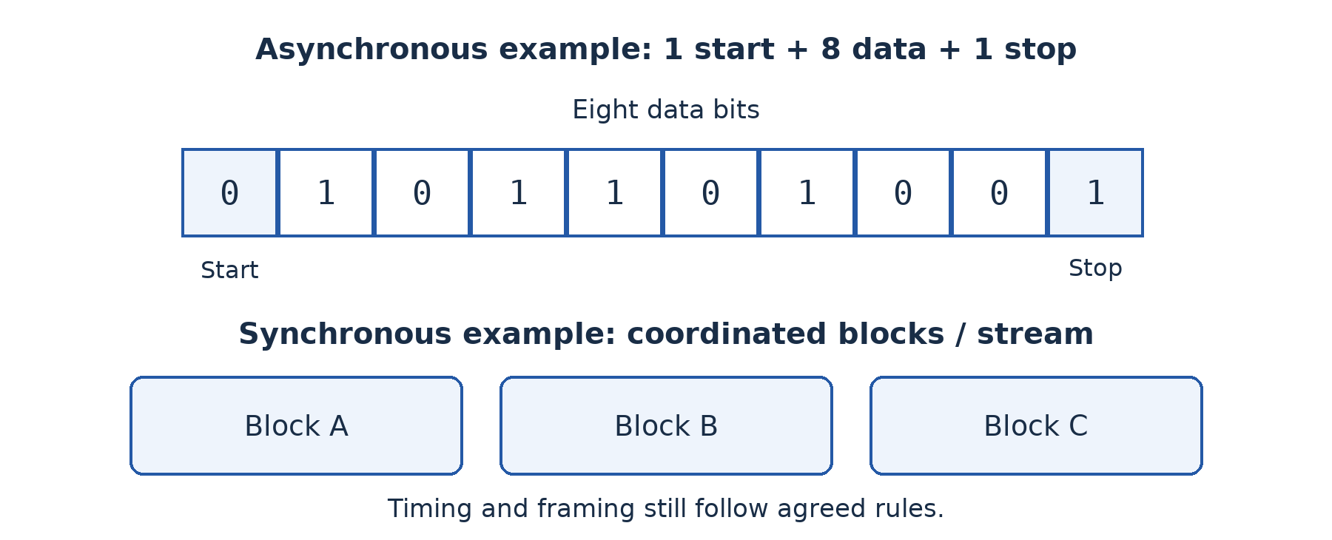
Figure 29.2 — A common asynchronous character frame uses start and stop bits. A synchronous stream coordinates timing across blocks; the drawing omits technology-specific details.

29.3 Analog and digital signals
An analog signal varies continuously over a range to represent information. A microphone's electrical representation of changing sound pressure is a familiar example. A digital signal represents information using a finite set of symbol states, commonly interpreted as binary 0 and 1. Physical voltages are never perfect mathematical squares, but the receiver decides which symbol state was intended within allowed ranges.
Noise can alter both kinds of physical signal. Digital interpretation can tolerate limited disturbance and allow regeneration and error detection, but it is not immune to error. Conversion from analog measurements to digital data involves sampling and quantisation. A device may process digital data and transmit it using a modulated physical waveform, so avoid assuming that the underlying radio wave itself becomes a row of literal square bits.
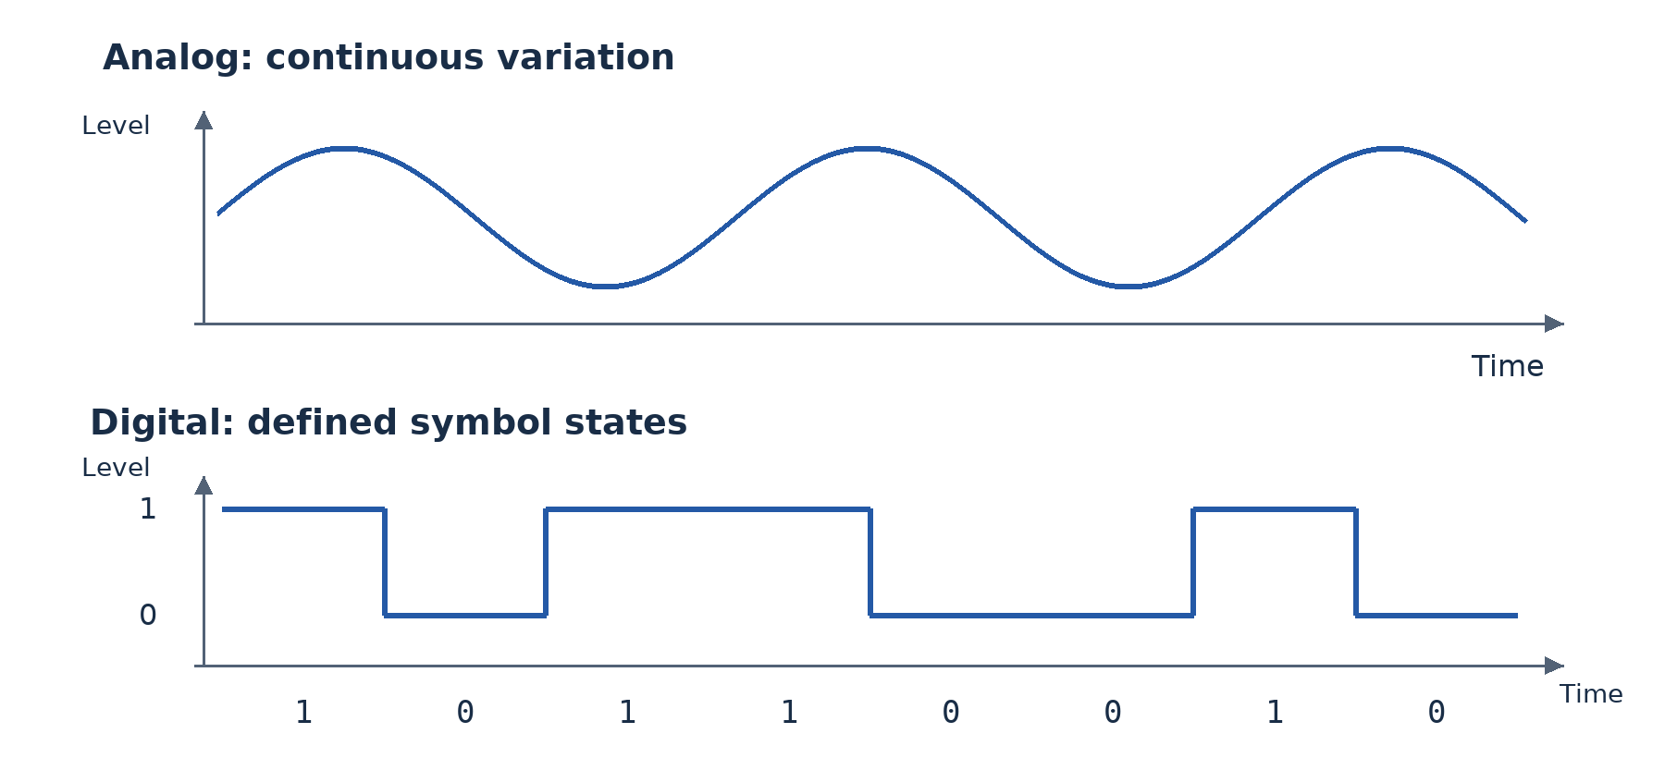
Figure 29.3 — The analog trace varies continuously; the simplified digital trace uses defined states. Time runs from left to right in both drawings.

Worked example — Explain all three descriptions
A simplified sensor link sends eight-bit readings one bit at a time, uses a start and stop bit for each reading and interprets two electrical levels as binary symbols. It is serial in bit arrangement, asynchronous in character framing and digital in representation. Whether it is simplex or duplex is a separate question about permitted communication directions.

Guided activity
Use eight cards to represent one byte. Move them through a single path, then through eight parallel paths. Introduce different delays on parallel paths and discuss skew. Next build an asynchronous frame with start, data and stop cards. Sketch one analog and one digital signal and label the axes and intended information states. No powered equipment is required for this conceptual activity.

Check your understanding
1. Compare serial and parallel on arrangement, wiring and distance-related difficulties.
2. Explain how an asynchronous receiver knows when to begin reading a character.
3. Calculate the useful-data proportion for one start bit, seven data bits, one parity bit and one stop bit.
4. Why is “digital signals cannot be affected by noise” incorrect?

Answer guidance
1. Serial sends successive bits along a path; parallel uses multiple paths simultaneously. Parallel adds conductors and timing coordination; actual speed depends on technology.
2. A start bit indicates a character boundary, and agreed rate and format determine subsequent sampling. Compatible timing is still required.
3. The frame contains 10 bits, of which 7 are data: 7 ÷ 10 × 100 = 70%.
4. Physical disturbances can cause a receiver to misinterpret a symbol. Defined states and checking improve robustness but do not make error impossible.

Lesson 30 — Guided and unguided transmission media
Week 8 · Supplied progression: PDF page 4
Learning outcomes — supplied progression
• Describe guided (wired) transmission media (e.g., copper wire, coaxial cable, optical fibre…).
• Describe unguided (wireless) transmission media (e.g., Bluetooth, microwave, Wi-Fi…).
• Choose an appropriate transmission medium for a given context.

A medium carries the signal
A transmission medium is the physical means by which a communication signal travels. Guided media constrain signals along a physical path, such as a cable. Unguided media carry electromagnetic signals through space rather than along a cable. Select a medium using distance, capacity, environment, mobility, installation, security and cost.

30.1 Twisted pair, coaxial cable and optical fibre
Twisted-pair copper cable uses pairs of insulated conductors twisted to reduce interference effects. Unshielded and shielded forms exist. It is widely used for Ethernet endpoints because appropriate equipment and installation are accessible. Correct category, connectors, termination and route length matter. For common copper Ethernet installations, the normal channel limit is 100 m; check the actual standard and complete installed channel rather than assuming every copper link has unlimited reach.
Coaxial cable has a central conductor, insulation and an outer conductive shield. Its structure supports suitable radio-frequency transmission and provides shielding. It is used in services such as cable television and some broadband access arrangements, and historically in bus Ethernet. Do not conclude that it is only historical or that any coaxial cable supports any required network service.
Optical fibre carries light through a core surrounded by cladding. Suitable fibre links offer high capacity and long reach and are not affected by electromagnetic interference in the same way as copper. Fibre also avoids an electrically conductive data path between buildings. It needs compatible optical interfaces and careful installation, termination and handling. Never look into an optical connector or laser source.
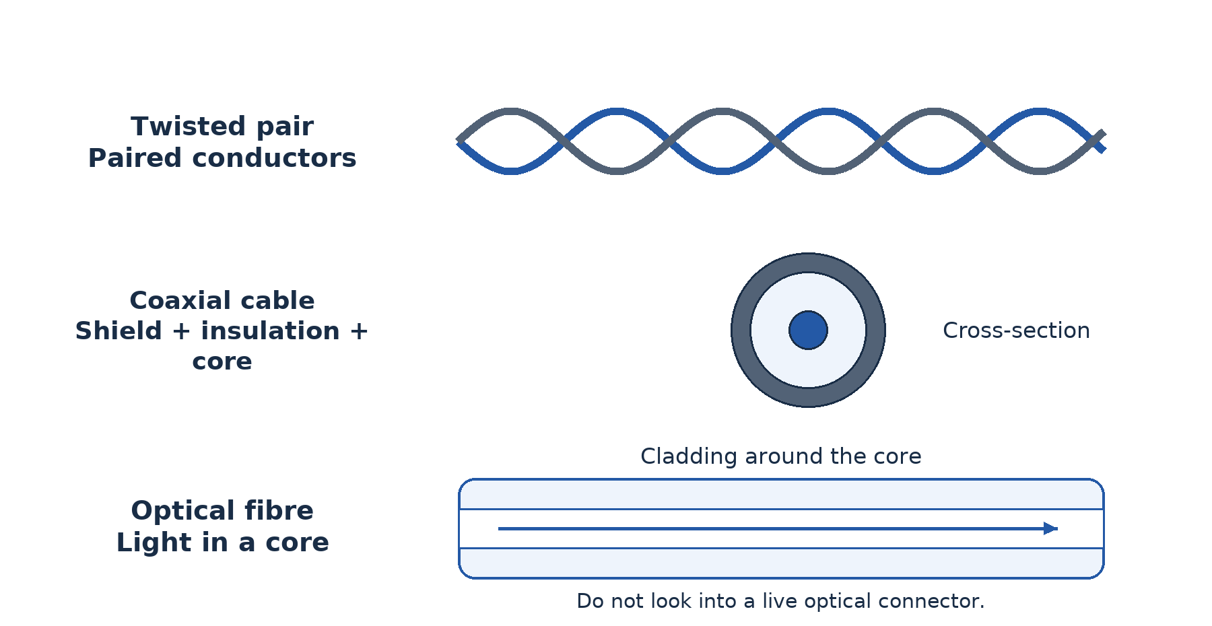
Figure 30.1 — Guided media differ in structure and signal type: paired electrical conductors, a shielded central conductor, and a light-carrying fibre.

30.2 Wireless options
Wi-Fi provides local wireless access using radio. It supports mobility and can reduce endpoint cabling, but coverage, interference, shared capacity and security configuration affect results. Walls and distance can reduce signal quality. An access point still commonly needs an upstream wired or other suitable connection.
Bluetooth is commonly used for short-range personal-device communication and some low-power applications. It is not simply a lower-cost replacement for every campus Wi-Fi network. Microwave point-to-point links can connect sites using directional radio equipment; line of sight, alignment, weather effects at relevant frequencies, licensing and local rules may matter. Infrared can serve short-range line-of-sight or reflected-light applications but is blocked by obstacles and is not suitable for every room layout.
Satellite communication uses a satellite relay to connect distant or difficult-to-reach locations. Coverage can be valuable where terrestrial services are unavailable. Equipment, subscription cost, unobstructed view and the particular satellite system's delay and capacity matter. Geostationary and lower-orbit systems have different characteristics, so avoid a single absolute claim about all satellite latency.

30.3 Choose for the actual route
Fixed computers within a room often suit wired Ethernet, while mobile learners or staff may need Wi-Fi. Between buildings 300 m apart, an ordinary single copper Ethernet run is not suitable under the common 100 m channel limit. Fibre or a correctly designed point-to-point wireless solution may be considered, with permissions, route, power, security and maintenance assessed.
Wireless is not automatically insecure and wired is not automatically secure. Wireless needs strong supported authentication and encryption, while cables and ports need physical protection and network access controls. A link's medium does not decide who is authorised to see an application record.

Worked example — Compare two inter-building options
Mboa's library is 300 m from the office. A protected fibre route offers stable high-capacity connectivity and electrical isolation but costs money to install and terminate. A directional wireless link may avoid trenching but requires appropriate mounting, line of sight, permissions, power and environmental assessment. A good recommendation states which site facts favour one option and what must be surveyed before purchase. It does not invent a guaranteed rate from distance alone.

Guided activity
Inspect safe cable samples or photographs and sketch their structure. Never cut or handle live cables. For a classroom, two campus buildings and a remote mobile worker, propose a medium and explain two reasons and one limitation. In a supervised lab, observe wireless signal changes at approved positions without disrupting other users or treating a signal-strength display as a complete performance test.

Check your understanding
1. Distinguish guided from unguided media and give two examples of each.
2. Explain two reasons fibre may suit an inter-building link and one installation drawback.
3. Why is a standard 300 m copper Ethernet channel a poor proposal for the example?
4. Compare Wi-Fi and Bluetooth by intended local use rather than only naming both as wireless.

Answer guidance
1. Guided signals follow a cable; unguided signals travel through space. Twisted pair/fibre and Wi-Fi/microwave are suitable examples.
2. Distance capability, capacity and electrical isolation can favour fibre; specialist installation and compatible optics add cost. Connect the reason to the route.
3. It exceeds the common 100 m channel limit for the specified ordinary copper Ethernet arrangement. A different engineered technology would need separate justification.
4. Wi-Fi commonly provides LAN access; Bluetooth commonly links nearby personal or low-power devices. Actual range and capacity depend on versions and conditions.

Lesson 31 — Peripheral device control mechanisms
Week 9 · Supplied progression: PDF page 5
Learning outcomes — supplied progression
• Explain the meaning and role of buffers, interrupts, interrupt priorities, polling and handshaking in controlling peripheral devices.
• Differentiate between the various techniques used to control communication between the computer and peripheral devices.
• Determine the technique used to control a device in a given network scenario.

The processor and the device work at different rates
A computer can prepare print data much faster than a printer produces paper. It can also perform other work while waiting for a key press. Peripheral control mechanisms coordinate these unequal speeds and notify the processor when attention is needed. They can operate together rather than being mutually exclusive alternatives.

31.1 Buffers
A buffer is a temporary storage area used while data moves between components with different rates or timing. A network interface may receive data into a buffer so the processor can handle it shortly afterwards. A printer buffer holds incoming data while the printing mechanism works. Buffering smooths short differences in rate; it cannot make a permanently slow device process unlimited data.
If incoming data continues faster than it can be removed, a buffer can fill. The system then needs flow control, waiting or another defined response. Buffer size and management affect performance and data loss. Spooling commonly stores queued jobs, often on secondary storage, so they can be processed later; it is related to temporary holding but is not simply another name for every small hardware buffer.

31.2 Polling and interrupts
With polling, the processor or controlling software checks a device's status repeatedly or at intervals. It might ask whether input is ready or a transfer has completed. Polling can be simple and predictable, but frequent checks can waste processing effort when nothing has changed. In some high-rate or specialised situations, carefully designed polling is useful, so “polling is always bad” is too simplistic.
An interrupt is a signal or event requesting processor attention. A device can indicate that data is ready or an operation has completed. The processor responds according to its architecture and current state, saves relevant context, runs an interrupt-handling routine and then resumes appropriate work. The exact hardware sequence varies, but the central idea is notification rather than repeatedly asking every idle device.
Interrupt priority determines which requests should receive attention first when several compete, subject to the system's rules. A time-sensitive event may need faster handling than a routine completion notice. Priority is not simply “the first device connected” or “the most expensive device”. Poor handling can delay other work, so interrupt routines are normally designed to do necessary immediate work efficiently.
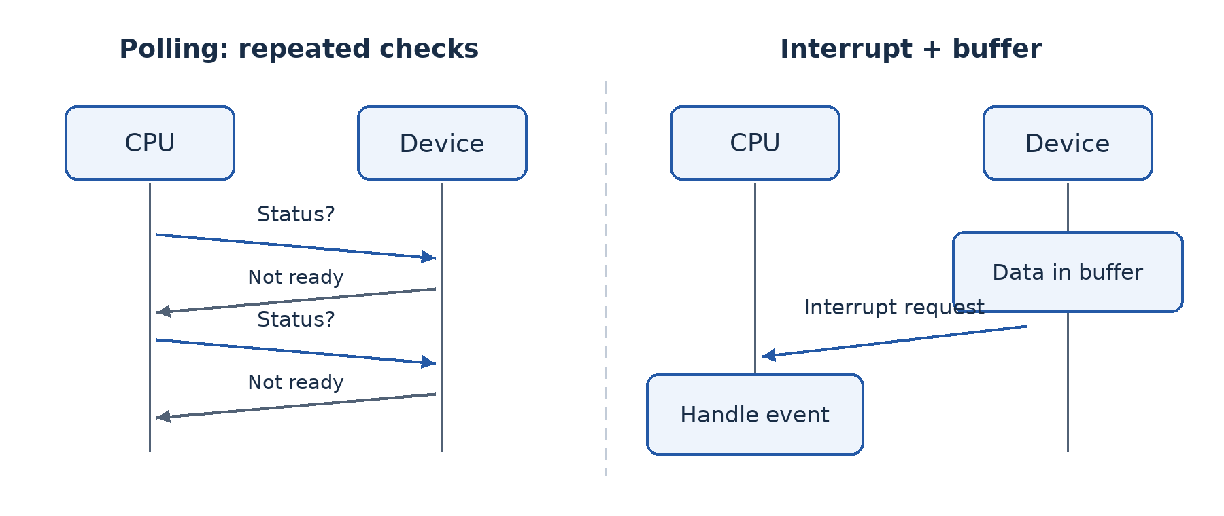
Figure 31.1 — Polling repeatedly checks status; an interrupt notifies the processor when attention is required. A buffer can hold the data while it awaits processing.

31.3 Handshaking and flow control
Handshaking is an exchange of control information to coordinate communication. A sender may indicate that data is ready, and a receiver may indicate readiness or acknowledge receipt according to the method. Hardware signals or protocol messages can provide this coordination. Its purpose is to agree conditions or control progress, not necessarily to authenticate a human user.
A device may therefore use a buffer to hold data, an interrupt to request processing and handshaking or flow control to avoid overrun. These terms describe different functions. In a network scenario, an interface can buffer received data, notify the processor and cooperate with protocol rules that regulate sending. Do not force the entire scenario into only one category when several mechanisms are described.

Worked example — Identify the evidence
“The processor checks the printer's status every few milliseconds” describes polling. “The interface signals that a receive buffer has data” describes an interrupt plus buffering. “The receiver tells the sender to wait until space is available” describes handshaking or flow-control coordination. The key is the action performed, not the device's name.

Guided activity
Use one learner as processor, two as devices and cards as buffer slots. First let the processor ask each device repeatedly. Repeat with devices raising a request card only when data is ready. Add a priority rule and show how it changes the response order. Finally let a receiver display “ready” or “wait” to model coordination. Explain which parts of the analogy correspond to storage, notification and control.

Check your understanding
1. Explain why buffering helps a fast sender communicate with a slower device, and why it has limits.
2. Compare polling and interrupts by who initiates the status exchange and how processing time is used.
3. What does interrupt priority control?
4. Can buffering and interrupts be used together? Explain with a network-interface example.

Answer guidance
1. Temporary storage absorbs short timing differences, but a finite buffer fills if the long-term input rate exceeds the removal rate.
2. Polling repeatedly asks for status; an interrupt requests attention when an event occurs. Either still requires actual data handling.
3. It helps determine service order for competing requests under system rules. It is not a measure of stored data size.
4. Yes. The interface can store received data in a buffer and interrupt the processor to arrange handling. The mechanisms solve different parts of the problem.

Lesson 32 — Network protocols and their roles
Week 9 · Supplied progression: PDF page 5
Learning outcomes — supplied progression
• Explain the meaning and role of network protocols in data transmission.
• Discuss the functions of protocols (e.g., IP, TCP, HTTP…) in communication.
• Evaluate how TCP/IP and other protocols facilitate reliable and efficient data transmission.

Common rules make communication meaningful
Two people speaking different languages may hear each other without understanding. Likewise, a signal reaching another computer is not enough: devices must agree on addressing, message structure, meaning, timing and error handling. A network protocol is a set of rules governing communication between network entities.

32.1 IP, TCP and UDP
Internet Protocol (IP) provides addressing and packet delivery across interconnected networks. Routers examine destination addressing and choose appropriate next steps according to routing information. IP offers a best-effort service; it does not itself guarantee that every packet arrives once, in order or within a deadline.
Transmission Control Protocol (TCP) provides a reliable, ordered byte-stream service between applications over IP. It establishes a connection, uses sequence information and acknowledgements to track delivery, retransmits when required and manages flow and congestion. The receiver can put received data into order and avoid presenting duplicate bytes to the application. TCP does not automatically encrypt data or guarantee a particular response time.
User Datagram Protocol (UDP) sends datagrams with relatively little transport-layer control. It does not itself establish the same connection state or provide TCP-style ordered reliable delivery. This can suit applications where timeliness matters and the application manages its own needs. It is not correct to say every UDP application is unreliable in the broad sense: an application can add reliability mechanisms on top. Likewise, UDP is not automatically the fastest choice in every workload.

32.2 Application and support protocols
HTTP defines requests and responses for web resources. HTTPS uses protected web communication with appropriate cryptographic transport protection and server authentication. HTTP/1.1 and HTTP/2 commonly use TCP; HTTP/3 uses QUIC over UDP. The last detail is useful context, not a demand to learn advanced QUIC internals in this lesson.
Domain Name System (DNS) resolves names to relevant records, including addresses. A user can type a memorable host name rather than manually maintaining its current address. Dynamic Host Configuration Protocol (DHCP) can assign hosts IP configuration such as an address, subnet information and gateway details. DNS finds information about names; DHCP supplies configuration. Confusing them makes troubleshooting difficult.
SMTP transfers outgoing e-mail between relevant systems; IMAP commonly lets a client access and synchronise mailbox content. FTP is a traditional file-transfer protocol whose basic form does not protect credentials or content. Use approved secure transfer methods for real sensitive work; SFTP is a different protocol operating over SSH, not merely an encrypted mode of FTP. ICMP carries IP-related control and diagnostic messages; tools such as ping use selected ICMP messages.

32.3 Why a suite is needed
No single protocol does everything. When opening a web page, a device may first obtain configuration, resolve a name, establish protected transport and exchange a web request. Each step addresses a different requirement. TCP/IP names a family or suite of cooperating protocols, not just two magic rules that replace all others.
Efficiency and reliability require trade-offs. Acknowledgements and retransmissions add traffic but help recover from loss. Flow control protects a receiver from being overwhelmed; congestion control responds to network conditions. The application should use appropriate services for its task rather than demand that every lower layer independently repeat the same work.
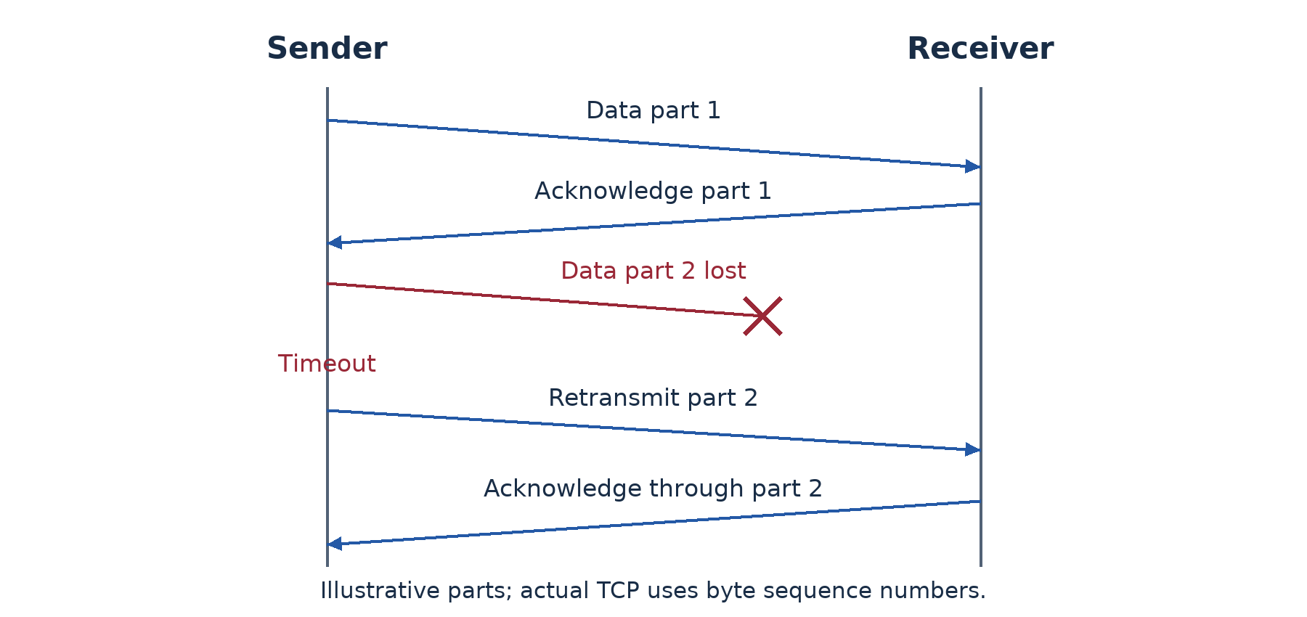
Figure 32.1 — Sequence information, acknowledgements and retransmission help TCP recover missing data. This simplified exchange omits connection setup and many implementation details.

Worked example — Find the role, not just the acronym
A computer has no valid local configuration, so first investigate addressing and DHCP or the approved static plan. If it reaches an address but a host name fails, DNS becomes a useful area to test. If the name resolves but a page fails, the web service, route, protected connection or access rules may be involved. These observations narrow possibilities; they do not prove a single cause without further testing.

Guided activity
Use a teacher-approved network to inspect configuration and resolve an approved host using the available system tools, such as ipconfig and nslookup. Record the role tested and avoid scanning other hosts. Without connectivity, arrange cards for address configuration, name resolution, transport and web request, explaining the protocol function at each stage.

Check your understanding
1. Explain how IP and TCP contribute different functions to reliable application communication.
2. Distinguish DNS from DHCP.
3. Compare TCP and UDP using an appropriate application requirement.
4. Why does using TCP not automatically make a connection confidential?

Answer guidance
1. IP handles addressing and best-effort packet forwarding; TCP supplies ordered stream delivery with detection and recovery mechanisms above IP.
2. DNS resolves names to records; DHCP supplies host configuration. Explain the different questions answered.
3. TCP's ordered reliable stream suits complete file delivery; a time-sensitive application may use UDP with appropriate application-level handling. Avoid claiming a universal speed rule.
4. TCP reliability concerns delivery, not secrecy. Appropriate encryption and authentication, such as protected web transport, are separate requirements.

Lesson 33 — Protocol suites and the OSI reference model
Week 9 · Supplied progression: PDF page 5
Learning outcomes — supplied progression
• Explain the role of protocol suites in network communication.
• Describe the seven layers of the OSI reference model and their functions.
• Relate network protocols to the appropriate layers of the OSI reference model.

Why use layers?
Sending a document involves application meaning, data representation, delivery between applications, routing, local links and physical signals. A layered model separates these responsibilities so they can be discussed and designed systematically. A protocol suite is a set of cooperating protocols. A reference model is a conceptual framework; it is not itself a cable, a software product or a guarantee that every real protocol fits one neat box.

33.1 The seven OSI layers
The Open Systems Interconnection (OSI) model has seven layers. Read from the user-facing end downwards when explaining how data is prepared for sending.
Layer 7, Application, provides communication functions used by applications. HTTP, SMTP and DNS are commonly mapped here. This does not mean the entire word processor or browser interface is the layer; the model concerns communication services and protocols.
Layer 6, Presentation, concerns representation such as encoding, format conversion, compression and aspects of encryption. Systems must agree how received bits represent meaningful data. Layer 5, Session, concerns establishing, managing and ending logical communication sessions and coordinating an ongoing dialogue. In many practical Internet applications these responsibilities are handled within application protocols and libraries rather than separate visible OSI programs.
Layer 4, Transport, provides end-to-end transport services between applications, including segmentation and reassembly as appropriate. TCP and UDP are commonly mapped here. Port numbers help identify application endpoints. Layer 3, Network, handles logical addressing and routing between networks; IP is the central Internet example. Routers principally operate on this forwarding responsibility.
Layer 2, Data Link, concerns frames and local-link delivery, including MAC addressing and media-access functions as appropriate. Ethernet and Wi-Fi include link-layer functions, and switches commonly forward at this level. Layer 1, Physical, concerns sending physical signals through the medium: electrical, optical or radio characteristics, interfaces and bit transmission. Ethernet and Wi-Fi standards include physical as well as link-layer specifications.
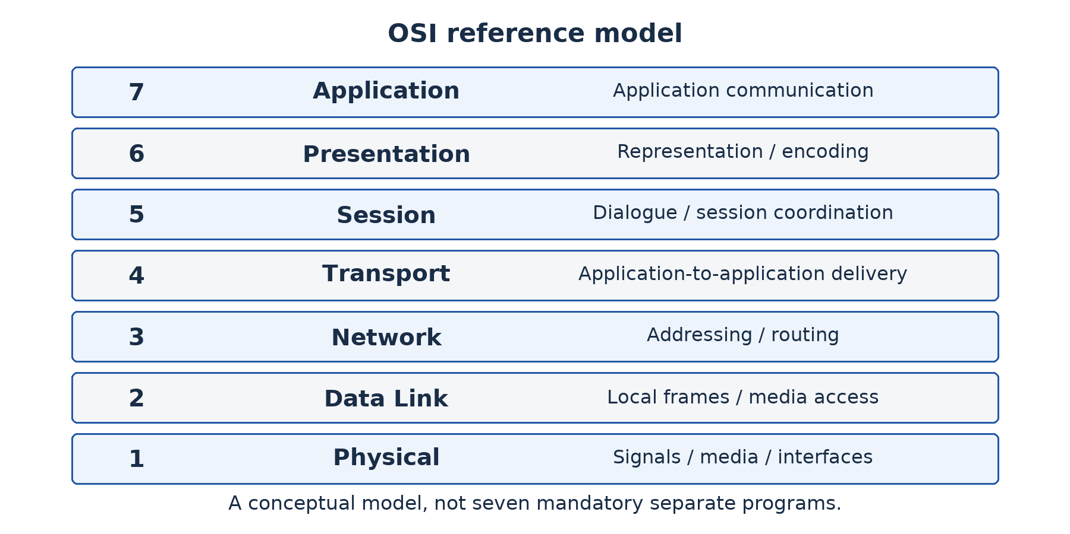
Figure 33.1 — The seven OSI layers organise communication responsibilities. Real Internet implementations commonly combine some of the upper-layer functions.

33.2 Encapsulation and decapsulation
Encapsulation adds the relevant control information as data passes towards lower-layer transmission. An application's data may be carried within a TCP segment, which is carried within an IP packet, which is carried within a local-link frame and transmitted as signals. Each enclosing unit supports a different part of delivery.
At the receiving end, decapsulation interprets and removes the appropriate enclosing information so that data reaches the intended application. A router forwards based on network-layer information and uses appropriate link framing on each hop; the same physical frame does not necessarily travel unchanged across the entire Internet.
The common protocol data unit names are data at the upper layers, segment for TCP or datagram for UDP, packet for IP, frame for the link and bits/signals for physical transmission. Terminology can vary by protocol; learn the role rather than forcing every transport unit to be called a TCP segment.
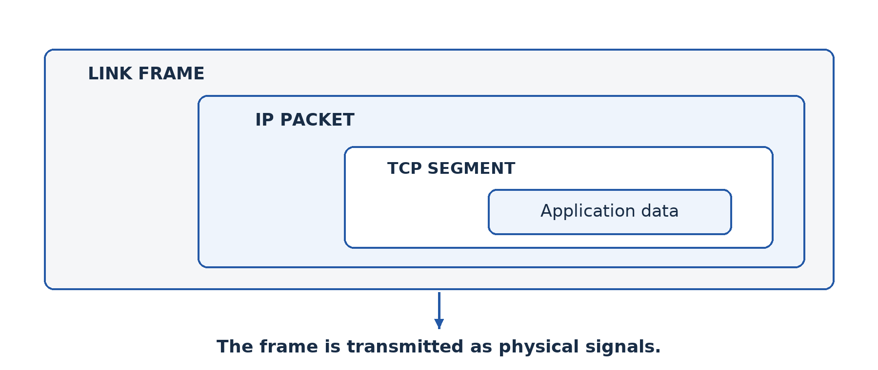
Figure 33.2 — Encapsulation places application data inside transport, network and link information. Receiving reverses the process for the destination application.

33.3 OSI and TCP/IP
A common four-layer TCP/IP teaching model groups responsibilities into application, transport, Internet and link. Its application layer covers much of OSI Layers 5–7; transport broadly corresponds to Layer 4; Internet to Layer 3; and link to Layers 1–2. Some textbooks use a five-layer form that separates physical and data-link responsibilities. These are modelling choices, not evidence that one network secretly has two different numbers of physical layers.
Mappings are useful approximations. TLS, for example, sits between application use and transport in common implementations and is often discussed with presentation-related protection. ARP operates at the link/Internet boundary for local address resolution. Recognising such boundaries is more accurate than insisting every real protocol has an undisputed single OSI label.

Worked example — Use the model to investigate
A computer shows no physical link: examine Layer 1 concerns such as cable, interface and power. It has a link but no appropriate address: investigate configuration and network-layer reachability. It reaches a server address but cannot resolve its name: inspect the application-support DNS service and configuration. The model guides questions; real faults can involve several layers, so use evidence rather than announcing a layer as the final diagnosis.

Guided activity
Draw the seven-layer model and place cards for HTTP, DNS, TCP, UDP, IP, Ethernet MAC and an optical signal at appropriate positions. Then explain a document transfer down one stack and up another. With approved lab access, identify one physical observation, one IP configuration observation and one application-service test. Never treat a memorised layer mnemonic as a substitute for explaining functions.

Check your understanding
1. State the seven OSI layers in order and explain the function of each.
2. Explain encapsulation using data, segment, packet and frame.
3. Map HTTP, TCP, IP and Ethernet MAC to their usual OSI layers.
4. Why is OSI called a reference model rather than the literal software architecture of every Internet device?

Answer guidance
1. Use the sequence Application, Presentation, Session, Transport, Network, Data Link, Physical, or its correct reverse. Functions matter as well as names.
2. Application data is carried within transport control information, then IP information, then local-link framing. The receiver interprets the appropriate enclosing information in reverse.
3. HTTP: 7; TCP: 4; IP: 3; Ethernet MAC: 2. Explain the responsibility rather than giving numbers alone.
4. It is a conceptual organisation of functions. Real suites combine functions and some protocols sit across conceptual boundaries.

Lesson 34 — Integration: Analyse a data-transmission problem
Week 9 · Supplied progression: PDF page 5 · Locally authored integration task

The situation
A fictional college links two buildings 300 m apart. The proposed plan uses one ordinary copper Ethernet channel for the full distance, says all modern Ethernet needs collision detection, calls Wi-Fi full-duplex because users can both upload and download, and claims a VPN will make a slow connection fast. Your team must review the plan before installation.

Required analysis
Identify and correct each unsupported claim. Explain the relevant distinction: medium and distance, shared versus switched full-duplex Ethernet, alternating versus simultaneous directions, and confidentiality versus capacity. Recommend at least two feasible inter-building options and explain which site facts must be checked before choosing.
Then trace a learner's web request using application, transport, network, link and physical responsibilities. Identify DNS, TCP or the relevant transport, IP and the local transmission medium at suitable points. Explain one role for buffering or interrupt notification in the receiving computer. Do not claim that the OSI model is itself installed as seven separate programs.

Evidence and demonstration
Submit a corrected annotated diagram and a short technical review. Use arrow cards to demonstrate duplex directions and nested envelopes to demonstrate encapsulation. If a teacher-approved lab is available, inspect a link, IP settings and one application service. Describe the test actually performed; do not infer an entire network's quality from one successful ping.
A peer group should challenge one recommendation by asking about cost, maintenance or failure. Revise the proposal to acknowledge a real trade-off rather than describing the selected medium as perfect. The integration scenario is locally authored to combine Lessons 27–33.

Assessment criteria — 20 marks
Use 8 marks for correcting the four misconceptions with reasons; 4 marks for a feasible media comparison; 4 marks for correct protocol/layer and peripheral-control explanations; and 4 marks for a labelled diagram, honest evidence and a defended revision. A correction earns more credit when it explains why the original claim fails.

Individual follow-up
Write a short answer to this question: “How can one network be a physical star, use full-duplex Ethernet links, carry serial digital transmission and support client/server services?” Explain what different question each description answers. If you can do so without treating the terms as competitors, you understand the main classifications in this part.

Evaluation 2 — Security and data transmission

Instructions
This locally authored Week 10 evaluation is placed before Lesson 35, following the supplied progression. Suggested conditions are 75 minutes and 50 marks. It covers Lessons 18–34 and assumes the earlier network foundations. It does not assess parity before parity has been taught.
1. Two lab computers have a physical link. Describe a safe sequence to configure and test a controlled shared folder. Distinguish connectivity from permission. [8]
2. Explain confidentiality, integrity and availability using a school records service. Give one suitable control for each. [9]
3. Contrast validation and verification. Explain a range check, a format check and independent double entry. [8]
4. Draw simplex, half-duplex and full-duplex signal directions. Explain why modern switched full-duplex Ethernet does not need CSMA/CD on each link. [7]
5. Compare suitable media for a 300 m inter-building connection and make a justified recommendation under stated assumptions. [6]
6. Explain the separate roles of DNS, IP and TCP in retrieving a web resource. [6]
7. Explain encapsulation and name the usual OSI layers for HTTP, TCP, IP and Ethernet MAC. [6]

Marking guidance
For Question 1, allow 2 marks each for authorised preparation and addressing, meaningful reachability testing, controlled sharing with suitable permissions, and an actual service/permission test without disabling security. For Question 2, use 3 marks per goal: accurate meaning, contextual harm and a matched control.
For Question 3, allow 2 marks for the contrast and 2 marks each for the three explained techniques. For Question 4, allow 1 mark per correct arrow diagram, 2 marks for describing the shared-half-duplex collision context and 2 marks for explaining its absence on separate full-duplex switch links. For Question 5, allow 2 marks per developed option and 2 marks for a conclusion tied to assumptions. For Question 6, allow 2 marks per protocol role. For Question 7, allow 2 marks for encapsulation and 1 mark per appropriate mapping.

Remediation 2
Sort wrong answers by cause: confused terminology, missing explanation, inaccurate diagram or unsupported recommendation. Redraw one failed diagram, perform or simulate one missing test, and rewrite one answer as “fact → consequence → justified choice”. Then attempt a fresh scenario. For example, replace the school records service with a clinic and choose controls again rather than merely memorising the previous wording.

Lesson 35 — Error detection and data-transfer checks
Week 10 · Supplied progression: PDF page 5
Learning outcomes — supplied progression
• Identify errors that may occur during data transmission.
• Describe data transfer checking mechanisms used to detect transmission errors.
• Explain parity checks as methods of error detection.

Detecting an error is not the same as correcting it
A sender transmits a binary message, but noise causes a receiver to interpret one bit incorrectly. A transmission error occurs when received data differs from what was sent. Detection mechanisms add or use information that helps recognise some errors. Recovery may then involve retransmission. No simple checking method should be described as proving that every possible error has been removed.

35.1 Types and causes of error
A single-bit error changes one bit. A burst error affects a sequence spanning multiple bit positions; not every bit inside that span must be changed. Interference, weak signals, damaged media and equipment faults can contribute to corrupted data. Packet-based communication can also suffer loss, duplication or reordering, which requires mechanisms beyond merely checking an individual bit's value.
A checking method has limitations determined by its design. It may detect some patterns but miss others. It is therefore important to distinguish “an error was not detected” from “the data is certainly correct”. Reliability usually combines checking, sequence information, acknowledgements and recovery rather than relying on one parity bit.

35.2 Parity step by step
A parity bit is added so that the total number of 1s in the protected group is even or odd according to the agreed rule. For even parity, choose the bit that makes the total count even. For odd parity, choose the bit that makes it odd. Sender and receiver must use the same convention and agree which bits are protected.
Take data 1011010. Count the 1s: positions 1, 3, 4 and 6 give four. Four is already even, so the even-parity bit is 0. Appending it on the right gives 10110100. For odd parity, append 1, giving 10110101, with five 1s. The parity bit does not mean “0 for correct” or “1 for wrong”; it enforces the chosen count.
Suppose the even-parity message becomes 10100100 after one bit changes. It now contains three 1s, so the receiver detects a parity failure. But if two data bits change and the received message is 11010100, it still contains four 1s. Even parity passes despite the altered data.
A single parity check detects any odd number of bit flips in the protected group, including a parity-bit flip, but it can miss even numbers of flips. It does not identify which bit is wrong and generally cannot correct the message by itself. A passed parity test is limited evidence, not proof of correctness.
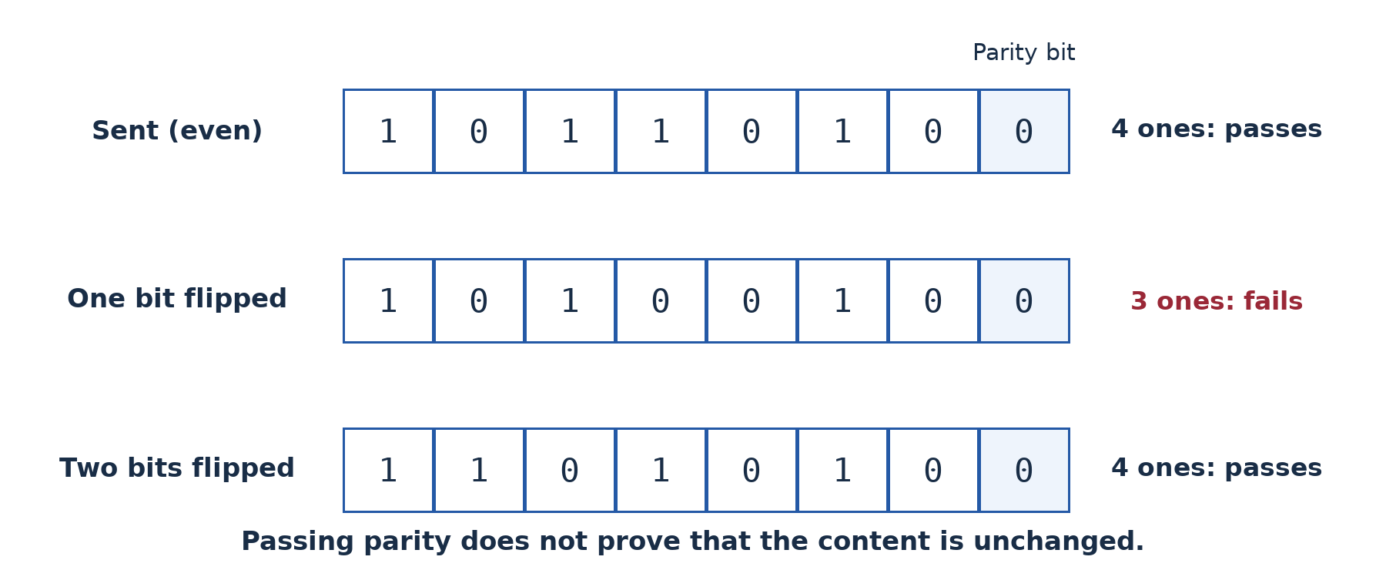
Figure 35.1 — Count all protected 1s, including the parity bit. One changed bit breaks parity; two changed bits can preserve it and escape detection.

35.3 Other checking and recovery methods
A checksum is a calculated summary transmitted with data and recomputed by the receiver. A simple classroom illustration adds byte values modulo a fixed range. If data values 12, 25 and 7 give a sum of 44, a changed value may produce a mismatch. However, changing them to 13, 24 and 7 still gives 44, demonstrating why a simple sum can miss compensating changes. Real checksum algorithms have defined rules and different strengths.
A cyclic redundancy check (CRC) uses a specified binary calculation to produce check information. Appropriate CRCs detect many important error patterns, including specified classes of burst errors. CRCs are widely useful for accidental corruption but are not cryptographic authentication: a deliberate attacker may be able to alter data and recompute an unprotected CRC.
An echo check returns received data for comparison with the original. It adds traffic and relies on the return process; it is not universal proof against every possible corruption. Automatic repeat request (ARQ) combines checking with feedback, timeouts and retransmission. A sender resends when an expected acknowledgement is missing or the receiver reports failure, according to the protocol. Sequence numbers help distinguish a repeated transmission from new data.

Worked example — Solve and interpret
For 1001001, there are three 1s. The even-parity bit is 1, giving four in total; the odd-parity bit is 0, leaving three. If a receiver reports a parity mismatch, request retransmission under the agreed recovery method. Do not “correct the last bit” simply because the last bit is parity: the error could be elsewhere.

Guided activity
Write five seven-bit messages and calculate both parity bits. A partner secretly flips one or two bits in selected protected groups. Check parity, then compare with the original to identify cases the check missed. Next role-play acknowledgement loss: the sender times out and resends, so the receiver needs sequence information to avoid treating duplicate data as new. No computer or real network traffic is required.

Check your understanding
1. Explain single-bit and burst errors and distinguish detection from correction.
2. Find even- and odd-parity bits for 1001001 and 1111000.
3. Why can two flipped bits escape a simple parity check?
4. Explain how a checksum or CRC differs from retransmission under ARQ.

Answer guidance
1. A single-bit error changes one bit; a burst spans a sequence of affected positions. Detecting a mismatch does not determine the correct original data.
2. 1001001 has three 1s: even bit 1, odd bit 0. 1111000 has four: even bit 0, odd bit 1. State the convention and count before answering.
3. Two flips preserve the odd/even count, even though the content may change. The receiver therefore sees a valid parity relationship.
4. A checksum or CRC supplies evidence of corruption according to its algorithm. ARQ uses feedback and timing to arrange another transmission; it is a recovery procedure, not simply another name for a check value.

Part 5 — Using the Internet to communicate and collaborate

Lesson 36 — History and development of the Internet
Week 10 · Supplied progression: PDF page 5
Learning outcomes — supplied progression
• Define the Internet and explain its purpose.
• Recall major events in the history of the Internet.
• Explain factors that led to growth of the internet.
• Explain advantages and disadvantages of the internet.

The Internet is not the same as the Web
A learner says, “The Internet was invented when websites appeared.” Websites made Internet use more visible, but network communication existed earlier. The Internet is a global interconnection of networks using the Internet protocol suite to exchange data. The World Wide Web is one service operating over that infrastructure, using linked resources commonly accessed through browsers.

36.1 Purpose and operation
The Internet allows devices on different networks to exchange information and use remote services. A user's local network connects through providers and other networks; routers forward packets towards their destinations. No single company owns the entire Internet. Many organisations operate parts and cooperate through standards and interconnection arrangements.
The Web, e-mail, messaging, file transfer and voice communication can all use Internet connectivity. A browser is an application used to access web content; a search engine is a service that helps find content. These are not synonyms for the Internet itself. A local intranet can use web technology without global connectivity, reinforcing the distinction between a service and its underlying extent.

36.2 Important historical steps
In 1969, ARPANET connected early research sites and helped demonstrate packet-switched networking. Packet switching divides communication into units that can be forwarded through a shared network rather than reserving one exclusive circuit for the whole conversation. The Internet grew from several lines of research and collaboration; it did not appear as one person's single finished invention.
During the 1970s, work associated with Vint Cerf, Bob Kahn and others developed the foundations of TCP/IP internetworking. In 1983, ARPANET's transition to TCP/IP became a major milestone. The Domain Name System developed during the 1980s to support a scalable naming system. Research and education networks helped extend connectivity.
In 1989, Tim Berners-Lee proposed the Web at CERN. Web technologies and early software became publicly available in the early 1990s, and graphical browsers helped popularise use. Commercial services expanded during the 1990s. Later broadband, mobile networks, Wi-Fi, smartphones, improved fibre infrastructure and online services widened everyday access. These are growth stages, not a reason to replace the Internet's history with a list of social-media launches.

36.3 Why use expanded
Shared protocols let diverse devices and networks communicate, reducing the need for every organisation to build an isolated incompatible system. Better physical infrastructure and cheaper computing made access more practical. Useful content and services created demand: research, commerce, communication, education and entertainment gave people reasons to connect.
Mobile devices reduced dependence on a desktop computer and a fixed office line. Yet access remains uneven. Price, electricity, local coverage, language, disability access and digital skills affect whether a nominally connected person can benefit. This digital divide concerns effective access and participation, not only the presence of a mobile signal.
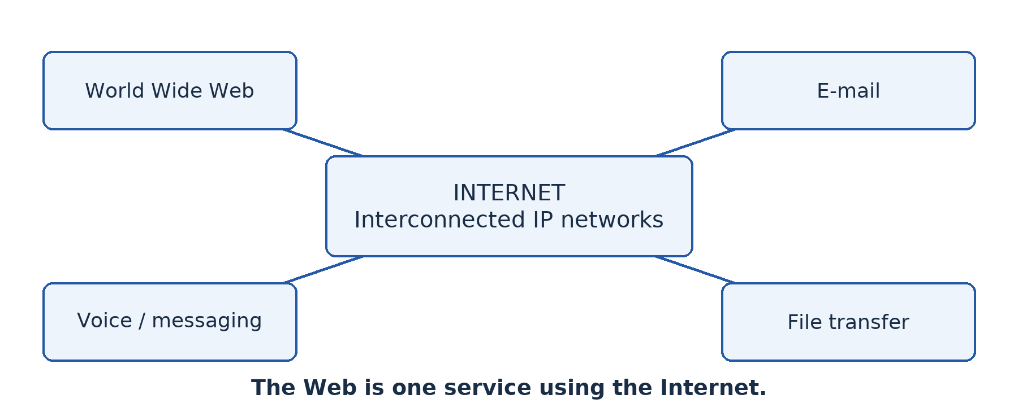
Figure 36.1 — The Internet carries several services. The Web is one of them, not the name of the entire infrastructure.

36.4 Advantages and disadvantages
The Internet can reduce communication delay, widen access to learning materials, support remote work and connect buyers with sellers. A learner can consult several sources rather than rely on one available textbook. A small business can reach distant customers, subject to logistics and trust.
Risks include misinformation, fraud, privacy loss, harassment, malware, distraction and dependence on external services. A message spreading quickly is not evidence that it is true. A service interruption can disrupt work, and requiring online-only procedures can exclude people without affordable access. Evaluate each benefit alongside its conditions and possible harms.

Worked example — Explain social impact
An online learning service lets a rural learner access a recorded explanation outside school hours. The benefit arises because distance and scheduling barriers are reduced. If data is expensive or the material lacks accessible text, the same service can exclude that learner. A balanced evaluation suggests downloadable low-data resources, school access points or printed alternatives rather than declaring the Internet entirely beneficial or entirely harmful.

Guided activity
Create a five-event timeline distinguishing networking milestones from Web milestones. Then choose education, business or family communication and write one developed benefit, one risk and one practical response. Without Internet access, use teacher-provided source cards. With access, compare a historical claim against a reliable source and record its publication context.

Check your understanding
1. Define the Internet and distinguish it from the Web.
2. Explain the importance of packet switching and TCP/IP in the history of interconnected networks.
3. Give three factors that encouraged growth and explain how each helped.
4. Evaluate one Internet application for a community with intermittent power and costly mobile data.

Answer guidance
1. The Internet interconnects networks using shared protocols; the Web provides linked resources over that infrastructure. E-mail supplies a useful non-Web example.
2. Packet switching supports shared forwarding of data units; TCP/IP supports communication across different networks. Neither is just another name for a browser.
3. Appropriate infrastructure, lower device costs, useful services and interoperable standards all help when the causal connection is explained.
4. Discuss the application benefit, actual access constraints and a realistic alternative or mitigation. Do not assume a service is inclusive merely because it is online.

Lesson 37 — Internet connectivity technologies and requirements
Week 11 · Supplied progression: PDF page 5
Learning outcomes — supplied progression
• Identify the technologies used to connect computers and networks to the Internet.
• Describe the role of devices in providing Internet connectivity.
• Use core features of a browser.

The connection has several parts
The school buys a Wi-Fi router but has no Internet service. Learners can connect to the wireless network yet cannot open external sites. The local access device is working in one role; the external path is missing. Internet connectivity needs a suitable access service, compatible equipment, correct configuration and an application capable of using the service.

37.1 Connection technologies
Dial-up uses a modem and a telephone connection, historically offering low data rates and often occupying the phone line. It is mainly useful here as a historical comparison. Digital subscriber line (DSL) carries data over suitable telephone copper using compatible provider equipment. Capacity depends on the service and line conditions, including distance to relevant equipment.
Cable broadband uses a provider's cable network with appropriate access equipment and shared capacity. Fibre access brings optical connectivity to a location or nearby distribution point; an ONT and compatible gateway equipment commonly provide the customer connection. Actual service rates, installation requirements and local availability must be checked.
Mobile data uses a cellular service through a phone, cellular router or other compatible device. A SIM or equivalent subscription identity, coverage and a suitable data plan are typically required. Tethering can share a phone's connection with a laptop, subject to policy, capacity and data cost. Mobile signal bars alone do not establish dependable throughput.
Fixed wireless and satellite can serve places where wired access is difficult. The precise system determines antenna placement, coverage, capacity, delay and cost. Choose after checking the actual location rather than assuming an entire town or rural area has the same service quality.

37.2 Device roles and configuration
A host needs an appropriate network interface. A local switch or access point connects it to the LAN. A router or gateway forwards external traffic; compatible modem, ONT or other provider-access equipment connects to the access service. The host needs an address, suitable subnet information, a gateway for remote networks and usually DNS configuration for host-name use. DHCP can provide much of this automatically.
The Internet service provider (ISP) supplies access under an agreed service plan. Compare installation, recurring cost, data allowance, upload and download capacity, delay, reliability, support and coverage. A fast connection at a provider's office does not prove performance at the school's site. Essential local services should be planned to survive an external outage where possible.
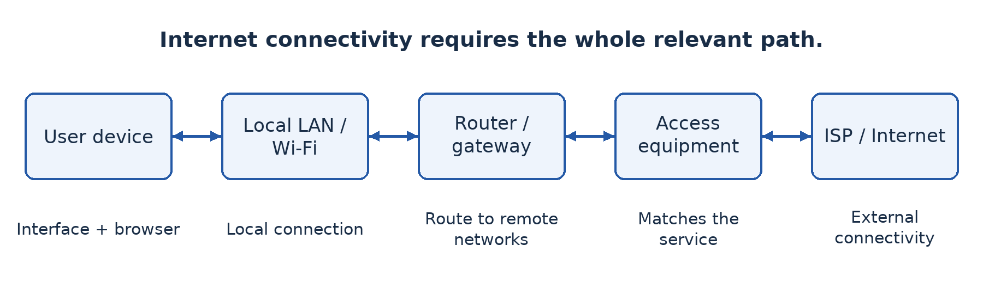
Figure 37.1 — The user's device, local network, gateway, access equipment and provider each have a role in Internet connectivity.

37.3 Use core browser features
A web browser retrieves and displays web resources. The address bar accepts a URL or search query; distinguish it from a search field embedded in a page. Tabs hold multiple pages, while back, forward and reload control navigation. A bookmark stores a useful location. History records browsing activity according to settings; a download manager tracks files saved from the Web.
Privacy and security controls include site permissions, cookie controls, certificate information, password-management settings and handling of suspicious downloads. Extensions add functionality but may request sensitive permissions, so install only approved ones. Private-browsing mode generally limits some local session storage; it does not make activity invisible to every website, employer, school network or provider.
A secure-connection indicator supports that the connection is protected and associated with the validated host under the browser's checks. It does not prove that the site's claims or business are honest. Read the actual domain and evaluate the source. Keep the browser updated and do not ignore certificate warnings simply to complete a task.

Worked example — Separate access from application failure
If a laptop reaches a local file server but no external site, the local network may be functioning while the provider route, gateway or external configuration fails. If one site alone fails, it is premature to declare that the entire Internet connection is down. Compare a small set of teacher-approved tests and inspect configuration before drawing a conclusion.

Guided practical
Open a teacher-approved local page or safe external page. Identify its address, open a second tab, follow a link, return, reload, bookmark the original page and locate the bookmark. Inspect site permissions and clear only the test site's data if instructed. Save a permitted document and locate the file afterwards. With no connection, perform the navigation tasks on the supplied offline HTML example; external-service testing remains separate.

Check your understanding
1. Explain why joining Wi-Fi does not prove that Internet access is available.
2. Compare fibre, mobile data and satellite for a specified school site using availability, cost and performance needs.
3. Explain the different roles of a browser, a search engine and an ISP.
4. What does private-browsing mode fail to guarantee?

Answer guidance
1. Wi-Fi may provide only local access; the provider service, gateway route or external configuration may be absent or faulty.
2. The answer must depend on surveyed availability and the school's needs. State assumptions rather than declaring one technology universally best.
3. A browser accesses resources, a search engine helps find information and an ISP supplies connectivity. One does not replace the others.
4. It does not provide universal anonymity or hide all network activity. Its main effects concern selected local browsing data and session handling.

Lesson 38 — Social networks and collaborative environments
Week 11 · Supplied progression: PDF page 6
Learning outcomes — supplied progression
• Define and identify examples of social media and collaborative environments.
• Describe the positive and negative impacts of social networks and Internet use in the community.
• Propose measures for the responsible and proper use of social media.
• Demonstrate how collaborative platforms can be used for communication, learning and teamwork.

Communication and collaboration overlap but differ
A class group exchanges short messages about homework. Another group jointly edits a project report, assigns tasks and reviews changes. Both communicate online, but the second has a structured shared-work process. Social media allows users to create, share and interact with content and communities. A collaborative environment provides tools for people to work together on shared tasks or resources.

38.1 Features and examples
Social platforms commonly offer profiles, posts, comments, groups, messaging, sharing and recommendation feeds. Examples include social-network services, discussion communities, video-sharing platforms and group-messaging tools. Their features and suitability change; choose according to the task and school policy rather than assume that popularity makes a service appropriate.
Collaborative tools can provide shared documents, calendars, task boards, version history, comments and controlled file storage. Examples include school-managed Google Workspace or Microsoft 365 environments, learning platforms and other approved shared editors. A messaging group may support teamwork, but message history alone may be poor at managing document versions or assigning responsibilities.

38.2 Positive and negative impacts
Social networks can distribute useful announcements, connect distant family members, help community organisations coordinate and let small businesses reach customers. Learners can exchange explanations and discover educational material. The value comes from the quality and purpose of interaction, not the quantity of messages.
Risks include misinformation, harassment, exposure of personal information, fraud, unwanted contact, distraction and exclusion. Recommendation systems may amplify engaging material whether or not it is accurate. A forwarded screenshot can lose its original date and context. Do not share another person's photograph, number or private message without appropriate permission.
Responsible use includes verifying claims before forwarding, using respectful language, setting suitable privacy controls, limiting unnecessary personal details and reporting abuse through approved routes. Block or report harmful contact rather than escalating a public argument. For threats or safeguarding concerns, involve a trusted adult or the school's designated support person. Avoid publicly reposting harmful material as a supposed warning.

38.3 Make collaborative work traceable
Start with a clear goal, roles, deadlines and a shared storage location. Set sharing rights deliberately: some members need editing, others only viewing or commenting. “Anyone with the link” may expose work more widely than intended. Test access with the actual intended accounts and remove unnecessary permission after the project.
Use comments to discuss a specific passage and suggestions or tracked changes when available to propose revisions. Version history helps inspect earlier states and recover selected changes, subject to the tool's capabilities. Agree file names and ownership so that the group does not create a confusing chain of “final-final” copies. A collaborative document still needs source acknowledgement and honest individual contribution.

Worked example — Repair a group's process
Four learners send separate report copies through a chat group. One corrects the introduction while another edits an older copy. Their problem is not lack of messages but poor version control. An approved shared document with named contributors, comment rules and a final reviewer can reduce conflicting copies. If connectivity is limited, assign offline sections and nominate one controlled merge process; do not pretend simultaneous online editing is always practical.

Guided practical
Using school-approved accounts, create a harmless group document with a title and task list. Share it only with named group members. Each learner contributes a paragraph, comments constructively on another paragraph and checks version history or an equivalent change log. Test a view-only account if available. Remove test access afterwards according to policy. Without accounts or connectivity, use a paper master document and coloured change slips, then complete the online procedure later.

Check your understanding
1. Distinguish social media from a collaborative environment and explain an area of overlap.
2. Explain two positive community effects and two risks of social networks.
3. Why can “anyone with the link can edit” be unsuitable for a school report?
4. Explain how comments, permissions and version history support different aspects of teamwork.

Answer guidance
1. Social media centres on content and interaction; collaborative environments support shared tasks and resources. A group can use both, but the functions differ.
2. Develop each effect through an example, such as rapid announcements or rapid false-rumour spread. Mere lists do not explain impact.
3. The link may be forwarded, allowing unintended readers or editors. Named access can better match the intended team and accountability needs.
4. Comments support discussion, permissions control actions and version history records or recovers changes. None alone replaces an agreed working process.

Lesson 39 — Internet services and information retrieval
Week 11 · Supplied progression: PDF page 6
Learning outcomes — supplied progression
• Describe the major services provided through the Internet.
• Create an e-mail account, attach a file to an e-mail and send it.
• Research information on a particular topic using retrieval services.

Choose the service that fits the job
The Internet carries many services. The Web supports linked pages and applications; e-mail supports addressed messages that need not be read immediately; instant messaging supports rapid exchanges; voice over IP (VoIP) carries voice over IP networks; and file-transfer services move files. Some cloud services provide storage and applications through remote systems. A browser may provide access to several services without making them all identical.

39.1 How e-mail works at a useful level
An e-mail account has an address, commonly in the form name@domain. A sender composes a message, and relevant mail servers accept, route and store it for the recipient. The recipient can use webmail or an e-mail client. SMTP is involved in sending and server transfer; IMAP commonly supports mailbox access and synchronisation. A message is not guaranteed to arrive or be read merely because the sender clicked Send.
The To field names principal recipients. Cc copies additional visible recipients. Bcc conceals listed recipients from the other recipients in the usual message display and can help avoid exposing a group's addresses. A subject describes the purpose; the body provides context; an attachment carries a separate file. Check the actual recipient and attachment before sending because a follow-up apology may not undo disclosure.

39.2 Guided practical — Create an account and send an attachment
The teacher must select an age-appropriate, school-approved service and explain privacy, recovery and school policy. Use a school-managed training account where available. Account creation may require the provider's eligibility and verification steps; do not bypass them, use false recovery details or collect learners' passwords. If the school creates accounts centrally, the learner should understand the process while using the assigned account for the practical.
1. Open the verified service address and choose account creation where authorised. Provide only required, approved information, create a strong unique password privately and configure recovery or multi-factor protection according to policy. Store recovery information through the approved method, not in a public notebook or screenshot.
2. Sign in and identify the inbox, sent folder and compose control. Create a small fictional report locally and confirm its filename and location. Avoid personal records or a file containing hidden sensitive information.
3. Compose a message to the teacher-designated recipient. Use a subject such as “Upper Sixth ICT — attachment practice”. Add a greeting, explain what is attached and sign with the approved classroom identifier.
4. Attach the intended file, wait for upload and check its name. Review the recipient and message before sending. Do not send to an invented real address; use only the teacher's confirmed recipient or paired test account.
5. Check the sent folder and any error notification. The recipient should confirm receipt and open the attachment safely. Record completion without exposing credentials or unrelated messages. Sign out on a shared computer and follow the school's local-data cleanup policy.
If no approved account can be created, practise composition with a paper or offline draft and label the sending component incomplete. An unsent draft is not evidence of delivery.

39.3 Retrieve information effectively
Begin with a focused question and useful keywords. “Network” is broad; “difference switch router school LAN” is more targeted. Quotation marks can search an exact phrase, and operators such as site: can restrict a search where the service supports them. Search features vary, so verify how the selected engine interprets an operator.
Evaluate authority, evidence, date, purpose and relevance. Prefer an original official document for an official requirement. An attractive page or top ranking is not proof of accuracy. Compare independent sources, distinguish advertisements from results and check whether a copied document still matches current requirements. Record the title, publisher, URL and access date so another person can locate what you used.

Worked example — A syllabus search
A learner needs the current school's first-term ICT objectives. A decade-old exam-preparation blog may explain useful ideas but cannot by itself establish this year's teaching sequence. The supplied current progression sheet is the primary source for that sequence. An official Board page can establish general examination information, while a mirrored older syllabus should be labelled with its age and source limitations. The answer matches the claim to an appropriate source.

Guided retrieval task
Research one teacher-approved question about network safety. Write a precise query, compare two sources, identify one claim each supports and explain which is stronger for your purpose. Do not copy whole pages. With no Internet, evaluate printed extracts that include publisher and date, then complete the search step when connected.

Check your understanding
1. Explain three Internet services and choose an appropriate task for each.
2. Describe the steps and evidence needed to send a safe attachment successfully.
3. Distinguish Cc from Bcc and give a privacy-related use for Bcc.
4. Explain why a high search ranking and a recent-looking page design are not sufficient evidence of reliability.

Answer guidance
1. Relate the service to its function: asynchronous message, shared web resource, live voice or file transfer. Do not treat a provider name as the definition.
2. Use an approved account and recipient, correct file, clear message, checked attachment and delivery evidence. A sent-folder entry alone does not prove it was read.
3. Cc recipients are normally visible; Bcc recipients are concealed from other recipients' usual view. It can avoid publishing a mailing list to everyone.
4. Ranking and design are influenced by factors other than truth. Assess the publisher, evidence, date of the actual material and suitability for the question.

Lesson 40 — Internet communication and teleworking
Week 11 · Supplied progression: PDF page 6
Learning outcomes — supplied progression
• Explain the concepts of teleworking, telecommuting and videoconferencing.
• Explain the use of URLs and cookies when accessing web services.
• Set up and use a teleconferencing platform for online communication.

Work is an activity, not always a location
Teleworking means doing work away from the usual workplace using ICT to communicate and access resources. Telecommuting is often used for working remotely instead of travelling to the normal workplace, particularly from home; usage overlaps with teleworking. Videoconferencing provides live audio and video communication among participants at different locations. It is one tool for remote work, not a complete remote-working system.

40.1 Opportunities and limits
Remote work can reduce commuting, widen access to expertise and support flexible arrangements. It requires suitable connectivity, equipment, access to work resources, clear communication and secure handling of information. Isolation, poor home conditions, interruptions, unequal access and blurred work boundaries can limit its benefits. Not every practical or customer-facing task can move online.
Videoconferencing can support a lesson, meeting or specialist consultation. Audio quality, upload capacity, delay, lighting and participant access affect usefulness. A telephone or audio-only connection may be more inclusive than insisting on video when data is expensive. Recording can help absent participants but requires appropriate permission and secure storage.

40.2 Understand URLs
A uniform resource locator (URL) identifies the location and access method of a resource. In the fictional example https://portal.mboa.example/learn/ict.html?term=1#tasks, https is the scheme, portal.mboa.example is the host, /learn/ict.html is the path, term=1 is a query component and tasks is a fragment identifying a location within the resource. The reserved .example domain makes clear that this is not a live school service.
Read host names carefully. In a name such as school.example.attacker.invalid, the appearance of “school” at the beginning does not make the host the school's real domain. Do not infer trust from a familiar word buried in a long URL. The protected-connection scheme also does not prove the site's business is honest. Obtain sensitive service addresses through independently trusted sources.
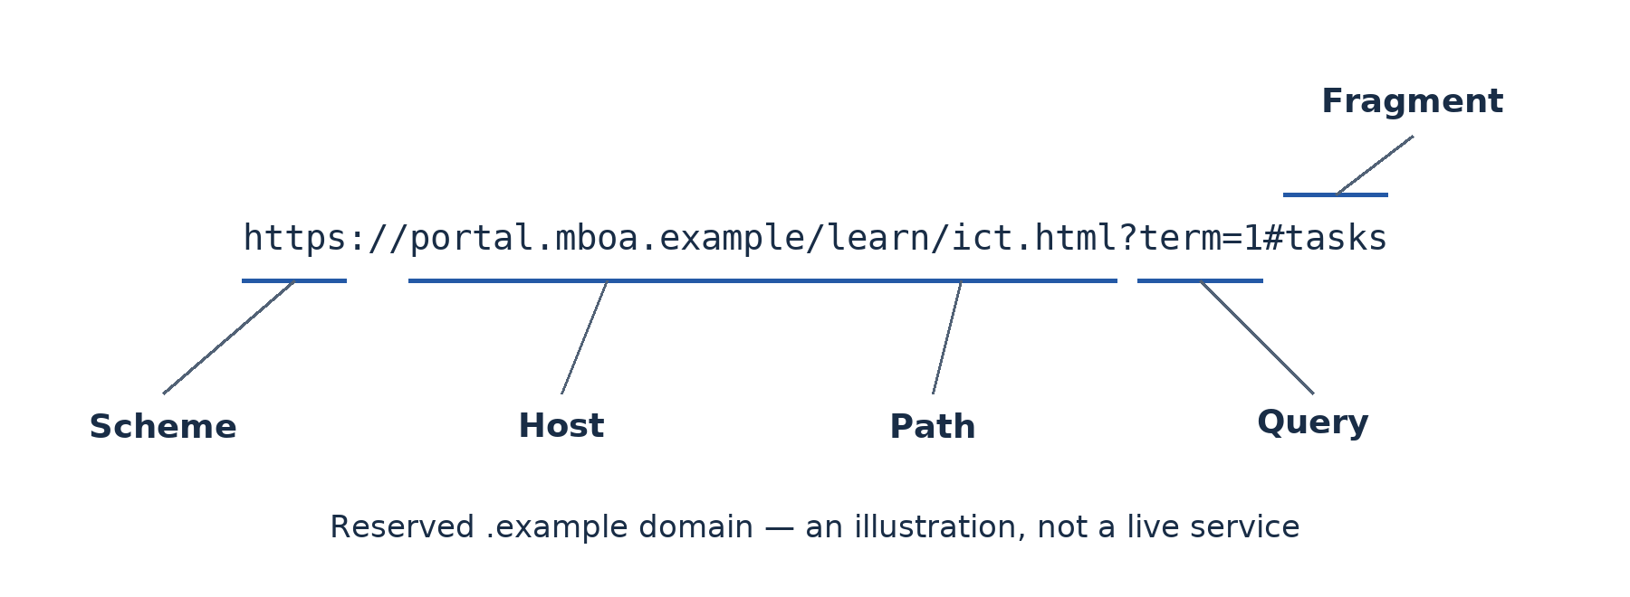
Figure 40.1 — A URL contains distinct components. This fictional address uses a reserved example domain and does not name a live school service.

40.3 Understand cookies
A cookie is a small item of state stored by a browser for a site according to applicable rules and settings. The browser can send relevant cookies with later requests so that the service can maintain a session, remember preferences or perform other functions. Because ordinary HTTP requests do not inherently remember all previous interactions, session state is useful for a logged-in service.
A cookie may contain a session identifier rather than the user's full details. Advertising or analytics uses can raise tracking and consent concerns, particularly across services. Cookies are not inherently executable viruses, and deleting them may sign a user out or remove preferences. Websites use other storage and identification methods too, so blocking cookies does not guarantee that no tracking occurs.
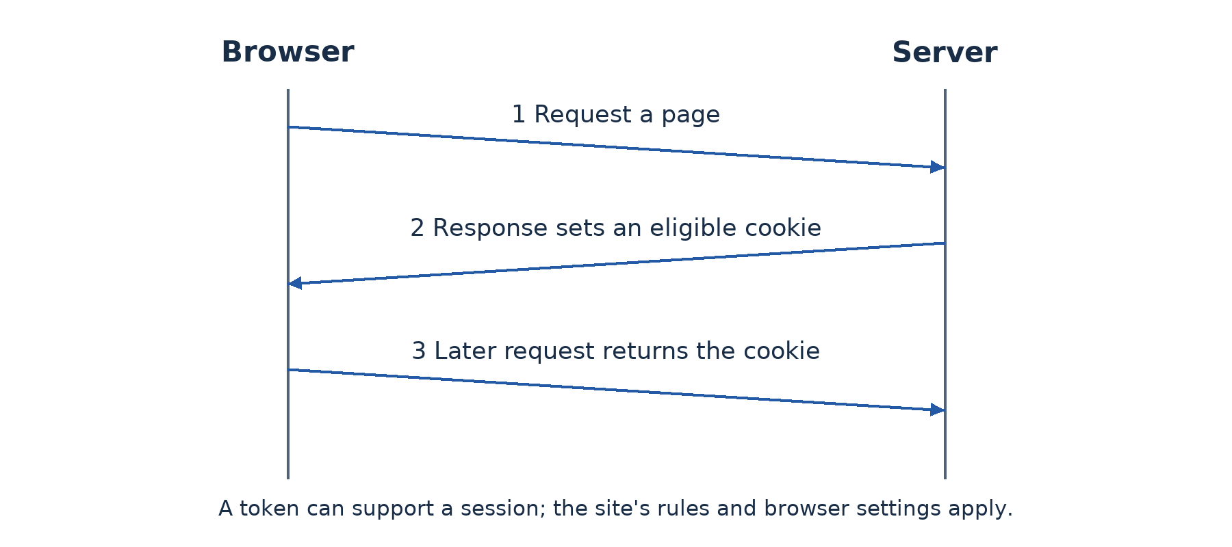
Figure 40.2 — A server can set a cookie, and the browser can return it on a later eligible request to support state such as a session.

40.4 Guided practical — Hold a controlled online meeting
Use an approved platform and teacher-managed accounts or guest access permitted by the service. The host creates a meeting, sets the time and agenda, and applies appropriate entry controls such as a passcode, waiting room or named invitations. Share the link only with intended participants and avoid publishing credentials in public groups.
Before joining, test microphone and camera permissions and use headphones if available to reduce feedback. Join with the approved identity, follow turn-taking rules and mute when not speaking. The host admits expected participants and limits screen sharing to the necessary people. Share only the selected application or document, not an entire desktop containing private information. Obtain permission before recording; if recording is unnecessary, leave it off.
Each learner should join, contribute a short statement and locate the leave control. A designated learner demonstrates screen sharing of a harmless slide under host control. At the end, the host ends the meeting for all participants, checks any saved files and removes temporary access as required. With no connection, role-play host and participant actions and complete the actual meeting later.

Worked example — Choose an inclusive meeting plan
A group has one stable connection and three expensive mobile connections. Send a short agenda and downloadable document beforehand, allow audio-only participation and provide a written action summary afterwards. This reduces data demand and excludes fewer people. A high-resolution video requirement might look impressive while making the meeting less useful.

Check your understanding
1. Explain teleworking, telecommuting and videoconferencing without treating them as identical terms.
2. Label the components of the fictional URL and explain why host-name checking matters.
3. Give two useful cookie functions and one privacy concern.
4. Describe four controls for a safe and inclusive classroom video meeting.

Answer guidance
1. Teleworking is remote work supported by ICT; telecommuting commonly emphasises replacing the journey to work; videoconferencing is a live communication tool used for many activities.
2. Identify scheme, host, path, query and fragment. A familiar word elsewhere in the address does not establish the actual host's identity.
3. Session continuity and preferences are useful; tracking can raise privacy concerns. Cookies are stored state, not automatically malicious programs.
4. Suitable entry controls, limited sharing, consent-based recording, private invitations and low-data alternatives are appropriate when their purpose is explained.

Lesson 41 — Integration: Connect, collaborate and communicate
Week 12 · Supplied progression: PDF page 6 · Locally authored integration task

The situation
Learners at the fictional school and a partner class in another town must prepare a joint report about safe Internet use. Connectivity is uneven, and a public chat link has already attracted an unexpected participant. Your group must organise the project with appropriate communication, source evaluation and access control.

Required work
Choose a communication plan that includes asynchronous work as well as a short live meeting if practical. Explain which Internet services support each task and why. Create an approved shared document with named access, a clear task list and a source section. Each learner contributes an explained point and reviews another member's work using comments or the platform's equivalent.
Find and evaluate two sources for a specific safety claim. Record enough publication information to locate them and explain why one is more authoritative for the claim. Send the completed permitted file to the teacher-designated recipient with a clear subject and correct attachment. Do not expose the group's addresses unnecessarily or send real personal records.
Set up a controlled meeting using the procedure from Lesson 40. Include an agenda, entry controls, limited screen sharing and an audio or offline alternative. Explain a fictional URL and a cookie-based session to demonstrate that the group understands how access differs from trust.

Evidence and equipment constraints
Submit the report, contribution or version evidence, an access-setting observation, source evaluation and the permitted e-mail or meeting completion evidence. Redact credentials, unrelated messages and personal details. If some online components cannot be performed, identify exactly what was simulated and arrange supervised completion rather than claiming a draft proves delivery.

Assessment criteria — 20 marks
Use 4 marks for suitable service and connectivity decisions; 6 marks for controlled collaboration and source evaluation; 6 marks for safe e-mail and meeting performance or later practical completion; and 4 marks for inclusive alternatives, honest evidence and individual explanation. These are local teaching criteria for the integration lesson.

Review guidance
A strong plan does not use a public editable link merely because it is easy. It addresses the unexpected participant by removing inappropriate access and reviewing sharing settings, not by publishing more personal information. Finish individually by explaining which project step would fail first during an Internet outage and how the group could continue useful work safely.

Part 6 — Digital services, learning and HTML

Lesson 42 — Electronic services: E-commerce, e-health and e-government
Week 12 · Supplied progression: PDF page 6
Learning outcomes — supplied progression
• Define some major electronic services (e-commerce, e-health and e-government).
• Describe some major electronic services.
• Explain the advantages and disadvantages of using electronic services.

A service is more than a page on a screen
A trader displays goods online, a clinic offers remote consultations and a public office lets users submit a form electronically. These are electronic services (e-services): services delivered or supported through electronic systems and communication networks. The important question is what useful service the user receives, not merely whether an organisation has a website.

42.1 E-commerce
E-commerce is buying and selling goods or services through electronic networks, together with the related ordering and transaction processes. A typical purchase involves finding a product, checking the seller and terms, placing an order, arranging payment, receiving confirmation, obtaining delivery and using after-sales support if needed. A digital catalogue without online ordering may support commerce without providing the whole transaction electronically.
Common relationships include business-to-consumer (B2C), such as a shop selling to an individual; business-to-business (B2B), such as a wholesaler supplying a retailer; and consumer-to-consumer (C2C), such as individuals trading through a marketplace. The relationship describes the participants, not a guarantee of trust or a particular payment method.
Benefits include reaching distant customers, comparing offers and reducing some travel. Risks include fraudulent sellers, misleading descriptions, exposed payment details, delivery failures and limited remedies. A protected connection is useful but does not establish the seller's honesty. Check independently verified contact details, total cost, delivery terms and return arrangements. Never make a real classroom purchase or disclose a personal payment code to demonstrate the process.
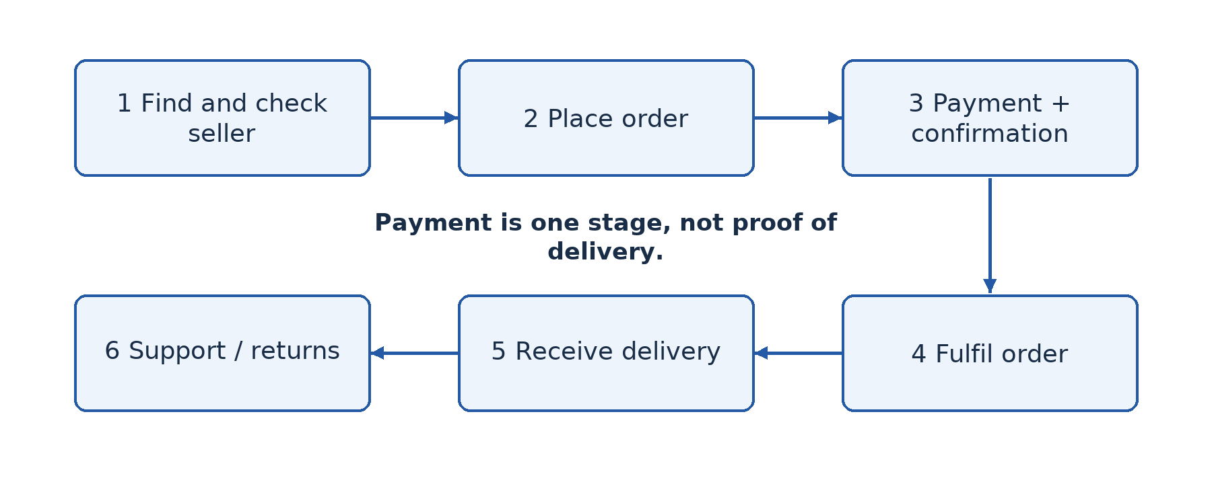
Figure 42.1 — An online purchase includes fulfilment and support as well as ordering and payment. A completed screen does not itself prove that goods arrived.

42.2 E-health
E-health uses ICT to support health services and health-related information. Examples include electronic records, appointment systems, digital public-health reporting and remote consultation. Telemedicine specifically concerns clinical services delivered at a distance, such as a clinician consulting another professional through a secure video link. A remote consultation does not automatically involve AI.
E-health can reduce travel and improve access to information or specialist support. It also raises confidentiality, accuracy, availability and inclusion concerns. Poor connectivity can interrupt a consultation, and some examinations require physical attendance. An online symptom page is not automatically qualified medical advice. Real treatment decisions belong with appropriately qualified professionals and approved services.

42.3 E-government
E-government is the use of ICT by public bodies to provide information, administration and services and support interaction with citizens or other organisations. Examples include access to public forms, electronic applications, tax-related services and examination administration. Some services only publish information; others support complete transactions. Do not assume that every stage of a public procedure can be completed online.
Benefits can include reduced travel, clearer status tracking and more convenient access. Limitations include unequal connectivity, complex forms, identity-verification requirements, language barriers, inaccessible design and service outages. An online-only process can shift costs to citizens rather than remove them. Assisted and offline channels may remain necessary.

42.4 Compare the three services
E-commerce primarily supports commercial exchange, e-health supports health needs and e-government supports public administration and services. All can use accounts, databases, secure communication and electronic forms. The consequences of error differ: an incorrect shopping item, a disclosed clinical record and an incorrectly processed public application create different harms. Select safeguards and user support accordingly.

Worked example — Follow the whole service
A fictional learner orders a textbook online. Finding the title is information retrieval; placing the order is part of e-commerce; a payment notification is evidence of one stage, not proof of delivery. If the book is not delivered, the learner needs a documented order and a support or refund route. The explanation follows the service outcome rather than treating a checkout button as the end of the process.

Guided activity
Use teacher-provided demonstration pages or a paper service flow. Follow a product enquiry, a fictional appointment request and a public-form search. Identify the user, requested information, processing, output and follow-up. Stop before submitting personal data, making payments or booking a real appointment. Compare which steps could work asynchronously and which might require immediate communication. Record the practical as a demonstration, not a real transaction.

Check your understanding
1. Define e-service, e-commerce, e-health and e-government with one accurate example each.
2. Explain why payment confirmation is not the same as successful delivery.
3. Give one developed benefit and one limitation for each of the three main services.
4. Why are telemedicine and AI-assisted diagnosis not synonyms?

Answer guidance
1. Link each definition to its purpose and service outcome. A product or institution name alone is not an explanation.
2. It concerns the payment stage. Fulfilment and delivery remain separate stages requiring their own evidence.
3. Connect convenience, access or efficiency to the particular users, then identify a realistic constraint and its consequence.
4. Telemedicine delivers clinical services at a distance; AI concerns intelligent processing such as pattern recognition. One can exist without the other.

Lesson 43 — Applications, benefits and challenges of electronic services
Week 12 · Supplied progression: PDF page 6
Learning outcomes — supplied progression
• Compare the applications of e-commerce, e-health and e-government in everyday life.
• Identify e-government platforms and explain their advantages and limits.
• Identify appropriate electronic services for solving common problems in the community.

Match the service to the community problem
A village committee wants a digital solution for three difficulties: travelling to obtain a public form, finding a specialist appointment and selling surplus produce. One application is unlikely to solve all three. Choose the appropriate service, then evaluate whether intended users can actually complete the task.

43.1 Compare applications in everyday life
For the public form, an official e-government information or application service is relevant. For a specialist appointment, an approved e-health booking or referral service fits. For produce sales, an e-commerce listing and ordering process may help, but transport, pricing and payment still need arrangements. The electronic interface does not remove the real-world service behind it.
Different stakeholders experience different benefits and costs. A citizen may save travel time but pay for data or assistance. A business may reach more customers but need to manage returns and delivery. A public body may reduce repeated data entry but must fund secure systems, staff training and accessible support. A balanced answer considers these perspectives instead of assuming that moving a form online eliminates all work.

43.2 Identify authentic public platforms
The Cameroon Direction Générale des Impôts (DGI) provides an official e-services directory at https://www.impots.cm/fr/e-services, listing tax-related services such as registration and declarations [S4]. This is an example to identify and inspect, not an instruction for learners to register as taxpayers or submit a declaration. Specific service labels and procedures can change.
The GCE Board's official site, https://camgceb.org/, provides examination information and public examination-related resources [S5]. It is another relevant public-service environment, but it should not be assumed that every candidate procedure is performed personally online or that this classroom exercise verifies a current registration process. Follow official school and Board instructions for real examination matters.
Obtain a service address from a trusted official source, inspect the actual host and read the purpose and publication information. A search advertisement, forwarded message or copied logo is insufficient evidence of authenticity. If a service redirects to another host, the teacher should verify that destination through official guidance before learners enter any information. Do not bypass certificate warnings or send identity documents to an unverified contact.

43.3 Evaluate usability and accessibility
Usability concerns whether intended users can complete tasks effectively and with reasonable effort. Look for clear navigation, understandable instructions, helpful errors, confirmation and support. Accessibility concerns use by people with varied abilities and assistive technologies. Text alternatives, keyboard access, readable structure and appropriate language support can make a practical difference.
Also consider low-bandwidth use, mobile screens and intermittent power. A large scanned form may be hard to download and unusable with a screen reader. A time-limited form may lose all progress during an interruption. An accessible downloadable alternative or an assisted service point can improve inclusion. Do not claim a complete accessibility audit from a quick classroom inspection; report the specific observations and their limits.

Worked example — Evaluate rather than praise
A public form can be downloaded without travelling to town, saving a journey for a connected user. However, if it requires a long high-quality scan upload and provides no clear error explanation, a user with costly mobile data may fail repeatedly. A reasoned recommendation suggests smaller accessible files, clear requirements, progress saving where appropriate and a supported alternative. “Online is faster” alone ignores the user's conditions.

Guided practical — Inspect, do not transact
The teacher verifies one official public-service page in advance or supplies a dated offline capture. State a harmless task such as locating instructions or a blank public form. Record the page title, host, date inspected and the steps used. Test keyboard navigation and mobile readability where equipment permits. Identify one strength, one observed barrier and one improvement tied to a user need. Do not create a real government account, submit personal data or make a payment.

Check your understanding
1. Select suitable e-services for the three community problems and justify each.
2. Identify two official public-service platforms discussed here and state their different purposes.
3. Distinguish usability from accessibility using a form example.
4. Explain why a service can save the administration time while still creating difficulties for citizens.

Answer guidance
1. Match public administration, health support and commercial exchange to the actual need. Include the non-digital arrangements needed to complete the outcome.
2. DGI provides tax-related public services; the GCE Board provides examination information and related public resources. Do not invent a specific live transaction that you have not verified.
3. Clear instructions improve usability; a labelled, keyboard-operable form can improve accessibility. The concepts overlap but are not identical.
4. Data costs, inaccessible formats, identity requirements and reduced offline assistance can shift burdens to users. Evaluate the whole process and affected people.

Lesson 44 — Computer-assisted learning and e-learning
Week 12 · Supplied progression: PDF page 6
Learning outcomes — supplied progression
• Describe Computer-Assisted Learning (CAL) and its role in the learning process.
• Identify different methods of course delivery (e.g., delivery through servers, CD-ROMs, e-books).
• Explain the advantages and limitations of CAL and e-learning.

A computer should support learning, not merely display pages
A learner watches a recorded explanation, answers practice questions and receives feedback. Another reads an e-book offline. Both can use ICT to support learning without participating in a live online lesson. Computer-assisted learning (CAL) uses computer-based resources or activities to support the learning process. E-learning uses electronic technologies and resources for learning, often but not always through a network; the exact breadth of the term varies by institution.

44.1 Forms of learning support
A tutorial explains a topic in a planned sequence. Drill-and-practice provides repeated exercises. A simulation lets learners explore a model of a process that may be expensive, dangerous or impractical to reproduce physically. An educational game can provide purposeful practice, but entertainment alone does not establish a learning benefit. Feedback helps a learner identify and correct a misunderstanding rather than merely see a score.
Earlier computer-based learning was often distributed on local machines or removable media. Networked platforms later made updating, communication and remote access easier. Mobile devices and downloadable resources widened delivery options. The important principle is choosing a resource for a learning objective and context, not assuming the newest delivery method is automatically more effective.

44.2 Delivery through servers, removable media and e-books
A learning management system (LMS) can organise courses, resources, assignments, quizzes and progress records. It may run on an Internet server or a local school server. A local LMS can serve computers over a LAN without external Internet access, though remote learners would need another access arrangement. Accounts and permissions protect learner work and records.
CD-ROMs and DVDs can distribute fixed resources without a live connection, where compatible drives exist. They can be useful in older installations but are harder to update and depend on available hardware. Files can also be distributed through other approved storage; the key distinction is offline availability rather than the assumption that every modern laptop has an optical drive.
An e-book provides digital text and may include navigation, search, illustrations, audio or interactive features depending on format. A downloadable PDF is not necessarily interactive or accessible; its structure matters. A platform may provide streaming video, downloadable recordings, text transcripts and quizzes. Offer low-data and accessible formats where feasible.

44.3 Synchronous, asynchronous and blended learning
Synchronous learning involves participants interacting at the same time, such as a scheduled live online lesson. Asynchronous learning allows participation at different times, such as reading notes and submitting work later. These terms describe timing, not whether the activity uses a computer. A recorded video viewed later is asynchronous even if it originally came from a live lesson.
Blended learning combines face-to-face teaching with appropriate electronic or online activities. The parts should support each other: a learner might read an offline explanation, perform a supervised practical and then complete feedback questions. Blended does not mean assigning a large unconnected online workload on top of normal teaching.
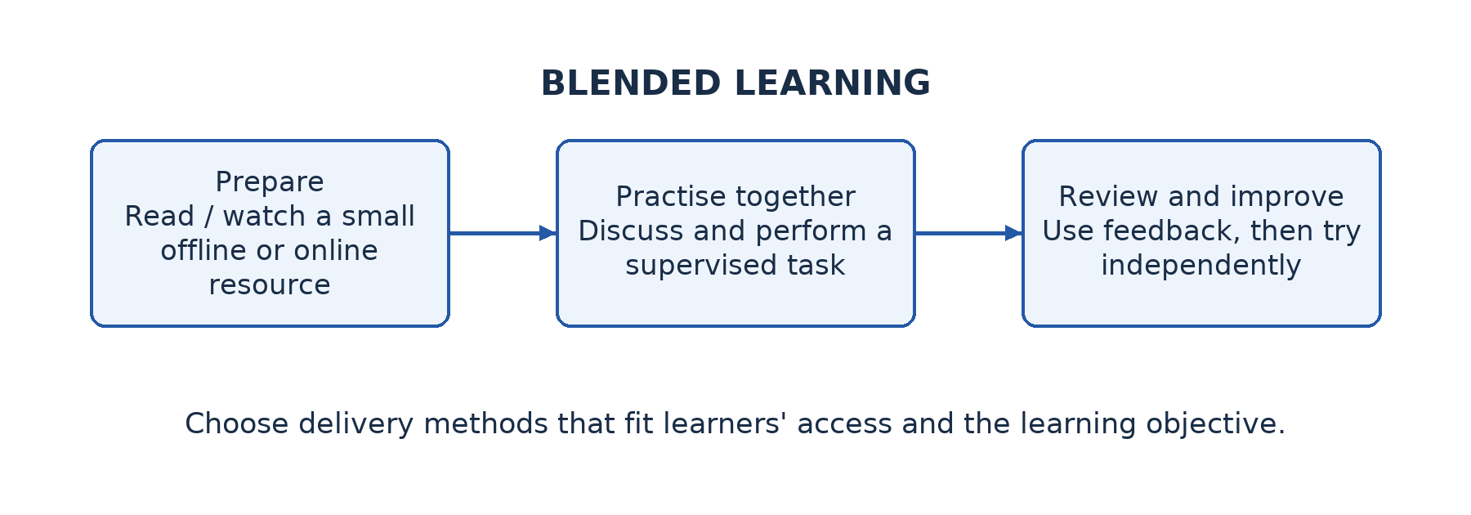
Figure 44.1 — A blended learning plan links preparation, classroom practice and feedback. Offline resources can support learners with unreliable connectivity.

44.4 Benefits and limitations
Electronic resources can support self-paced review, repeated practice, remote access and varied media. A simulation can make an invisible process easier to investigate. Teachers may obtain useful evidence from quizzes or submissions. These benefits depend on suitable content, meaningful tasks and feedback.
Limitations include device cost, power, connectivity, inaccessible design, reduced social contact, distraction and the need for self-management. A learner can click through every page without understanding. Teachers still need to identify misconceptions, support motivation and assess actual competence. Practical tasks may require supervised equipment rather than a video alone.

Worked example — Plan for intermittent connectivity
Mboa's learners can connect at school twice a week but not reliably at home. Provide downloadable text and a small recorded explanation, ask for an offline task, then use school time for discussion and practical testing. A short later quiz provides feedback. Requiring daily live high-resolution video would ignore the stated constraint and might exclude the learners who most need support.

Guided activity
Design a one-week lesson package for a younger class learning file management. State the objective, resource, delivery method, activity, feedback and evidence of success. Include a learner without home Internet and a learner who needs readable text rather than audio alone. If an approved LMS exists, upload a fictional resource and submit a test response; otherwise organise the package as an offline folder and explain the remaining platform steps.

Check your understanding
1. Define CAL and explain two ways a computer can support learning beyond displaying text.
2. Compare delivery through an Internet LMS, local server and offline e-book.
3. Distinguish synchronous, asynchronous and blended learning with examples.
4. Evaluate e-learning for learners with shared devices and intermittent power.

Answer guidance
1. Simulations, purposeful practice and useful feedback can support understanding. Explain the learning mechanism rather than merely listing media.
2. Discuss access, updating, interaction and offline availability. A local server need not have public Internet access, while a downloaded e-book may be used independently.
3. Same-time interaction, different-time participation and a purposeful combination of face-to-face and electronic work answer different design questions.
4. Weigh access and flexibility against resource constraints, then propose downloadable materials, school access and suitable non-digital support. Avoid an absolute verdict without context.

Lesson 45 — Integration: Design a digital services and learning programme
Week 13 · Supplied progression: PDF page 6 · Locally authored integration task

The situation
A fictional community centre wants to help residents locate public information, understand safe online shopping and access learning resources. It has three shared computers, a printer, limited weekly Internet data and volunteers with different levels of confidence. Some users need language or accessibility support.

Your proposal
Design a small service programme combining Lessons 42–44. Choose one public-information task, one commercial-literacy activity and one learning resource. Explain the service purpose, users, necessary equipment and actual outcome for each. Do not propose that volunteers make real payments, submit identity documents or give medical advice on behalf of visitors without proper authority.
Show how volunteers will verify official addresses and explain transaction stages. Include a rule for handling uncertainty or suspected fraud. Plan low-data or offline resources, private handling of information and a practical way to assist users without learning their passwords. State what the centre can do and what requires referral to an authorised institution or professional.
Prepare a simple learning session that combines an explanation, supervised practice and feedback. Include a resident without a personal device and a user who cannot comfortably read a small-screen scanned document. Explain why each adaptation improves participation. A programme that only names three websites does not meet the task.

Demonstration and evidence
Use fictional records and teacher-approved demonstration pages. Show how to locate a public instruction, trace an online order without paying, and open a downloadable learning resource. Submit the programme, a service-flow sketch, an accessibility observation and a short evaluation of the resource limits. If a live page is unavailable, use a dated offline capture and state that current functionality has not been tested.

Assessment criteria — 20 marks
Use 6 marks for appropriate services linked to community needs; 6 marks for realistic delivery, privacy and safety arrangements; 4 marks for a coherent learning activity and inclusion measures; and 4 marks for clear demonstration, evidence and reflective improvement. These are locally authored criteria for the integration lesson.

Review guidance
A strong programme distinguishes finding information from completing a regulated transaction. It allows a resident to retain control of credentials and provides an escalation route when volunteers cannot help safely. After another group's review, explain one change that makes the programme more usable for a person with limited connectivity or a disability. The improvement should address an observed or clearly described barrier, not a vague claim that the programme is “user friendly”.

Lesson 46 — Developing simple web pages using HTML
Week 13 · Supplied progression: PDF page 6
Learning outcomes — supplied progression
• Identify the role of tags and attributes in a web page.
• Implement basic HTML tags to structure a web page.
• Create simple web pages using HTML and a text editor.

Begin with structure, not decoration
The ICT club wants a small offline website explaining its activities. A browser needs to know which text is a heading, which items form a list and where links lead. Hypertext Markup Language (HTML) describes the structure and meaning of web content. It is a markup language, not a general-purpose programming language for calculations and control logic. Styling with CSS and interactivity with JavaScript are later-term topics, not requirements of this lesson.

46.1 Tags, elements and attributes
A tag is markup such as <p> or </p>. An element includes its markup and content, such as <p>Welcome to our club.</p>. Many elements have an opening tag, content and closing tag. Attributes supply additional information in the opening tag. In <a href="about.html">About the club</a>, the href attribute specifies the link destination.
Some elements, including <img>, <br> and <meta>, are void elements and do not have closing tags in HTML. Nest elements properly: an inner element should close before the surrounding element closes. HTML indentation helps a human reader see structure, even though the browser does not display the indentation as page layout.
<!doctype html> identifies a modern HTML document. The <html> element contains the document; lang="en" declares its language. The <head> contains metadata such as character encoding and the page title. The <body> contains the content presented to the user. <title> supplies a browser-tab title; it is different from the visible <h1> heading in the body.
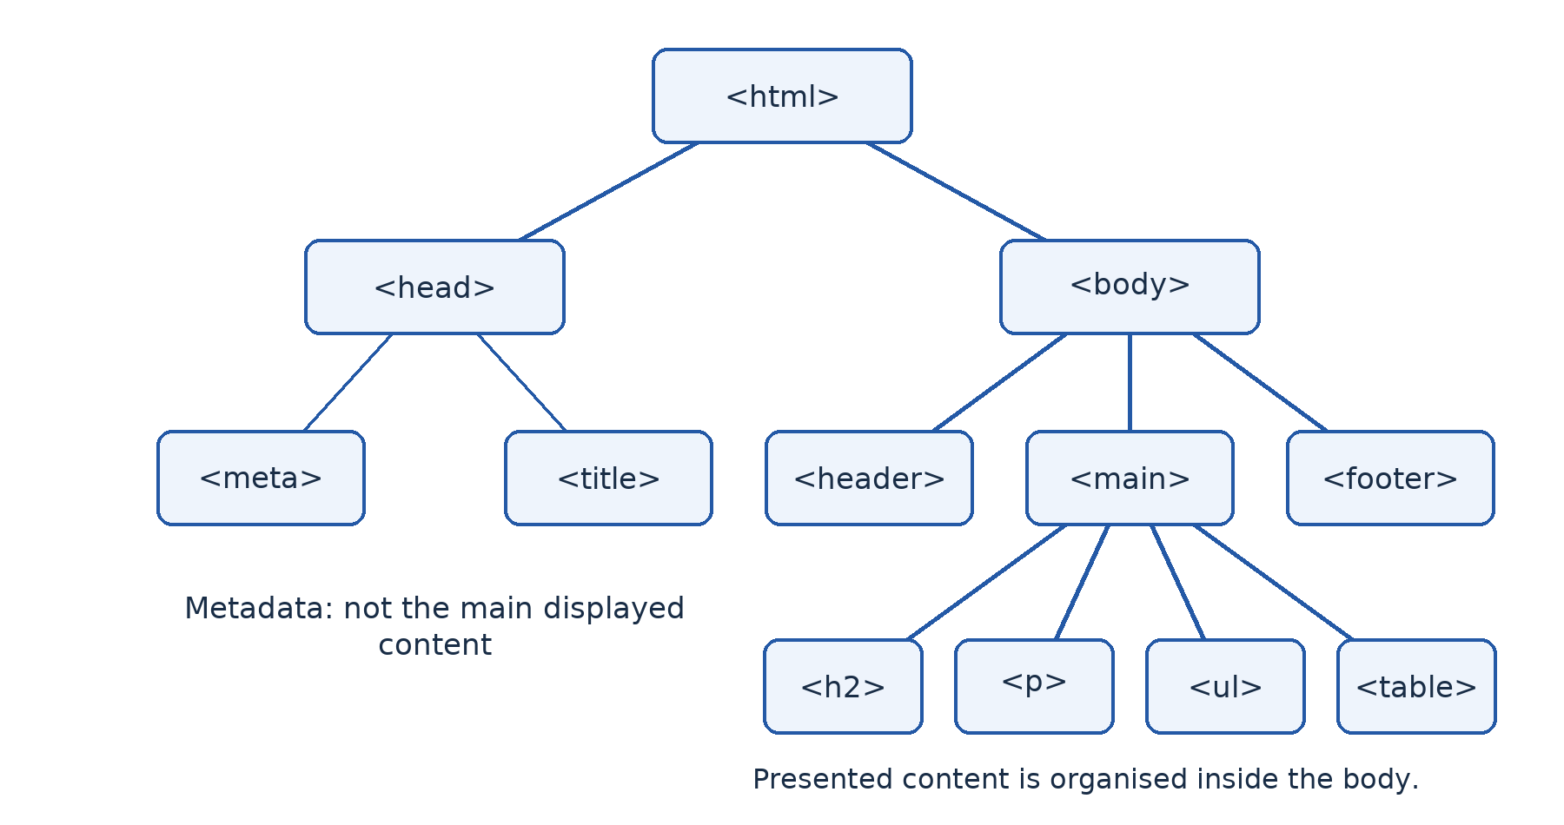
Figure 46.1 — The document contains a head for metadata and a body for presented content. Tags organise a tree of elements rather than a list of formatting commands.

46.2 Basic content elements
Use <h1> for the main page heading and appropriate lower-level headings such as <h2> for sections. A heading level describes structure, not merely desired text size. Use <p> for a paragraph, <strong> for strong importance and <em> for emphasis. Ordinary repeated spaces do not create reliable page layout; HTML normally collapses such whitespace in normal text.
An unordered list uses <ul> and an ordered list uses <ol>, each containing <li> items. An anchor <a> uses href to link to another resource or a page fragment. An image uses src for its location and alt for an appropriate text alternative. A meaningful image needs a useful description; a purely decorative image should normally have empty alternative text, alt="", so assistive technology can ignore it.
A data table uses <table>, rows <tr>, heading cells <th> and data cells <td>. A <caption> explains the table's purpose, and scope can clarify header relationships. Tables are for genuinely tabular data, not a substitute for writing explanations or laying out an entire page. The browser may show a simple table without decorative borders; appearance can be styled in the next term.
A relative path, such as about.html or images/club.svg, is interpreted from the relevant document location. An absolute URL, such as an approved https:// address, includes the access scheme and destination. A fragment link such as #activities refers to an element with the corresponding id in the page. Filenames and letter case can matter when files move between systems.

46.3 Full worked page — index.html
Create the following page in a plain-text editor. The same source and a matching image are supplied in examples/upper-sixth-ict/site/. The page is fictional and works locally without an Internet connection.
Example file: index.html
<!doctype html>
<html lang="en">
<head>
<meta charset="utf-8">
<meta name="viewport"
content="width=device-width, initial-scale=1">
<title>Mboa ICT Club — Home</title>
</head>
<body>
<header>
<h1>Mboa ICT Club</h1>
<p>Learning to use technology responsibly.</p>
<nav aria-label="Main navigation">
<a href="index.html">Home</a>
<a href="about.html">About</a>
<a href="#activities">Activities</a>
</nav>
</header>
<main>
<img src="images/club.svg" width="160"
alt="An open book with a small circuit symbol">
<section id="activities">
<h2>Our activities</h2>
<p>We practise <strong>safe</strong> computing
and explain our choices <em>clearly</em>.</p>
<ul>
<li>Build simple web pages.</li>
<li>Share files with permission.</li>
<li>Check information before forwarding it.</li>
</ul>
</section>
<section>
<h2>How to join a practice session</h2>
<ol>
<li>Ask the teacher for the approved timetable.</li>
<li>Bring your ICT notebook.</li>
<li>Use only the assigned test account.</li>
</ol>
</section>
<section>
<h2>Practice timetable</h2>
<table>
<caption>Fictional club sessions</caption>
<tr>
<th scope="col">Day</th>
<th scope="col">Activity</th>
</tr>
<tr><td>Tuesday</td><td>HTML practice</td></tr>
<tr><td>Thursday</td><td>Network diagrams</td></tr>
</table>
</section>
</main>
<footer>
<p>Classroom example — not a real public service.</p>
</footer>
</body>
</html>

The heading appears in the page because it is in the body; the title appears in the browser tab because it is metadata. The image path looks in an images folder beside index.html. The Activities link finds the section with id="activities". The table is appropriate because days and activities have a row-and-column relationship. These connections explain what the source means rather than asking you to copy mysterious tags.

46.4 A second linked page — about.html
Save the following in the same folder. Its link back to the home page makes navigation work in both directions.
Example file: about.html
<!doctype html>
<html lang="en">
<head>
<meta charset="utf-8">
<meta name="viewport"
content="width=device-width, initial-scale=1">
<title>Mboa ICT Club — About</title>
</head>
<body>
<header>
<h1>About the ICT club</h1>
<nav aria-label="Main navigation">
<a href="index.html">Home</a>
<a href="about.html">About</a>
</nav>
</header>
<main>
<h2>Our purpose</h2>
<p>We learn by explaining, practising and reviewing.</p>
<h2>Our safety rule</h2>
<p>Use fictional data and ask before sharing.</p>
</main>
<footer>
<p>This is a fictional classroom website.</p>
</footer>
</body>
</html>

46.5 Guided practical — Edit, save, open and test
1. Create a folder named ict-club, an images subfolder and the two HTML files. Copy the supplied club.svg image into images. Use a plain-text editor, not a word processor that adds document formatting.
2. Save the pages as UTF-8 text with .html extensions. Check that the editor has not silently added .txt. Open index.html in a browser using the file manager or the browser's open-file control.
3. Compare source with output. Locate the main heading, paragraphs, lists, image and table. Follow About, return Home and test the Activities fragment. Check that the image still loads when the folder is copied to another location.
4. Change one sentence in the editor, save, then reload the browser. If nothing changes, check that you edited the file the browser actually opened. Saving and reloading are different actions.
5. Inspect and correct a teacher-provided harmless error, such as a misspelt filename, missing closing tag or wrong image path. Record the symptom, cause and correction. If an approved validator is available, use its feedback; a page appearing in a browser does not prove that its markup is fully correct.
6. Ask a partner to navigate using the keyboard and explain whether the headings, links and image alternative communicate their purpose. Keep content fictional and do not publish it as a real school service. No CSS, JavaScript or hosting is needed for this first-term practical.
Without a computer, annotate the source and draw the expected page structure on paper, then complete actual editing and browser testing later. Keep the entire folder when submitting: a page that depends on a missing image or second file is incomplete.

Worked example — Debug a missing image
The page contains src="image/club.svg", but the folder is named images. The browser cannot find the referenced file. Correct the relative path to images/club.svg, save and reload. Replacing the computer or adding an Internet connection would not solve this local path error. If the image cannot be shown, its appropriate alt text still communicates its meaning.

Check your understanding
1. Distinguish a tag, an element and an attribute with an example of each.
2. Explain the roles of head, title, body, href, src and alt.
3. Write a paragraph, a three-item ordered list and a link to about.html.
4. Explain why a page may open successfully yet contain invalid markup or broken links.
5. Describe the edit–save–reload cycle and three checks for a file that seems not to update.

Answer guidance
1. <p> is a tag, <p>Hello.</p> is an element, and href="about.html" supplies a link attribute. Preserve the distinction between markup token and complete element.
2. The head holds metadata, title labels the tab, body holds presented content, href gives a link target, src identifies an embedded resource and alt provides an image text alternative appropriate to its purpose.
3. Use properly nested <p>, <ol> with three <li> elements, and <a href="about.html">About</a>. Link text should communicate the destination.
4. Browsers recover from some errors and do not automatically prove that every link or resource works. Test the files and use validation where available.
5. Edit the intended source, save it and reload the displayed page. Check the open path, extension and saved contents; also consider caching only after confirming the correct file is in use.

Independent assignment
Adapt the two-page example into a fictional learning-club site. Include meaningful headings, connected explanations, one useful image with appropriate alternative text, a list, navigation in both directions and a small genuine data table. Submit the complete folder and a short debugging record. You are assessed on clear structure and working content, not decoration from later-term technologies.

Consolidation — Explain, apply and evaluate

A connected view of the term
This term began with AI decisions and ended with creating a small web resource. The connection is the responsible use of information systems. An AI service needs appropriate data, evaluation and human oversight. A network service needs connectivity, compatible equipment, controlled access and reliable operation. An online public service needs usable design and trustworthy handling of information. A learning resource needs explanations and meaningful activities, not simply a screen full of facts.
Keep the main classifications separate. Coverage describes geographical extent; architecture describes service roles; topology describes connections; duplex mode describes permitted directions; medium describes how a signal travels; and protocol describes communication rules. One installation can have a campus coverage, client/server file services, a tree of switched stars, full-duplex Ethernet endpoints, copper and fibre media, and TCP/IP communication. These descriptions complement one another.

Extended practice questions
These are original classroom questions, not copied GCE questions or an official prediction of an examination. Attempt them before reading the guidance.
1. A school wants AI to decide who receives financial assistance. Explain the required data, an honest test, two ethical risks and a responsible decision process.
2. A college has a laboratory and library on one campus and a study centre in another town. Recommend coverage, service architecture and a physical layout. Explain one failure and one growth issue.
3. Two computers have link lights, but neither can open the other's shared folder. Describe a safe diagnosis that distinguishes addressing, service availability, authentication and permissions.
4. A teacher needs remote access to restricted files. Explain how a VPN, signed certificates, firewall policy and file permissions contribute different protections. Identify two remaining risks.
5. A registration record contains the wrong but in-range mark. Explain how validation and verification address different parts of the problem and how an authorised correction should be made.
6. Compare serial with parallel, synchronous with asynchronous, and analog with digital transmission. Explain why these are not three competing labels for one property.
7. A school proposes a standard copper Ethernet channel across 300 m between buildings. Evaluate fibre and directional wireless alternatives using the route, environment, cost, maintenance and resilience.
8. Describe a web request using DNS, transport, IP, local frames and physical signals. Explain where the OSI model helps and why not every actual protocol has an undisputed single-layer label.
9. Add even and odd parity to 1001001. Show a single-bit error and explain why some two-bit errors pass. Describe how retransmission can help recover data.
10. Plan an online group assignment for learners with uneven connectivity. Include source evaluation, permissions, safe attachment sending, a controlled meeting and an asynchronous alternative.
11. Compare e-commerce, e-health and e-government for three community needs. Evaluate the benefits and barriers for users rather than only the service provider.
12. Build a two-page HTML resource for the fictional school. Explain the document structure, test the relative paths and navigation, and submit the complete folder with a debugging record.

Answer planning and selected model reasoning
For Question 1, begin with a clearly limited purpose and relevant, permitted data. Avoid treating previous decisions as automatically fair labels. Separate training from independent testing and assess results for affected groups. Explain privacy and unfair exclusion, then connect safeguards to those harms. Keep accountable humans in the decision and provide an appeal route. A list of ethical words without actions is not a complete response.
For Question 2, distinguish the local or campus arrangement from the inter-town WAN. Explain why centrally managed files and accounts may suit the college, while recognising cost and shared-service dependence. A switched star within rooms and a hierarchical campus arrangement may be practical. Analyse an actual failed component and reserve justified growth capacity. Another technically sound design can be defended if it meets the needs.
For Question 3, preserve the approved configuration and test one hypothesis at a time. Check the physical interface and addresses, then a permitted reachability test, then the actual share name and service, then the account and effective permissions. Do not disable the firewall or grant anonymous full control to produce an apparent success. Record what each test establishes and what it leaves uncertain.
For Question 4, the VPN protects selected traffic between its endpoints. Signed certificates support trusted identity checks, firewall rules limit allowed traffic, and permissions limit resource operations. An infected endpoint or stolen authorised account remains a risk. Neither a tunnel nor a protected-connection icon proves that every action at the endpoint is safe.
For Question 9, the data has three 1s. Append 1 for even parity or 0 for odd parity under the stated right-appended convention. Explain the total count and show how an odd number of flips changes parity while an even number may not. A mismatch detects a problem but does not locate it. ARQ adds feedback, timeout and retransmission; sequence information helps manage repeats.
For Question 12, assess structure and behaviour. The tab title belongs in the head, presented content in the body, and links must point to actual files or existing fragment identifiers. A meaningful image needs appropriate alternative text. Open both pages locally, test navigation and resources, save and reload an edit, and correct a recorded fault. A screenshot of one attractive page is not proof that the whole folder works.

Practical completion record
A learner should eventually be able to show the following on approved equipment, not only describe them. Keep evidence free of credentials and personal information.
• A simple Teachable Machine model, independent test observations and an explanation of at least one failure.
• A controlled two-computer share with configuration, service-access and permission-test evidence.
• An authenticated VPN connection to a prepared lab gateway, a permitted resource test and a teacher-designated blocked-resource observation; otherwise record the practical as still outstanding.
• A test of read-only and editing roles plus validation boundaries and a verification comparison on fictional data.
• Browser navigation and settings use, an approved e-mail account with confirmed attachment receipt, and a focused information search with source evaluation.
• A shared document with deliberate permissions and contribution evidence, plus participation in a controlled online meeting.
• A non-transactional inspection of an approved public-service page and a learning resource chosen for an actual access need.
• Two connected HTML pages, their local image, successful navigation tests and a short debugging record.

Compact vocabulary reference
This reference helps you locate meanings already explained in the lessons. It is not a replacement for those explanations.
AI: computing concerned with tasks associated with intelligence. Machine learning: learning useful patterns from data. Model: the learned representation used for prediction. Training: adjusting a model from examples. Inference: using a trained model on input. Generalisation: useful performance on new cases. Bias: a systematic tendency that can distort results or disadvantage users.
Network: connected devices communicating through agreed rules. Protocol: communication rules. LAN: local-area connectivity. CAN: campus-area connectivity in this course. WAN: wide-area connectivity. Client: a service requester. Server: a service provider. Topology: a connection arrangement. Switch: a device forwarding local frames. Router: a device forwarding packets between IP networks.
Throughput: achieved useful transfer rate. Latency: delay. Buffer: temporary holding storage during transfer. Interrupt: a request for processor attention. Polling: repeated status checking. Handshaking: exchange of control information to coordinate communication. Encapsulation: adding relevant enclosing communication information. Parity: an agreed odd/even count relationship used for limited error detection.
Authentication: verifying identity. Authorisation: deciding permitted actions. Confidentiality: limiting information to authorised parties. Integrity: protecting against inappropriate alteration. Availability: access when needed. Encryption: transforming readable data into protected ciphertext using a key. Digital signature: cryptographic evidence supporting authenticity and integrity under a trusted key association. Least privilege: only the necessary authority.
Validation: checking input against defined rules. Verification: checking faithful copying against a source in this data-entry context. Intranet: internal organisational services using Internet technologies. Extranet: selected services extended to authorised external users. VPN: a protected logical connection over another network. URL: a resource location and access description. Cookie: browser-held site state used under applicable rules.
CAL: computer-assisted learning. LMS: a system organising learning resources and activities. Synchronous learning: same-time interaction. Asynchronous learning: participation at different times. HTML: markup describing web content structure. Tag: a markup token. Element: the structured unit including markup and content where applicable. Attribute: additional information on an element.

Source and alignment notes

What determines the lesson coverage?
[S1] Primary source: 2026-2027 ICT Upper Sixth Progression Sheet.pdf, supplied in this repository. First-term Lessons 1–46 appear on PDF pages 1–6. The sheet places Evaluation 1 and remediation after Lesson 17, and Evaluation 2 and remediation after Lesson 34. CSS begins at Lesson 47 on PDF page 7 and is excluded here. The objectives shown with each reading lesson are transcribed from the supplied sheet with punctuation and capitalisation normalised. Integration scenarios, examples, questions, answer guidance and marks in this book are locally authored.
Important source discrepancy: the file is named Upper Sixth, but the printed first-page heading says “NATIONAL HARMONISED LOWERSIXTH PROGRESSION SHEET”. Its content begins with the AI and networking sequence used here. This book follows the file supplied as Upper Sixth; it does not claim to have obtained an official correction of that heading. The separate Lower Sixth file in the repository begins with a different sequence. The school should confirm any administrative ambiguity with its responsible authority.

Sources used to check teaching expectations
[S2] Cameroon GCE Board, “GCE Advanced Level”. Official general examination description, consulted 23 October 2026. It places the examination at the end of Upper Sixth and describes thinking, application, synthesis and evaluation. It is used for general level expectations, not as a substitute for a current subject-specific syllabus or an official marking scheme. [2]
[S3] MINESEC, High School Teaching Syllabus for Information and Communication Technology, August 2020. Consulted through a third-party public mirror on 23 October 2026. The introduction and learner-profile sections emphasise principles, practical competence and informed use of ICT. This older document provides pedagogical context only; its mirror and date mean it is not presented as a newly verified 2026–2027 examination syllabus. The supplied progression determines this book's term sequence. [3]
[S4] Direction Générale des Impôts, official e-services directory. Consulted 23 October 2026 as an example of a Cameroonian public-service platform. The exercise is limited to locating information and evaluating access; it does not verify a complete live tax procedure or ask learners to transact. Service interfaces may change. [2]
[S5] Cameroon GCE Board, official homepage. Consulted 23 October 2026 for an examination-related public-service example. No learner should infer a current registration procedure from a classroom example rather than official instructions. [7]
A separately authenticated current GCE ICT examination syllabus was not supplied or verified in this revision. Consequently, this book makes no claim about current paper weightings, exact examination timing or an official marking allocation. The Form 1–5 Computer Science teacher guide in the repository is not used as an authoritative Upper Sixth ICT guide.

Editorial method
The earlier Upper Sixth ICT file was reviewed for scope, lesson sequence and instructional limitations. This revision replaces table-dominated summaries with connected explanations, worked reasoning, original labelled diagrams, practical procedures and checks with answer guidance. Tables are discussed where they are genuine subject content, such as HTML data tables; they are not used to contain the book's main teaching text. Diagram captions explain what to notice rather than leaving instructions to draw a figure later.
Technical wording distinguishes concepts often blurred in short summaries: telemedicine from AI, coverage from architecture and topology, half-duplex shared Ethernet from switched full-duplex Ethernet, validation from verification, signatures from encryption, and VPN protection from authorisation. Local organisations in scenarios are fictional unless an official public platform is explicitly identified and sourced. Practical interfaces may change, so the teacher should pre-test approved tools and adapt control names without changing the underlying learning objective.

